Primarily Teaching Grant Lesson Plan

Name: Alex Abbe

Title: Do they work? Analyzing and evaluating WWI Propaganda Posters

Grade-level: 10

Subject Area: American History II: 1900-Present

Topic: World War I Propaganda

Standards:
Iowa Core Social Studies (History):
- Understand cause and effect relationships and other historical thinking skills in order to interpret events and issues
- Understand processes such as using a variety of sources, providing, validating, and weighing evidence for claims, checking credibility of sources, and searching for causality
- Understand how and why events may be interpreted differently depending upon the perspectives of participants, witnesses, reporters, and historians

Iowa Core Literacy Standards for History/Social Studies:
- RH.9-10.1 Cite specific textual evidence to support analysis of primary and secondary sources
- RH.9-10.5 Analyze how a text uses structure to emphasize key points or advance an explanation or analysis
- WHST.9-10.4 Produce clear and coherent writing in which the development, organization, and style are appropriate to task, purpose, and audience
- WHST.9-10.9 Draw evidence from information to support analysis, reflection, and research
- WHST.9-10.10 Write routinely over extended time frames and shorter time frames for a range of discipline specific tasks, purposes, and audiences.

Compelling Question:
- Are World War I propaganda posters an effective way to get the public to support the war effort?

Learning Objectives:
- Students will be able to cite textual evidence to support their claims
- Students will be able to analyze a historical document, utilizing the different “levels” of reading
- Students will be able to identify and evaluate the effectiveness of an author’s work
- Students will be able to write according to the specific task at hand

Materials:
- 1 propaganda poster per student (only for their assigned poster)
- 1 “3 Levels of World War I Propaganda” assignment sheet per student (See questions directly below this lesson)
- RAFT Graphic Organizer: https://docs.google.com/document/d/1r8wH9lVJcujPy1m5HNQzwKTxZQ-Q_xTQS4SO_qaRhWs/edit?usp=sharing

Resource Table of Library of Congress Materials:
Image | Description | Citation | URL
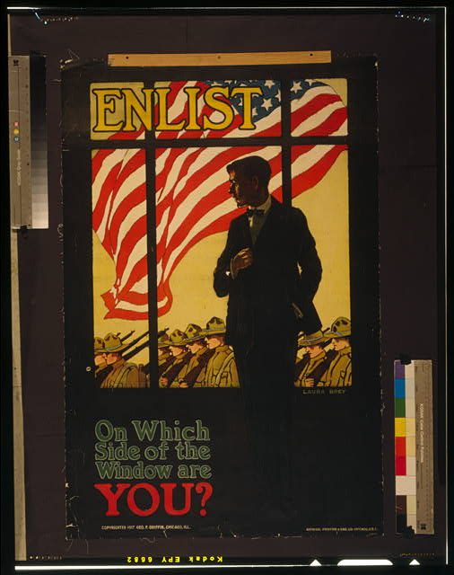 | Enlist: On which side of the window are you? (Man looking through a window at American soldiers marching by) | "Enlist On Which Side of the Window Are You? /." Library of Congress. Library of Congress, n.d. Web. 19 Aug. 2014. <http://www.loc.gov/pictures/item/98503178/>. | http://www.loc.gov/pictures/item/98503178/
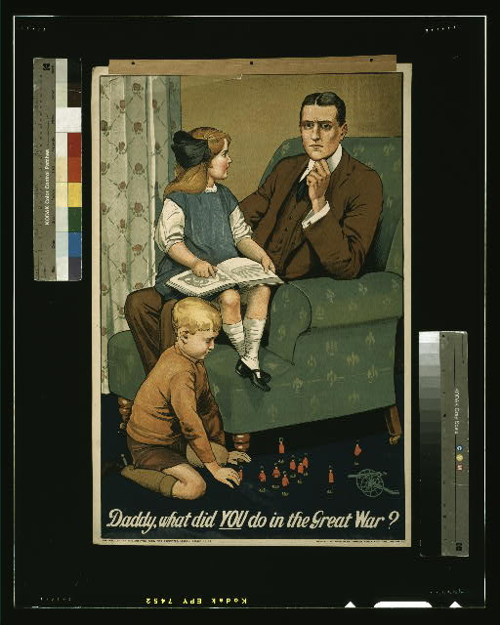 | Daddy what did you do in the Great War? (Father sitting with his children at home. Children are playing war and questioning him) | "Daddy, What Did You Do in the Great War?" Library of Congress. Library of Congress, n.d. Web. 19 Aug. 2014. <http://www.loc.gov/pictures/item/2003663090/>. | http://www.loc.gov/pictures/item/2003663090/
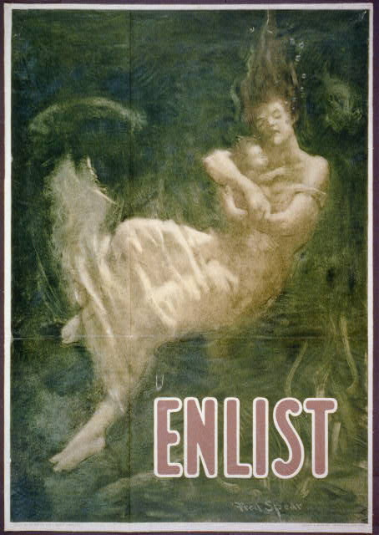 | Enlist (Woman and child aboard the Lusitania sinking to the ocean floor) | "Enlist." Library of Congress. Library of Congress, n.d. Web. 19 Aug. 2014. <http://www.loc.gov/pictures/item/00651156/>. | http://www.loc.gov/pictures/item/00651156/
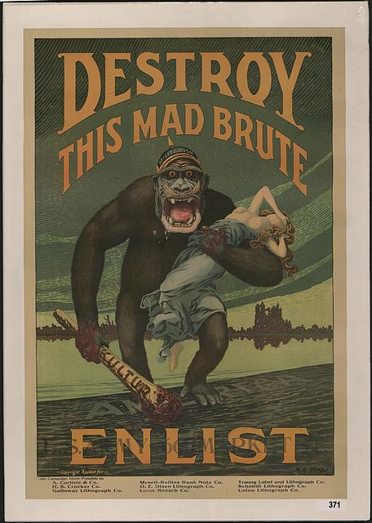 | Destroy This Mad Brute: Enlist (Gorilla holding a half-naked woman as he reaches the American shore) | "Destroy This Mad Brute Enlist - U.S. Army." Library of Congress. Library of Congress, n.d. Web. 19 Aug. 2014. <http://www.loc.gov/pictures/item/2010652057/>. | http://www.loc.gov/pictures/item/2010652057/
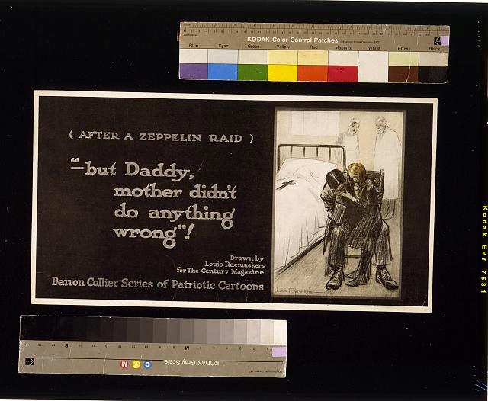 | (After a Zeppelin Raid) “-but Daddy, mother didn’t do anything wrong”! (Father and daughter mourn in a hospital over the death of the mother | "After a Zeppelin Raid -- "but Daddy, Mother Didn't Do Anything Wrong!""Library of Congress. Library of Congress, n.d. Web. 19 Aug. 2014. <http://www.loc.gov/pictures/item/2004666229/>. | http://www.loc.gov/pictures/item/2004666229/
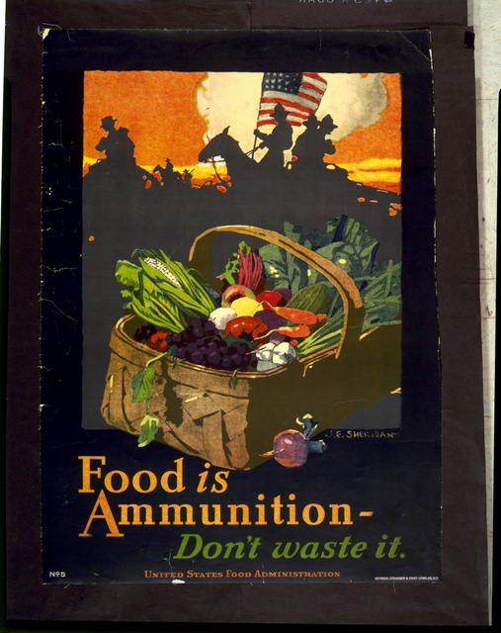 | Food is Ammunition-Don’t Waste it | "Food Is Ammunition--don't Waste It." Library of Congress. Library of Congress, n.d. Web. 19 Aug. 2014. <http://www.loc.gov/pictures/item/94514370/>. | http://www.loc.gov/pictures/item/94514370/

Procedure:
- Divide students into groups of 2-3 depending on the class size. Assign one propaganda poster to each group. There should be 2 groups per poster, although other posters could be added to this lesson so each group has their own instead of “doubling up” on them.
- Although they are in groups, students will individually answer each question prior to checking in and discussing with their group mates. While collaborating, students should strengthen and adjust their own work based on the thoughts of those around them. Discussion guidelines and expectations already in place in the classroom should be followed to promote actual collaboration as opposed to each student just “sitting and sharing”/”show and tell.” Groups will follow this process one question at a time. An emphasis should be placed on citing textual evidence. If students are in the beginning stages of citing textual evidence with historical documents, a teacher-think aloud and modeling process could be implemented with a different poster to lead into the small group work.
- At teacher’s discretion and with time permitting a representative from each group could share out his/her thoughts by walking the rest of the class through the Text, Context, and Subtext of the poster. Comparisons/contrasts between groups with the same poster could also be made. This would be a great opportunity to stress the idea that history is not the past. It’s the study and interpretation of past events and although the same document is used, different interpretations can be decided on. There isn’t always necessarily a black and white, right or wrong answer with history. An emphasis should also be placed on citing textual evidence and an examination of the author’s purpose and techniques used to achieve (or not…) it.
- To wrap things up and move into the evaluation phase, students should be directed to the RAFT graphic organizer. If students aren’t familiar with RAFT, a good way to introduce the strategy is to have students write the same message and purpose, just with a different role, audience, or format (ex: speaking to principal as opposed to best friend, speaking in church as opposed to Friday night’s football game). Although in many cases students have complete control over the RAFT technique for the written piece, the role and topic/purpose of this one has been determined so as to meet the lesson objectives and standards (although it could be adjusted per teacher discretion). In this case R = a member of the intended audience the author of the poster was targeting, A =(suggestions: his/herself, a family member or friend,soldier serving in the war, the general public or specific sub-group) F = (suggestions: newspaper opinion piece, letter, diary entry, etc.) T = Evaluation of the effectiveness of the poster based on textual evidence. A good place to start for students is their “3 Levels of World War I Propaganda” assignment sheet. That formative assessment serves as a scaffold or ramp to this assessment.

Assessments:
- Formative: Group and class discussion, “3 Levels of World War I Propaganda”
- Summative: RAFT written piece

Optional Extension: Connections to the “here and now”/real-world could be made in terms of how people use different techniques to try and achieve their purpose and deliver their message. (Example at the time this lesson is written: political TV ads, Hamas vs. Israel, ISIS vs. United States, the situation involving Michael Brown in Ferguson, MO)

3 Levels of World War I Propaganda

TEXT
What is the poster explicitly telling you? What is “on the surface”? What can you observe and read?

CONTEXT
What is going on during the time period of this poster? What background knowledge do you have that helps you understand what’s shown in this poster? How can you connect what you already know to this poster?

SUBTEXT (Reading between the lines and looking “below the surface”)
Besides what is clearly and explicitly shown, what’s really being stated? Are there messages lurking “below the surface”? Cite your evidence from the poster.

Audience: Who is the targeted audience? How do you know?

What techniques does the author use to send his messages, achieve his purpose, and reach his targeted audience? Cite your evidence from the poster.

FOCUSING ON THE POSTER’S CORE
“Boil down” the poster in 3 words or less. You could summarize it or select words or a phrase that represents it.

