Primarily Teaching Lesson Plan

Name: Brandon Lantzky

Title: Examining changes brought about to life styles by technology in the late 1800’s.

Grade Level: 10th Grade

Subject Area: United States History
Topic: Industrialism

Standards:
- Understand the role of innovation on the development and interaction of societies
- Understand significant changes caused by technology, industrialization, urbanization, and population growth and the effects of these changes.
- Understand the historical impact of the interaction and interdependence of science, technology, and society in a variety of cultural settings.

Compelling Question: How did technological advances in the late 1800’s affect the lives of American citizens?

Learning Objectives:
- Students will analyze images of ice harvest and distribution.
- Students will analyze a letter.
- Students will support the following statement. “Advances in technology in the late 1800’s had an impact on the lives of Americans.

Materials:
- Ice Block Images
- Copies of the Oblinger Letter

Resource Table of Library of Congress Material
Image | Description | Citation | URL
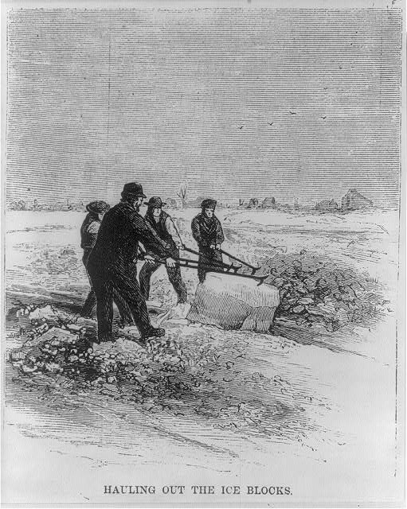 | A wood engraving of Ice workers in 1870 from Harper’s Weekly. | Hauling Out the Ice Blocks. c1870. Wood Engraving. Library of Congress Prints and Photographs Division Washington, D.C. 20540 USA. Lib of Congress. Web. 8 Aug. 2014 | http://lcweb2.loc.gov/service/pnp/cph/3a40000/3a43000/3a43900/3a43936r.jpg
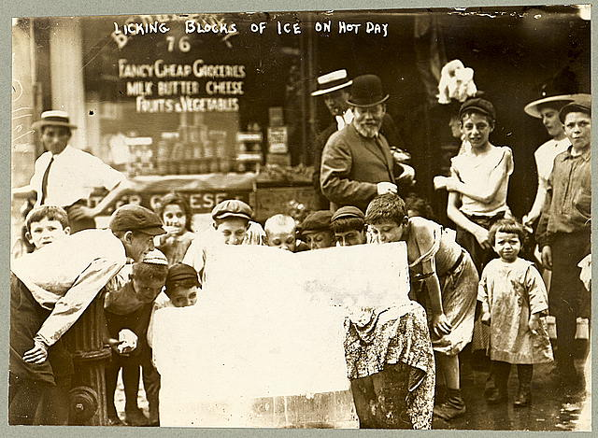 | An image of children in New York City licking a block of ice in front of a grocery store. July 6, 1912 | Licking blocks of Ice on a Hot Day. c1912. Photograph. Library of Congress Prints and Photographs Division Washington, D.C. 20540 USA. Lib of Congress. Web. 8 Aug. 2014 | http://lcweb2.loc.gov/service/pnp/ppmsc/00100/00148r.jpg
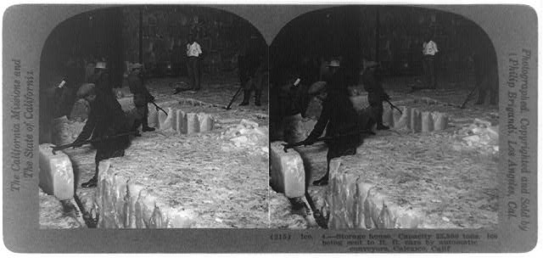 | This shows the size of the warehouse and how the ice was stored. | Brigandi, Phillip.Storage House, capacity 22,500 tons—Ice being sent to R.R. cars by automatic conveyors, Calexico, Calif. c1920. Photograph. Library of Congress Prints and Photographs Division Washington, D.C. 20540 USA. Lib of Congress. Web. 8 Aug. 2014 | http://lcweb2.loc.gov/service/pnp/cph/3b30000/3b38000/3b38900/3b38964r.jpg
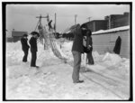 | A photo of men loading ice onto wagons. | Ice harvesting, shooting the cakes wagons. ca1903. Photograph. Library of Congress Prints and Photographs Division Washington, D.C. 20540 USA. Lib of Congress. Web. 8 Aug. 2014 | http://lcweb2.loc.gov/service/pnp/det/4a00000/4a05000/4a05600/4a05657_150px.jpg
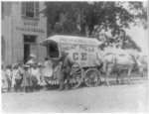 | A photo of an ice wagon  Kennebec Ice horse-drawn wagon parked in front of Birney Public School - school children lined up with teacher behind wagon as man shows them large chunk of ice suspended by tongs, Washington, D.C. | Johnston, Frances Brnjamin. Kennebec Ice horse-drawn wagon parked in front of Birney Public School - school children lined up with teacher behind wagon as man shows them large chunk of ice suspended by tongs, Washington, D.C.. c1899. Photograph. Library of Congress Prints and Photographs Division Washington, D.C. 20540 USA. Lib of Congress. Web. 8 Aug. 2014 | http://lcweb2.loc.gov/service/pnp/cph/3a50000/3a52000/3a52000/3a52034_150px.jpg
Oblinger Letter | Letter from Uriah W. Oblinger to Mattie V. Thomas, January 13, 1867. | Nebraska State Historical Society, [Digital ID, e.g., nbhips 12036] | http://memory.loc.gov/cgi-bin/query/h?ammem/psbib:@field(DOCID+@lit(l038))

Procedure:

- Show students pictures #1, #2, and #3. Ask the students to discuss with a partner what the see in the picture. (Tell them not to think too hard, just list what they see.)
- Bring the class back together and discuss what they think is going on in the pictures.
- Ask the students if they have ever experienced anything like this. They will probably answer no.
- Have the students make a list of inventions/technology in their lives that accomplish the goal of the ice blocks.
- Show the students the love letter from Minnesota.
- Ask the students to answer the following questions.
  - Who wrote this letter?
  - When was it written?
  - Who was it written to?
- Have the students read the letter.
  - Ask them what was happening in the letter.
  - Have the students brainstorm technology that would make the lives of the people in this letter easier. (A heating system, lights, instant communication, electricity).
- Have the students research major technological advances of the late 1800’s. Have the students compile a list in a Google Document and have them cite their sources in MLA format. Tell the students that if the source is not a quality source, or if the source is not cited, it will be deleted from the document.

Assessment:
- The student should re-write the letter or write a telegram as if it were written in 1920 instead of 1867. The letter should reflect the changes that took place between the time the original letter was written and 1920.
- The students should choose a character from one of the ice block photos. They should create a fictional diary entry explaining how one of the major technological advances of the late 1800’s affected their lives.

