Primarily Teaching Grant Lesson Plan

Name: Kelly Parriott

Title: You Say You Want a Revolution?!

Grade-level: 11th grade

Subject Area: United States History

Topic: The start of the American Revolution

Standards:
- Determine the central ideas or information of a primary or secondary source; provide an accurate summary that makes clear the relationship among the key details and ideas. (RH. 11-12.2.)
- Integrate and evaluate multiple sources of information presented in diverse formats and media (e.g., visually, quantitatively, as well as in words) in order to address a question or solve a problem. (RH.11-12.7.)
- Integrate information from diverse sources, both primary and secondary, into a coherent understanding of an idea or event, noting discrepancies among sources. (RH. 11-12.9.)

Compelling Question: American Revolutionaries: traders or fighters?

Learning Objectives:
- Students will analyze the series of events that led to the American Revolution.
- Students will evaluate the Revolution from both British and Patriots’ view points.

Materials:
- Computers for each student
- Internet connection
- Primary resources handout
- Headphones for each student
- The Americans, McDougal Littell Textbook (optional)
- Pens

Resource Table of Library of Congress Materials:
Image | Description | Citation | URL
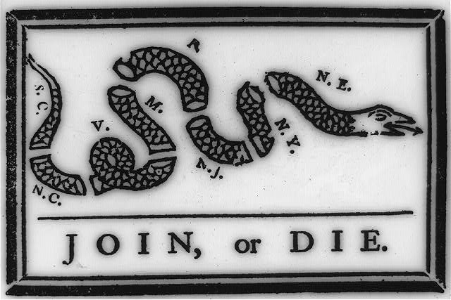 | Benjamin Franklin's warning to the British colonies in America "join or die" exhorting them to unite against the French and the Natives, shows a segmented snake, "S.C., N.C., V., M., R., N.J., N.Y., [and] N.E. | Published in:  The ungentlemanly art ; a history of American political cartoons / Stephen Hess and Milton Kaplan. New York : Macmillan, [1968], p. 52 (II-3). | http://www.loc.gov/pictures/item/2002695523/
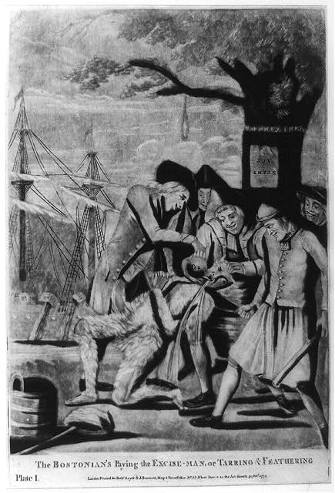 | Print shows five men forcing a tarred and feathered customs officer to drink from a teapot, a bucket and a liberty cap are on the ground at his feet. They stand beneath the "Liberty Tree" from which a rope with a noose hangs; in the background, shadowy figures on a ship dump tea overboard. | London : Printed for Robt. Sayer & J. Bennett, Map & Printseller, No. 53, Fleet Street as the Act directs, 1774 Octr. 31. | http://www.loc.gov/pictures/resource/cph.3a11950/
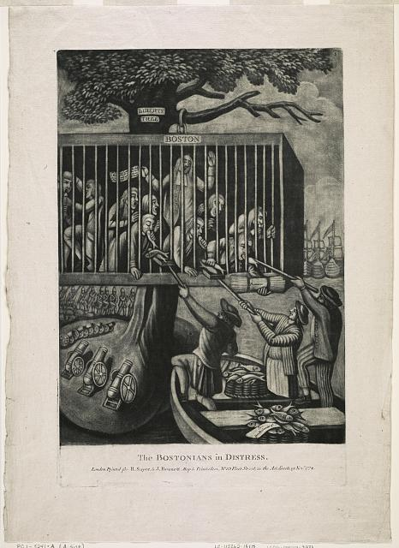 | Print shows a re-drawn and reversed image of the famous British political cartoon where Bostonians held captive in a cage are suspended from the "Liberty Tree." Three British sailors standing in a boat feed them fish from a basket labeled "To -- from the Committee of --" in return for a bundle of papers labeled "Promises"; around the tree and in the background are cannons and British troops. The paper in the hand of one jailed Bostonian says "They tried with the Lord in their Troubl & he saved them out of their Distress. CVIL 13." | "Creating the United States" at the Library of Congress, Washington, D.C., 2011 | http://www.loc.gov/pictures/resource/ppmsca.31272/
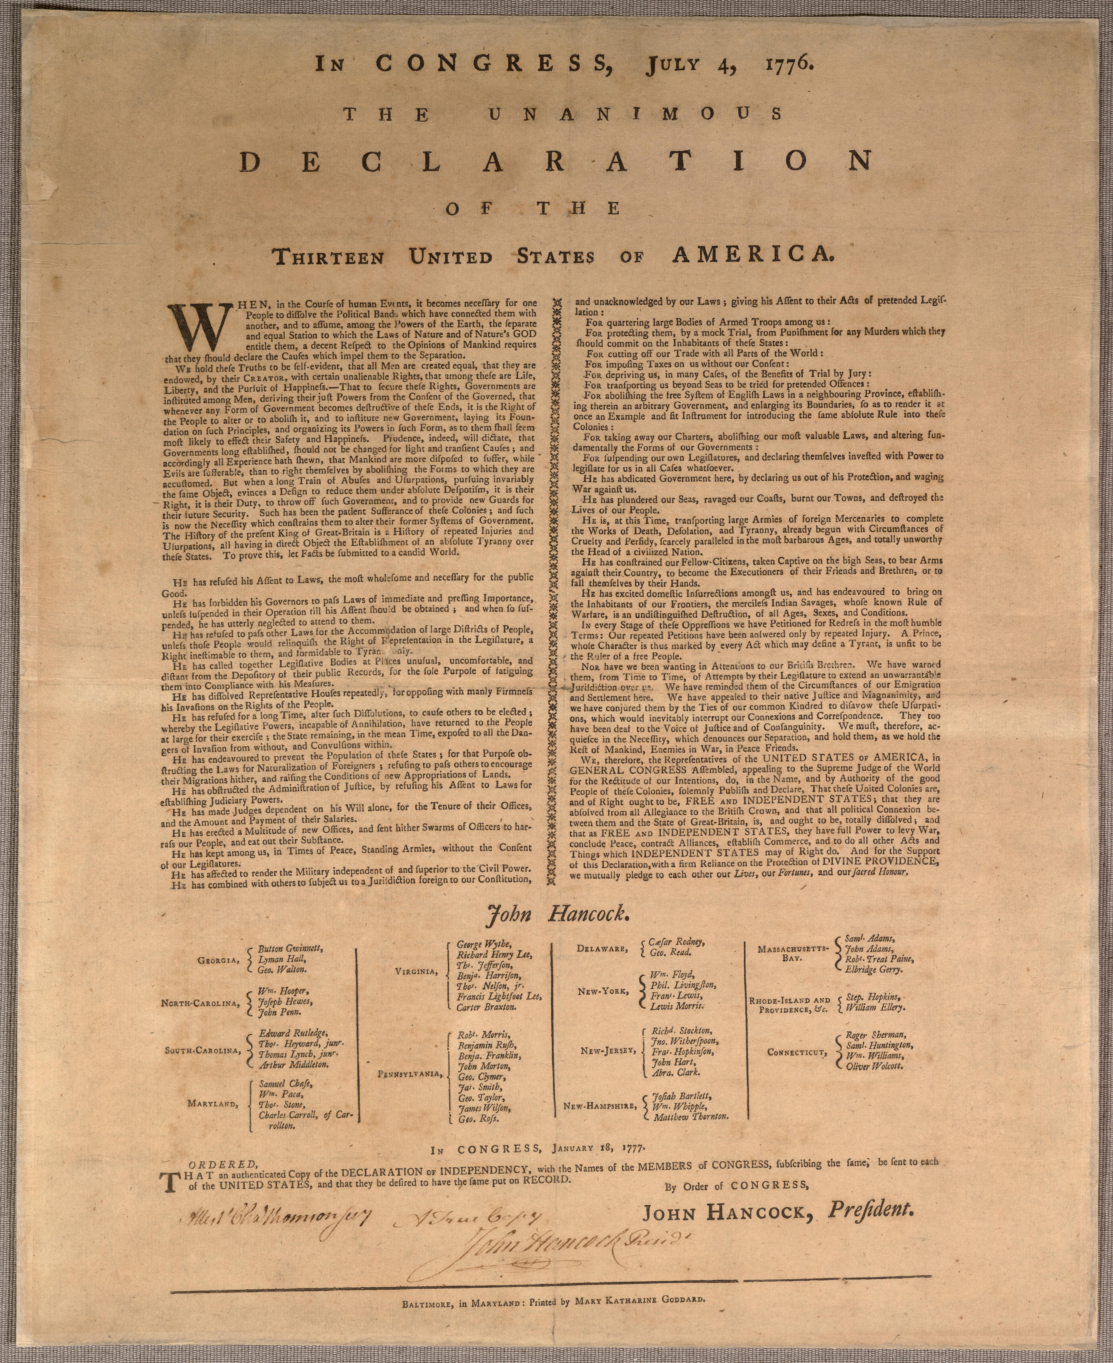 | The Declaration of Independence | Armitage, David. The Declaration of Independence: A Global History. Cambridge, Mass.: Harvard University Press, 2007 | http://memory.loc.gov/service/rbc/bdsdcc/02101/0001.jpg
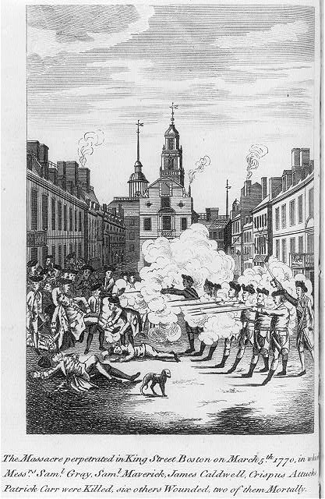 | Print shows British troops firing on citizens in Boston. Created by Patriot Paul Revere | Illus. in:  A short narrative of the horrid massacre in Boston, ... observations on the state of things prior to that catastrophe. Printed by order of the town of Boston. London : Reprinted for E. and C. Dilly, and J. Almon, 1770, frontispiece. | http://www.loc.gov/pictures/resource/cph.3a45748/
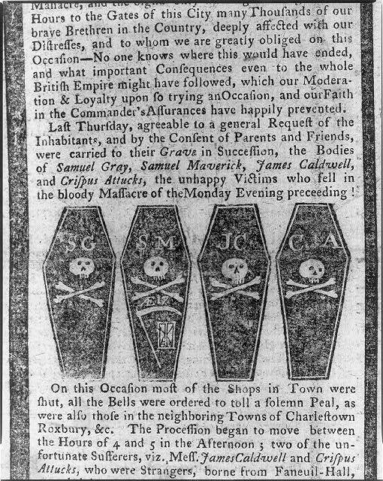 | Print shows section of newspaper column with illustration of four coffins bearing skull and crossbones and the initials of those killed: Samuel Gray, Samuel Maverick, James Caldwell, and Crispus Attucks. | Illus. in:  The Boston Gazette, and Country Journal, 1770 March 12. | http://www.loc.gov/pictures/item/2004672647/

Procedure:
- Depending on your schools computer situation be sure to reserve computers in advanced for this lesson. This self-paced lesson has student look at a verity of primary and secondary resources to gain insight to the events leading up to the start of the Revolutionary War.
- Step one: Handout the primary source analysis worksheet to each student in the class.
- Step two: inform students they will use the Library of Congress Website to take a closer look at primary documents having to do with pre-Revolution events. They should follow all directions on the handout and answer the questions in the space provided. This will take about 60-75 minutes for students to complete.
- Step three: Once all students have completed their assignments discuss student answers as a class. Have students turn their handouts in after the discussion.

Assessment: Students will complete the handouts provided. Teacher will formatively assess student work, and provide informative feedback to student’s responses. Teacher should check for student understanding of the multiple viewpoints’.

Go to the following link http://www.loc.gov/pictures/resource/cph.3a12149/ using the image and the information provided answer the following question. (Join or Die)

- What do you think the letters over each part of the snake represent?

- Explain the message of the cartoon.

- This cartoon was originally made for the French and Indian War, looking at the picture in the Massachusetts Spy what do you think is the new meaning of the cartoon came to be during the American Revolution?
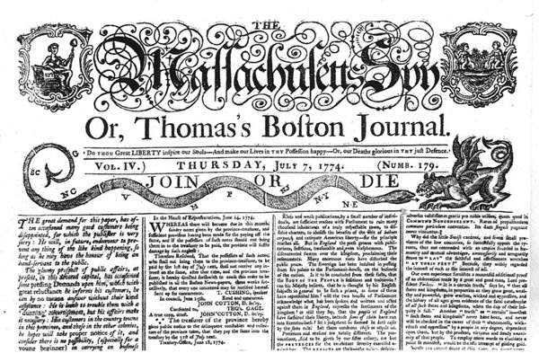

- What special interest groups would side with this cartoon’s message? What group would disagree with the message? Why?

Read the following account from George Hewes. Then answer the questions:
George Hewes was a member of the band of "Indians" that boarded the tea ships the night of the Boston Tea Party. His recollection of the event was published some years later. We join his story as the group makes its way to the tea-laden ships:
"It was now evening, and I immediately dressed myself in the costume of an Indian, equipped with a small hatchet, which I and my associates denominated the tomahawk, with which, and a club, after having painted my face and hands with coal dust in the shop of a blacksmith, I repaired to Griffin's wharf, where the ships lay that contained the tea. When I first appeared in the street after being thus disguised, I fell in with many who were dressed, equipped and painted as I was, and who fell in with me and marched in order to the place of our destination.
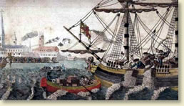
The Boston Tea Party
When we arrived at the wharf, there were three of our number who assumed an authority to direct our operations, to which we readily submitted. They divided us into three parties, for the purpose of boarding the three ships which contained the tea at the same time. The name of him who commanded the division to which I was assigned was Leonard Pitt. The names of the other commanders I never knew. We were immediately ordered by the respective commanders to board all the ships at the same time, which we promptly obeyed. The commander of the division to which I belonged, as soon as we were on board the ship, appointed me boatswain, and ordered me to go to the captain and demand of him the keys to the hatches and a dozen candles. I made the demand accordingly, and the captain promptly replied, and delivered the articles; but requested me at the same time to do no damage to the ship or rigging. We then were ordered by our commander to open the hatches and take out all the chests of tea and throw them overboard, and we immediately proceeded to execute his orders, first cutting and splitting the chests with our tomahawks, so as thoroughly to expose them to the effects of the water.
In about three hours from the time we went on board, we had thus broken and thrown overboard every tea chest to be found in the ship, while those in the other ships were disposing of the tea in the same way, at the same time. We were surrounded by British armed ships, but no attempt was made to resist us.
...The next morning, after we had cleared the ships of the tea, it was discovered that very considerable quantities of it were floating upon the surface of the water; and to prevent the possibility of any of its being saved for use, a number of small boats were manned by sailors and citizens, who rowed them into those parts of the harbor wherever the tea was visible, and by beating it with oars and paddles so thoroughly drenched it as to render its entire destruction inevitable."
"The Boston Tea Party, 1773," EyeWitness to History, www.eyewitnesstohistory.com (2002).

- Why do you think they dressed as Indians?

- Why did the colonist throw the tea into the harbor?

- List three things the author said that help you understand the events that happened the night of the Boston Tea Party:

- Imagine you were the Captain or sailor of the ships that were under attack. Write an “eye witness account” about the Boston Tea Party from their point of view.

Go to the following link http://www.loc.gov/pictures/resource/ppmsca.31272/ use the image to answer the questions below. (Bostonians in distress)

Visuals | Words
1. List the objects or people you see in the cartoon. | 1. Identify the cartoon caption and or title.
2. What objects on your list are symbols? What do you think these symbols mean? | 2. Locate three words or phrases used by the cartoonist to identify objects or people within the cartoon. Which do you think is most significant and why?
3. This was printed in a London paper. Make an argument where this is a pro-British cartoon.

4. Make an argument where this is a pro-Patriot cartoon.

Go to the following link http://www.loc.gov/pictures/resource/cph.3a11950/ using the image and the information provided answer the following question. (paying the tax man)
- 1. What do you see happening in the background of this picture?

- 2. This image was printed in England. Why would the British print this picture?

- 3. How can this be considered propaganda? What is the message that the artist is trying to portray?

To give you a little back ground on the Boston Massacre click on the link https://www.youtube.com/watch?v=_rTrUL7ns2E and watch the reenactment of the trial of the soldiers who were accused of killing people in the Boston Massacre. Then look at the images found at the following links. http://www.loc.gov/pictures/item/2004670035/ (Boston Massacre) http://www.loc.gov/pictures/item/2004672647/ (coffins of 4 dead Boston)

1. Paul Revere is the creator of this propaganda that was published in many newspapers in the colonies, how did he stir up anti-British sentiment among his fellow colonists through this picture?

2. Why isn’t this a true depiction of what happened?

3. Why did Revere misrepresent what happened?

Take a look at the Declaration of Independence using the following site. You can zoom in and out to get a closer look at the document. http://memory.loc.gov/service/rbc/bdsdcc/02101/0001.jpg Answer the following questions:
- Write down 4 key points that are made in the document.

- Write down any questions that come to mind as you look at the document.

- What makes this document difficult to read?

This is a link to a satirical music video about the founding fathers breaking up with the British. https://www.youtube.com/watch?v=uZfRaWAtBVg&list=PL513D575BC208B739 (video) After watching the video answer the following questions:
- List 3 events that we learned about in this lesson that were found in the music video.

- Why do you think they turn into a hard rock band at the end of the video?

Read the following information and/or your Americans textbook pages 96-99 for additional information on the events leading up to the American Revolution.
HISTORICAL BACKGROUND on Join or Die:
Representatives of seven colonies met in Albany to secure the allegiance of the Iroquois Confederacy, and to unite the colonies in matters of defense. Benjamin Franklin proposed the Albany Plan of Union, which provided for a congress of delegates representing all the colonies. England rejected it because each was unwilling to give up any of its powers of local government to a grand council. This was America’s first political cartoon, which appeared in Franklin’s newspaper shortly after the Albany Congress. This drawing was based on the popular superstition that a snake that had been cut in two would come to life if the pieces were joined before sunset. This drawing immediately caught the public’s eye and was reproduced in other newspapers.
HISTORICAL BACKGROUND on the Stamp Act:
In 1765, upon George Grenville’s recommendation, the British Parliament enacted the Stamp Act as a means of raising colonial tax revenues to help pay the cost of the French and Indian War in North America. The Stamp Act was the first direct tax imposed by Britain on its American colonies. This law placed a tax on newspapers, almanacs, pamphlets, playing cards, and legal documents. The Colonists reacted immediately, asserting that the Stamp Act was an attempt to raise money in the colonies without the approval of colonial legislatures. Patrick Henry in the Virginia House of Burgesses stated “No Taxation without Representation”. This became the slogan of the day. Patriotic societies, known as “The Sons of Liberty” were formed to organize resistance to the tax; resistance to the act was demonstrated through debates in the colonial legislatures, written documents (including legislative resolves, prints, and songs), and mob/crowd actions such as tarring and feathering tax collectors. Merchants pledged to halt the import of British goods, and the people vowed to stop buying English products until the tax was repealed.

HISTORICAL BACKGROUND on Boston Tea Party :
The British East Indian Company was in financial distress, partly as a result of the colonial boycott of English tea. To save the company from ruin, Parliament passed the Tea Act, which allowed the company to ship tea to America without paying the existing heavy duty in England. This allowed the company to sell the tea more cheaply than the colonial importers of English tea as well as the smugglers of foreign tea. This would ruin many American tea merchants. In many American ports, the colonists boycotted the tea. It was either sent back to England, or locked up in warehouses and left to rot. In Boston, with the encouragement of The Sons of Liberty, the citizens refused to permit the unloading of three tea ships. During the night of December 16, 1773, the Boston Tea Party took place. Bostonians disguised as Indians boarded the ships and dumped 342 chests (worth $75,000) into the harbor.

HISTORICAL BACKGROUND on Boston Massacre:
The people of Boston threatened and harmed British customs officials trying to collect taxes. So, the British quartered troops in Boston to protect their officials (Quartering Acts). In Boston, as elsewhere, there were bitter feelings between the colonists and the redcoats, the British troops. On one occasion, a riotous crowd of Bostonians shouted insults and threw snowballs at a detachment of soldiers. The redcoats fired into the mob, killing five townspeople and wounding six others. The angry citizens, led by Samuel Adams, demanded the removal of the British troops. To prevent an uprising, the governor withdrew the soldiers from the city. News of the massacre spread throughout the colonies and aroused hatred everywhere.
HISTORICAL BACKGROUND on the Intolerable Acts:
Parliament moved quickly to punish Massachusetts for the Boston Tea Party and to reassert its authority over the colonies. It passed a series of acts that the colonists called “intolerable.” This political cartoon shows colonial protest against the Intolerable Acts. In August of 1774, the Williamsburg Resolutions were passed. Virginians were urged to sign a pledge of loyalty to the Continental Congress and to stop the export of tobacco to England, the colonies’ major and most profitable crop, until all taxes on imported goods were repealed.
Cite: http://howingtonhistory.wikispaces.com/file/view/Amer+Rev+Political+Cartoons.pdf

