Primarily Teaching Grant
Lesson Plan Template

Name: Bill Ruttenberg

Title: Controlling Public Thought: The Use of Propaganda in WWI

Grade-Level: 7th Grade

Subject Area: Social Studies - World Geography (Europe Unit)

Topic: Propaganda in WWI - Changing Public Opinion

Standards: SS.06-08.09.02 & SS.06-08.05.01

Compelling Question: How does the media control public thought?

Learning Objectives: The students will analyze documents from WWI and evaluate the use of propaganda to sway public opinion and formulate the “us versus them” mentality. They will compare WWI propaganda to the present day use of propaganda to see how propaganda has changed, but yet also stayed the same. They will create their own piece of propaganda to persuade their audience to support their opinion. This will demonstrate their comprehension of how propaganda can be used in various ways.

Materials: Computer with internet access, paper, pencil, art supplies (crayons, markers, etc.), words and history to the song “Over There”, earbuds.

Resource Table of Library of Congress Materials:

Image | Description | Citation | URL
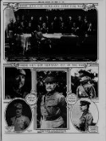 | This is the newspaper The Sun. It has pictures of all who were involved in WWI. It uses the “us versus them” technique. Germany is the bad guy and all others are good and peaceful. | The sun. (New York [N.Y.]), 17 Nov. 1918. Chronicling America: Historic American Newspapers. Lib. of Congress. <http://chroniclingamerica.loc.gov/lccn/sn83030431/1918-11-17/ed-1/seq-27/> | <http://chroniclingamerica.loc.gov/lccn/sn83030431/1918-11-17/ed-1/seq-27/>
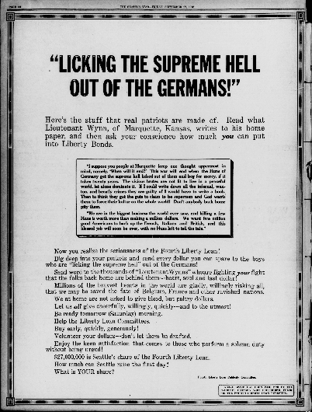 | The Seattle Star was using quotes from generals in the war to gain support for the Liberty Loans. | The Seattle star. (Seattle, Wash.), 27 Sept. 1918. Chronicling America: Historic American Newspapers. Lib. of Congress. <http://chroniclingamerica.loc.gov/lccn/sn87093407/1918-09-27/ed-1/seq-10/> | <http://chroniclingamerica.loc.gov/lccn/sn87093407/1918-09-27/ed-1/seq-10/>
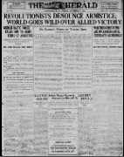 | The Washington Herald was using language to make other people out to be the bad guys, calling them revolutionists. Also, it makes it sound like we have total support as the “world goes wild for Allied victory”. | The Washington herald. (Washington, D.C.), 12 Nov. 1918. Chronicling America: Historic American Newspapers. Lib. of Congress. <http://chroniclingamerica.loc.gov/lccn/sn83045433/1918-11-12/ed-1/seq-1/> | <http://chroniclingamerica.loc.gov/lccn/sn83045433/1918-11-12/ed-1/seq-1/>
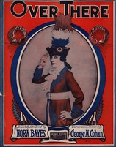 | World War One song Over There used to help draw patriotic people into supporting the war. | Nora Bayes. Cond. Josef Pasternack. Over There. Victor, 1917. Library of Congress: National Jukebox. Web. 12 Aug. 2014. <http://www.loc.gov/jukebox/recordings/detail/id/5977>. | <http://www.loc.gov/jukebox/recordings/detail/id/5977>  http://history1900s.about.com/od/1910s/a/overtheresong.htm
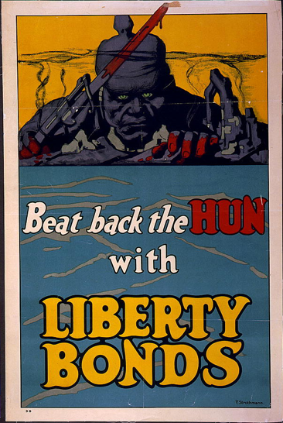 | Propaganda Poster: Beat back the HUN with Liberty Bonds. | Strothmann, Frederick. Beat Back the Hun with Liberty Bonds / F. Strothmann. 1918. Library of Congress: Prints and Photographs Online Catalogue, Washington, D.C. | <http://www.loc.gov/pictures/resource/cph.3g02950/>
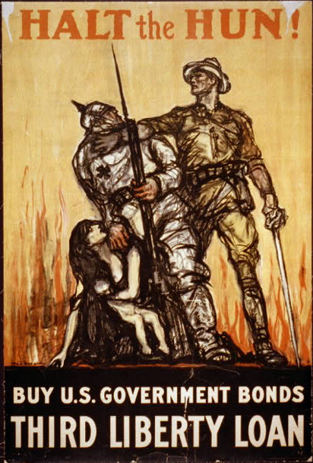 | Propaganda Poster: HALT the HUN!  Buy U.S. Government Bonds  Third Liberty Loan | Raleigh, Henry. Halt the Hun! Buy U.S. Government Bonds, Third Liberty Loan / Raleigh. 1918? Library of Congress: Prints and Photographs Online Catalogue, Washington, D.C. | http://www.loc.gov/pictures/resource/cph.3g02792/

Procedure:
- The teacher will have the song Over There playing in the background as students enter the classroom. The teacher will hand out a numbered piece of scrap paper which will tell the students what group they will be working in.
- The students will group up according to their numbered pieces of paper.
- The teacher will have the question written on the board, “What is propaganda?”
- The students will come up with a definition within their groups. They will share it with the class after about a minute of discussion. (Time can vary according to students and the work output.)
- The teacher will write the different definitions on the board and compare them.
- As a class, the students will discuss the right/wrong answers and why they are right/wrong. The teacher will help to guide the discussion.
- The teacher will then hand out various pieces of propaganda (or have them linked on MOODLE) to each of the groups. The teacher will give the directions: Identify the source using good “historical thinking skills”. (There are posters on the wall with Wineburg’s Thinking Like A Historian message.)
- The students will put their thoughts onto paper (handed in at the end of the group work, so that the teacher can analyze how well the class understands propaganda) and then they will present their findings to the class, and explain what is going on in the examples they were given.
- The teacher will critique their analysis as they explain to the class their thoughts.
- The teacher will then give the class the question: “What do they all have in common?”
- The students will hopefully identify some of the themes that are present in the examples: such as demonizing the enemy. The word “HUN” should come into the discussion.
- The teacher will hand out lyrics and play the song Over There again.
- The class will discuss the song and how even music could be used as propaganda.
- The teacher will pose the question, “How does the media use propaganda today and what are some specific examples?”
- The students will discuss the question for a few minutes and then be allowed to go search for some examples on the internet. Using Wineburg’s Thinking Like A Historian, the students will identify their sources and the messages they were trying to get across. (Political Adds, etc.)
- The teacher will discuss how some messages are similar to WWI and others have changed.
- The students will participate in the discussion.
- The teacher will give the final assignment.
- The students will have their choice of time period to work in (major event) and their choice of media to use. They will create a piece of propaganda to persuade an audience to do something they want them to do according to the event they chose. In the process, they have to incorporate the “us versus them” mentality used during World War One. They will have a couple of class periods to finish the assignment. They also must analyze their own propaganda using the Thinning Like A Historian method.

Assessment: The student will create a piece of propaganda (poster, 20 second commercial, newspaper article, or a song) to persuade an audience to think in a certain way. They must explain who their audience is and how/why they are trying to change that audiences’ opinion. They will be given a rubric with criteria that must be included in the message.

