Location | ID #r | Description | Image
S14 d61 | I 08709 | US Navy | 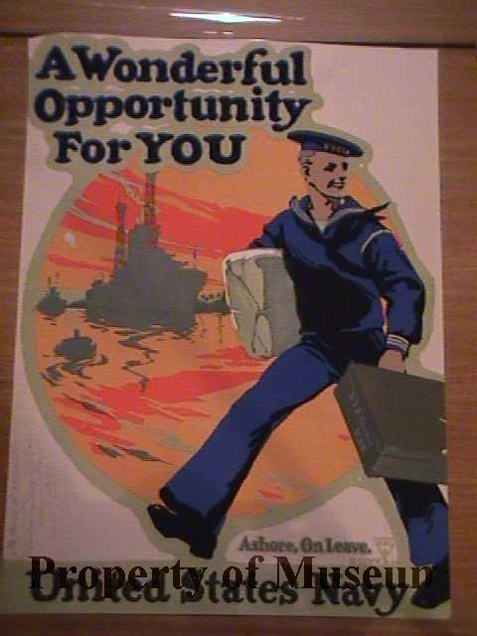
S14 d61 | I 08688 | Spirit of 1917 US Marines | 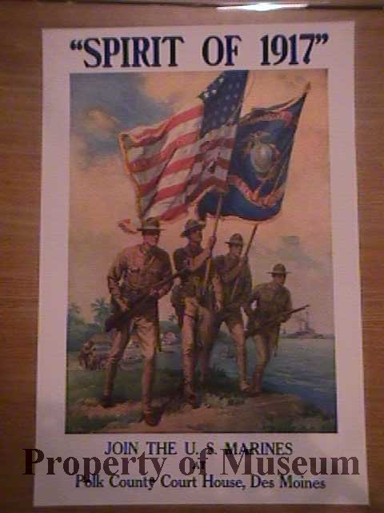
S14 d61 | I 09094 | Enlist in the Navy | 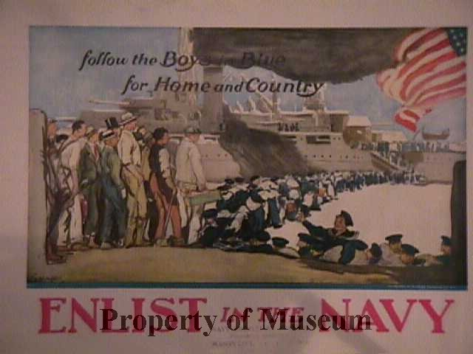
S14 d 62 | I 08753 | Uncle Sam- reprinted from Leslie’s Preparedness Number 07/06/1916 | 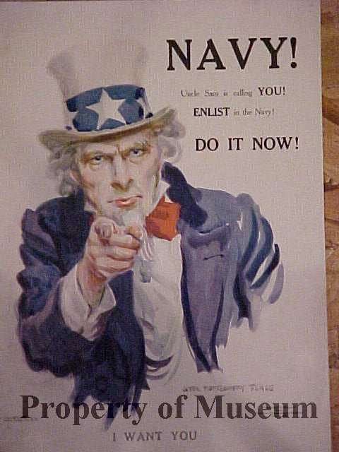
S14 d 62 | I 09121 | Hun- Buy Liberty Bonds | 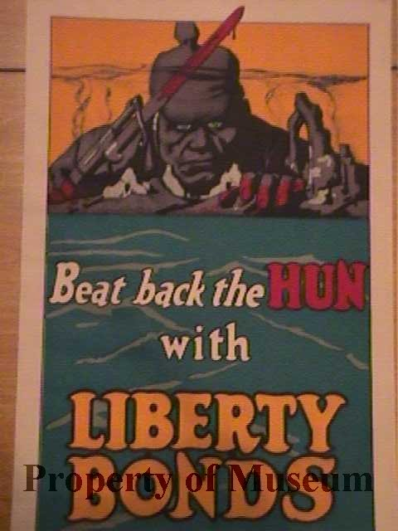
S14 d 62 | I 08652 |  | 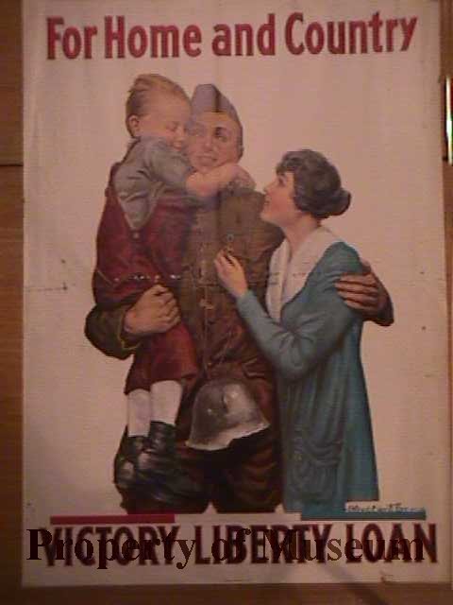
S14 d 63 | I 09958 | Food is Ammunition- Don’t Waste It | 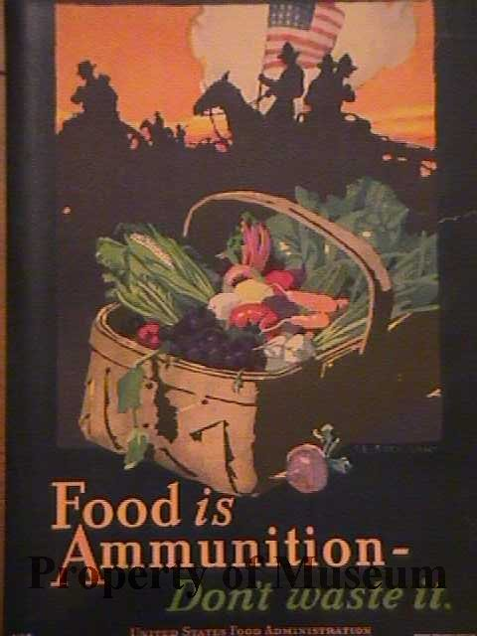
S14 d 63 | I 09091 | Fruits of Victory | 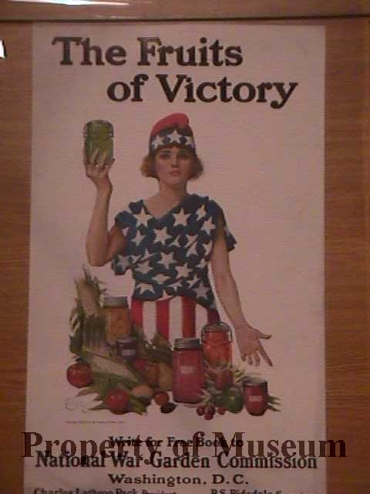
S14 d64 | I 08596 | Join the Army Air Service | 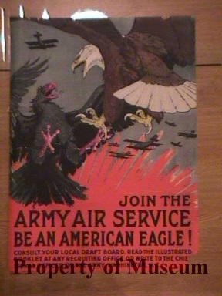
S14 d65 | I 08520 | Women: Help America’s Sons Win the War | 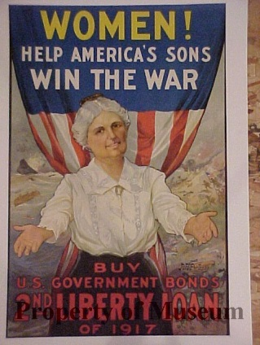
S14 d65 | I 08804 | Little Americans | 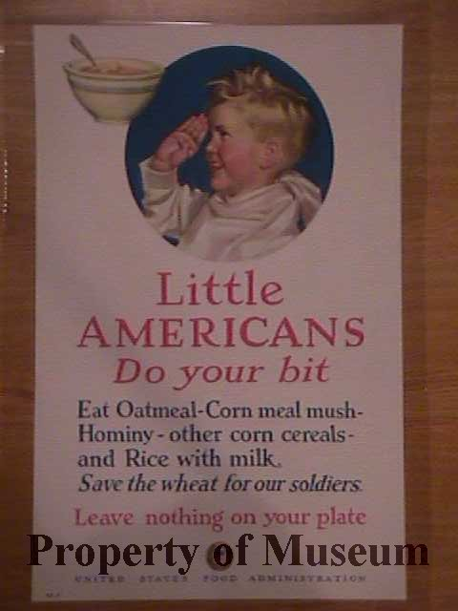
S14 d65 | I 08654 | Americans All | 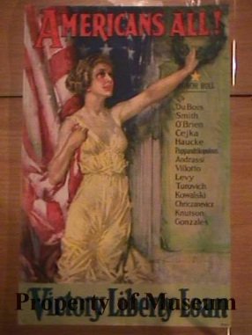
S14 d65 | I 08701 | Gee I Wish I Were a Man, I’d Join the Navy | 