Primarily Teaching Grant Lesson Plan

Name: Lorie Blumeyer

Title: Trail of Tears

Grade-level: 8th

Subject Area: Social Studies

Topic: Manifest Destiny

Standards:
Iowa Core in Social Studies
- Essential Concept and/or Skill: Understand historical patterns, periods of time and the relationships among these elements. (SS.6-8.H.1)
- Understand concepts such as chronology, causality, change, conflict, and complexity.
- Essential Concept and/or Skill: Understand the role of individuals and groups within a society as promoters of change or the status quo. (SS.6-8.H.4)
- Understand that specific individuals and the values those individuals held had an impact on history.
Iowa Core Literacy Standards for History/Social Studies
- Cite specific textual evidence to support analysis of primary and secondary sources. (RH.6-8.1)

Compelling Question:
- Was the suffering of the Cherokee Nation (and other Native American tribes) a necessity in our country? What are some alternate plans that would result in a similar outcome?

Learning Objectives:
- Students will summarize the political and industrial atmosphere of our nation in the early 1800s.
- Students will examine and analyze primary sources related to the Trail of Tears.
- Students will design one or more alternatives to the actions taken by President Jackson and evaluate its potential as compared to actual events.

Materials:
- Computer for research, reading, and creating written response (1:1 MacBook Air for all students)
- Textbook: Creating America chapter 12, section 2 https://sites.google.com/a/pcmonroe.k12.ia.us/mrs-blumeyer/assignments
- Reading Guide ch 12, sec 2 https://sites.google.com/a/pcmonroe.k12.ia.us/mrs-blumeyer/u7-reading-guide
- Letter; George Washington to Senate on Cherokee Indians 1790 http://www.loc.gov/teachers/classroommaterials/presentationsandactivities/presentations/timeline/newnatn/nativeam/gwletter.html
- Trail of Tears Powwow A Local Legacy http://www.americaslibrary.gov/es/ky/es_ky_powwow_1.html
- Indian Removal Act http://memory.loc.gov/cgi-bin/ampage?collId=llsl&fileName=004/llsl004.db&recNum=458
- Chief Little John and the Trail of Tears October 3, 1790 http://www.americaslibrary.gov/jb/nation/jb_nation_tears_1.html
- A map of the Eastern Cherokee Nation in 1835 http://www.americaslibrary.gov/aa/jackson/aa_jackson_indians_3_e.html
- The 6 Cs Primary Source Analysis Tool https://sites.google.com/a/pcmonroe.k12.ia.us/mrs-blumeyer/additional-resources
- LOC Primary Source Analysis Tool https://sites.google.com/a/pcmonroe.k12.ia.us/mrs-blumeyer/additional-resources

Resource Table of Library of Congress Materials:

Image | Description | Citation | URL
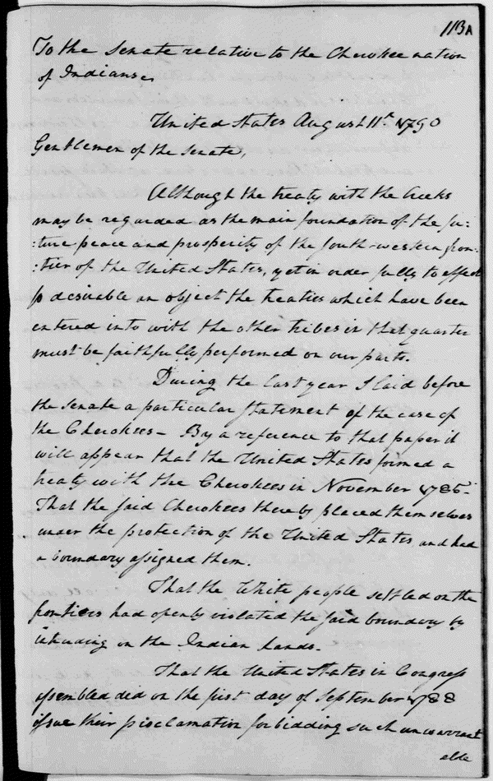 | Letter from George Washington to Senate on Cherokee Indians | Letter from George Washington to Senate about Cherokee Nation. 1790. | http://www.loc.gov/teachers/classroommaterials/presentationsandactivities/presentations/timeline/newnatn/nativeam/gwletter.html
 | Trail of Tears Powwow  A Local Legacy | Library of Congress. (n.d.). Trail of Tears Powwow A Local Legacy. Retrieved January 1, 2014, from http://www.americaslibrary.gov/es/ky/es_ky_powwow_1.html | http://www.americaslibrary.gov/es/ky/es_ky_powwow_1.html
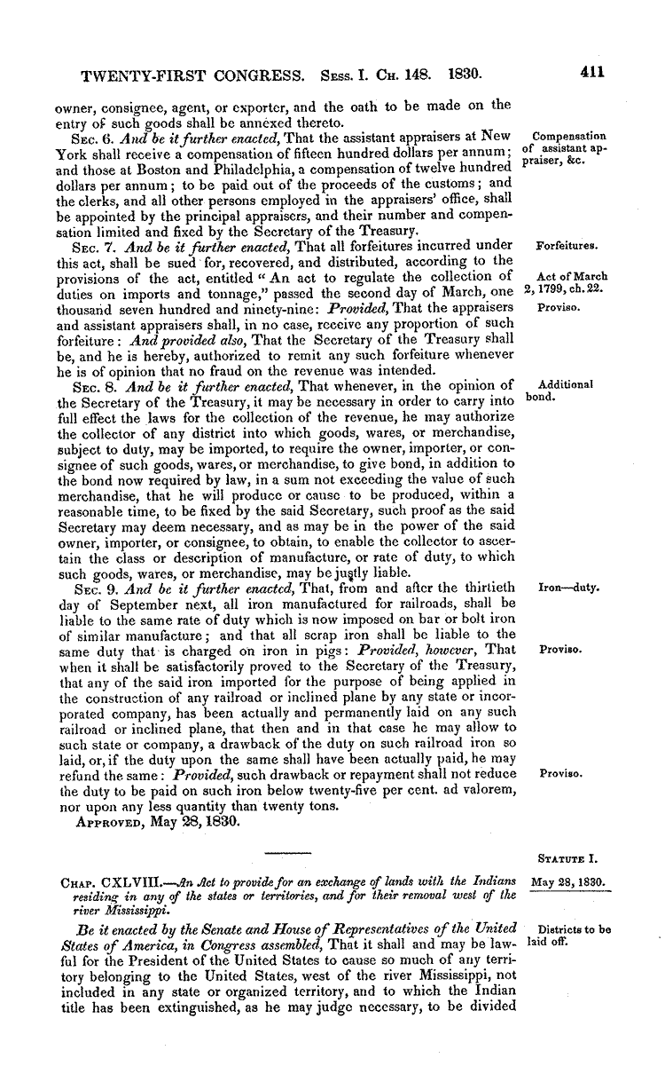 | Indian Removal Act | Jackson, A., & Twenty- Congress. (1830, January 1). The Indian Removal Act. Retrieved January 1, 2014, from http://memory.loc.gov/cgi-bin/ampage?collId=llsl&fileName=004/llsl004.db&recNum=458 | http://memory.loc.gov/cgi-bin/ampage?collId=llsl&fileName=004/llsl004.db&recNum=458
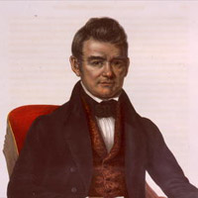 | Chief Little John and the "Trail of Tears"  October 3, 1790 | Chief Little John and the “Trail of Tears” October 3, 1790 - Jump Back in Time | America's Library - Library of Congress. (n.d.). Retrieved August 20, 2014, from http://www.americaslibrary.gov/jb/nation/jb_nation_tears_1.html | http://www.americaslibrary.gov/jb/nation/jb_nation_tears_1.html
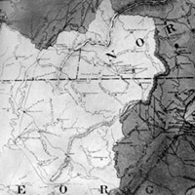 | A map of the Eastern Cherokee Nation in 1835 | Jackson, A. (1835, January 1). From Horseshoe Bend to the Trail of Tears. Retrieved August 20, 2014. | http://www.americaslibrary.gov/aa/jackson/aa_jackson_indians_3_e.html

Procedure:
- Students will work together in groups (pods by color) to collect complete this assignment.
- Students will work to recreate political and industrial atmosphere of our nation in the 1820s. Students may use textbook, reading guide, and other related articles as provided on our class website.
- Students will list events/actions in President Jackson’s career that relate to or lead to the “Indian Removal Act”. (use textbook and related articles)
- Students will use graphic organizers provided to examine and analyze primary source documents related to the Trail of Tears. These are located on the class website.
  - You may use the LOC Primary Source Analysis Tool and the 6 Cs Primary Source Analysis Tool for the examination of primary sources in the classroom. (use each at least once, you may use a combination of these tools)
- Students will design one or two alternate plans that could have been implemented to avoid the Trail of Tears.

Assessment: How will you know students learned what you intended? Describe any formative and summative assessment strategies you intend on using.

Using Google Classroom, students will choose an alternate plan, created during group work time, and complete a five paragraph essay including the following:
- State the details of the alternate plan you like the best. This should be a realistic and reasonable plan.
- State your reasons/argument to support your choice of the plan.
- State textual evidence (from provided sources; both primary and secondary) to support your choice.
- Consider the political atmosphere of 1830 and determine the following:
  - If you were President Andrew Jackson, would you have courage to implement your chosen plan?
  - Would it destroy or strengthen your political career?
- Describe the outcome you would expect from your plan. Consider if it would be helpful to Native Americans, specifically the Cherokee Nation.

