

Accessing Resources from the Library of Congress

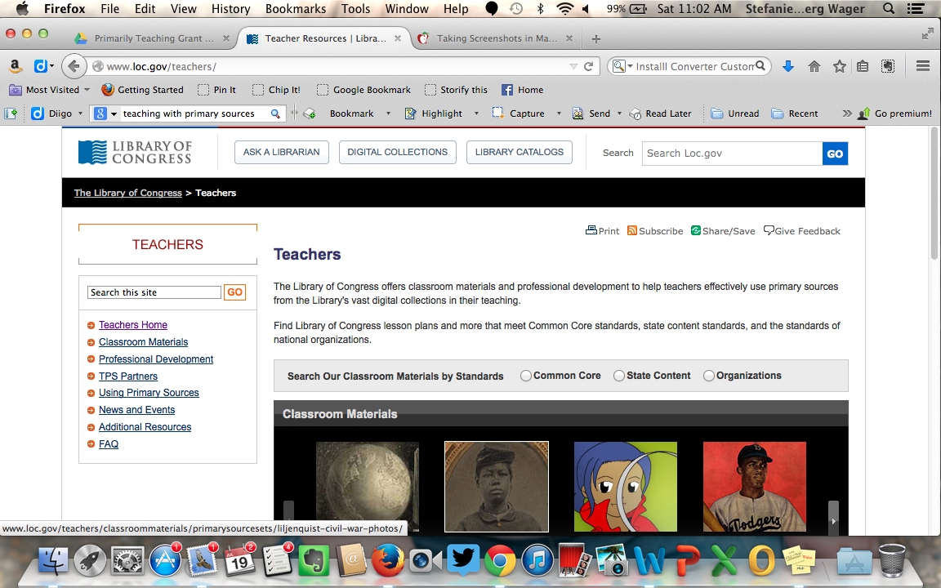
Teachers Section

Go www.loc.gov/teachers OR fom the Library of Congress homepage, click on Teachers under Especially For.

The Teachers page is an online resource, created especially for teachers.
It includes:

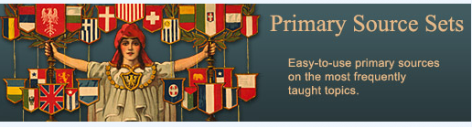
Classroom Materials
- Primary Source Sets
- Lesson Plans
- Presentations & Activities
- Themed Resources
- Collection Connections

Professional Development
- Library-Facilitated Training
- Online Modules
- Self-Directed
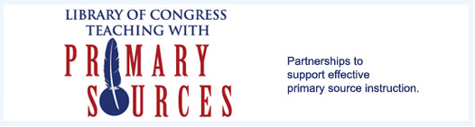
TPS Partners
- TPS Program

Using Primary Sources
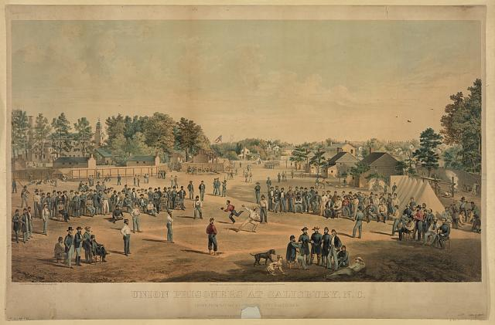
- Why Use Primary Sources
- Citing Primary Sources
- Copyright and Primary Sources
- Finding Primary Sources
- Teacher’s Guides and Analysis Tools

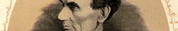
News and Events
- News and Events at LOC and other Places

Additional Resources
- Slide Shows/Handouts
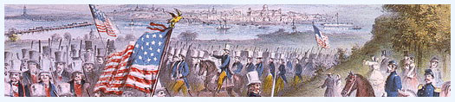
- Resources from Outside the Library
- Class Starters
- More Library Resources

Identifying State Standards
The Library of Congress offers a tool that helps educators search for lesson plans and primary source activities that meets Common Core standards, state content standards, and standards of national organizations.

Choose Common Core

Select a State, Grade and Subject

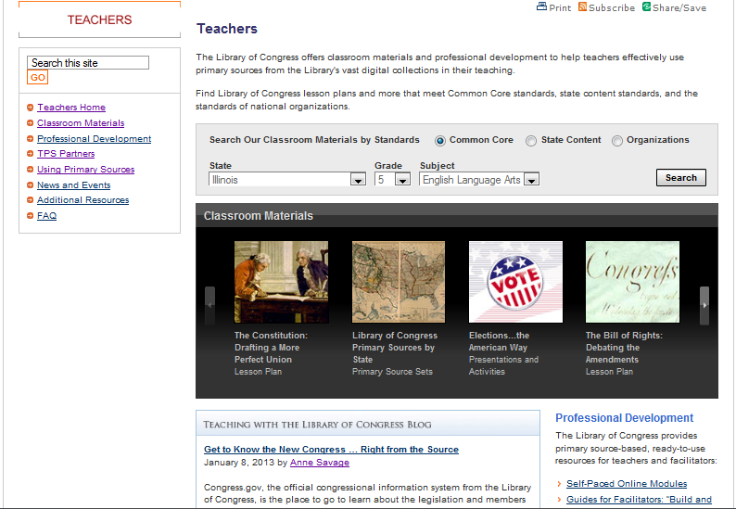

Iowa Search Results Example
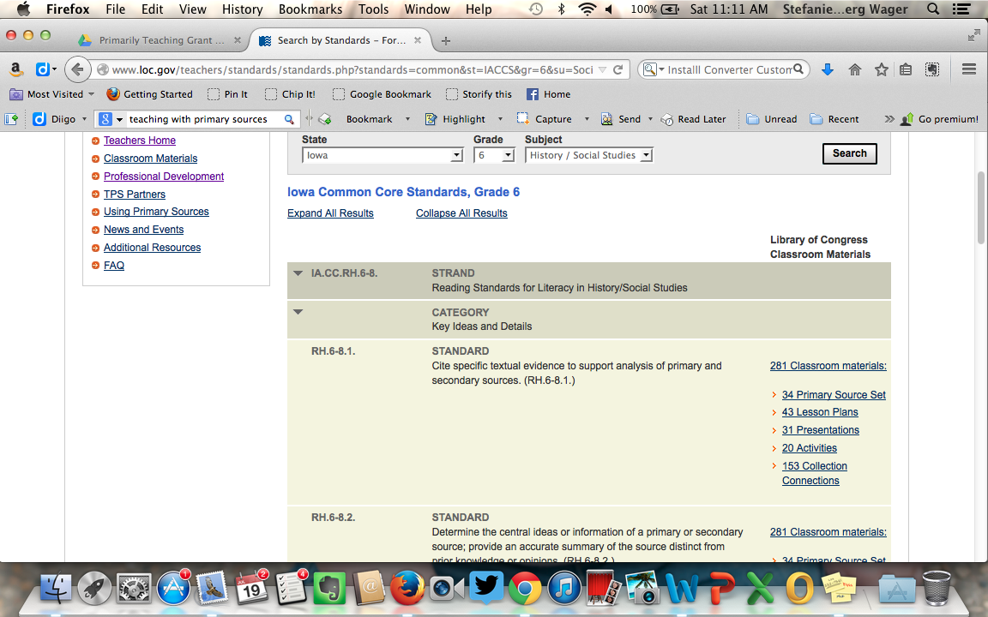

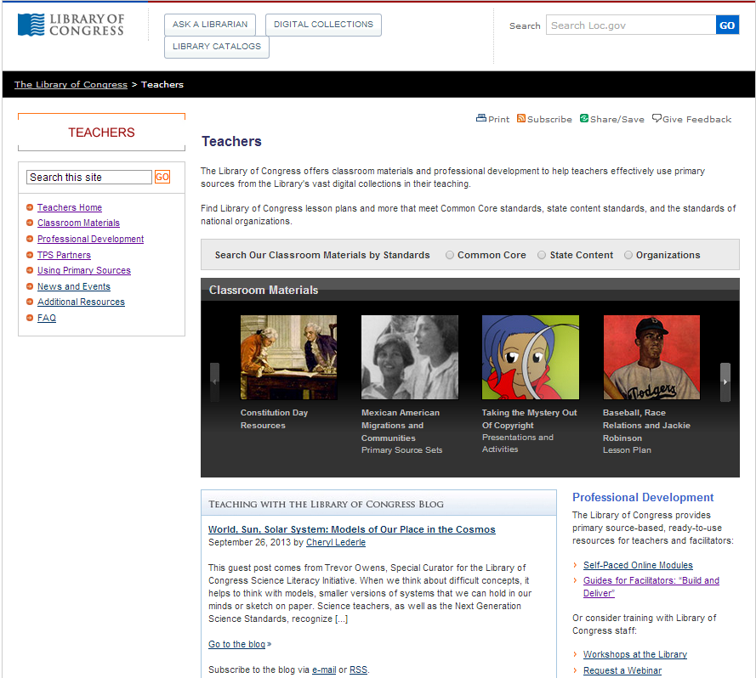
Classroom Materials

- Click on Classroom Materials on the left.

You will find lesson plans,
themed resources, primary source
sets, presentations and
activities to use in your
classroom.

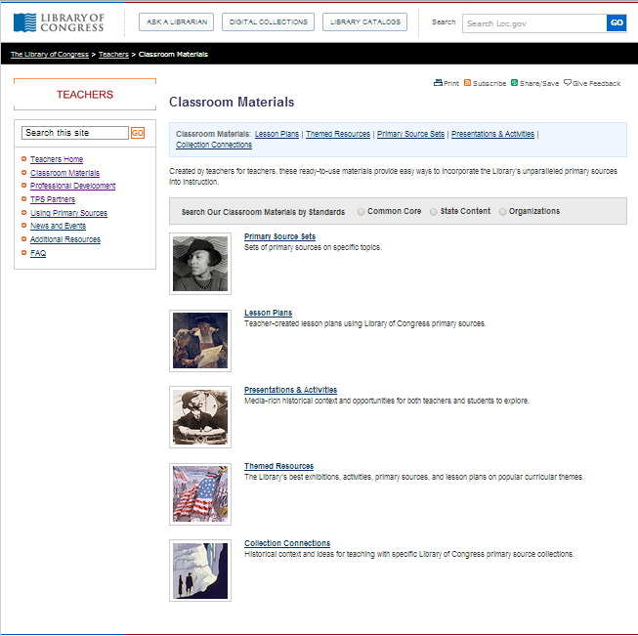
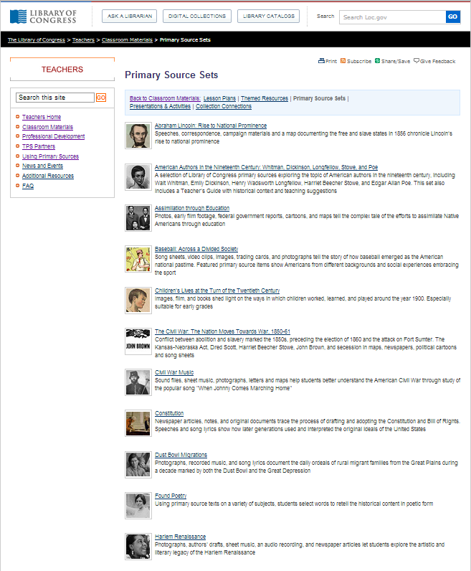
Primary Source Sets

- Click on Primary Source Sets to view all of the sets.

Primary Source Sets are sets of primary sources on specific topics.
Lesson Plans

- Click on Lesson Plans

Under Lesson Plans you will find lessons created by teachers, librarians and media specialist from across the U.S.

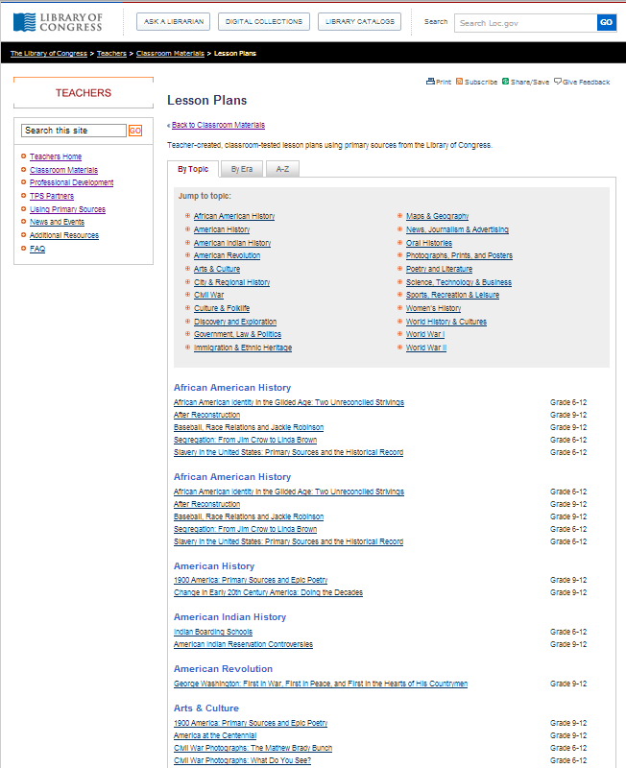

Presentations and Activities

- Click on Presentations and Activities

These are examples of Presentations and Activities that the Library of Congress provides to enhance and support your curriculum. By visiting the online presentations and activities, your students will view primary sources that will help bring history to life.

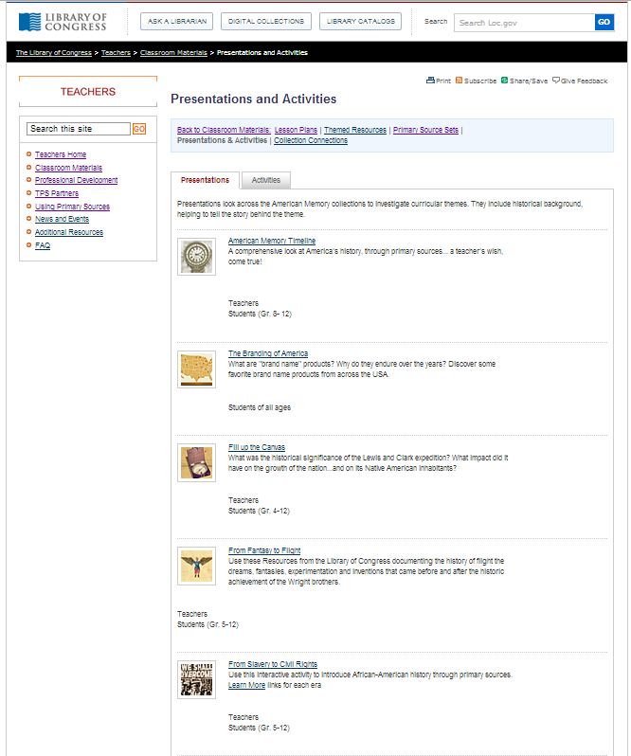

Themed Resources

- Click on Themed Resources

Under Themed Resources you will find a variety of resources gathered together about common curricular themes.

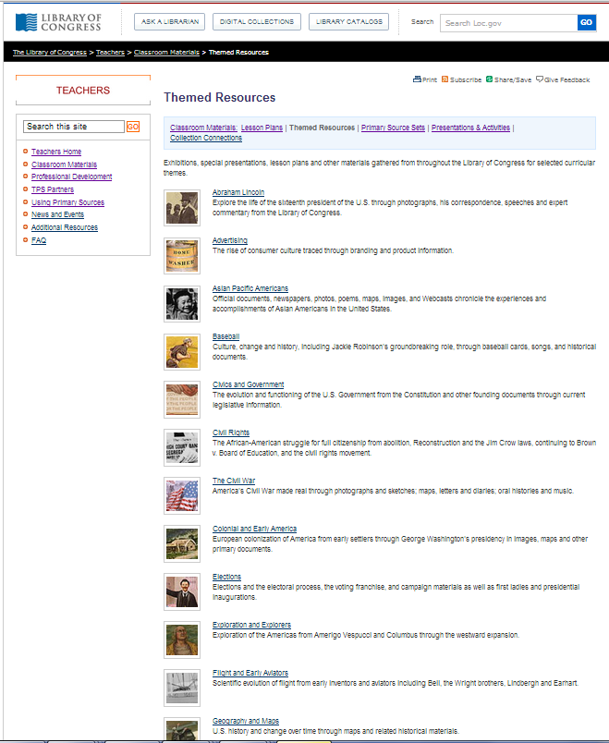

Collection Connections

- Click on Collection Connections

Explore the wonderful Library of Congress primary source collections to gather ideas and learn more historical information about a variety of subjects.

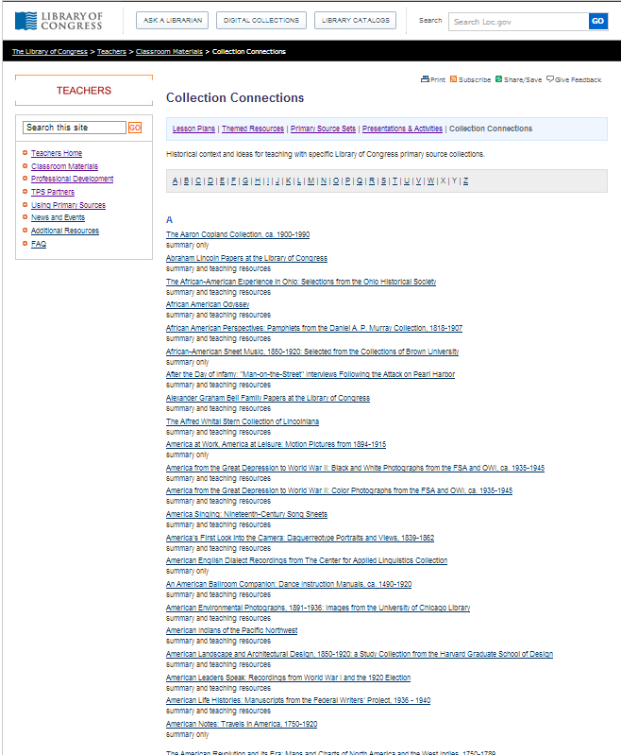

American Memory Section

American Memory is an online gateway to rich primary resources relating to the history and culture of the United States. The site offers millions of digital a variety of collections. Special collections include documents, films, manuscripts, photographs, and sound recordings that tell the American story.

From the Library of Congress homepage, click on American Memory.

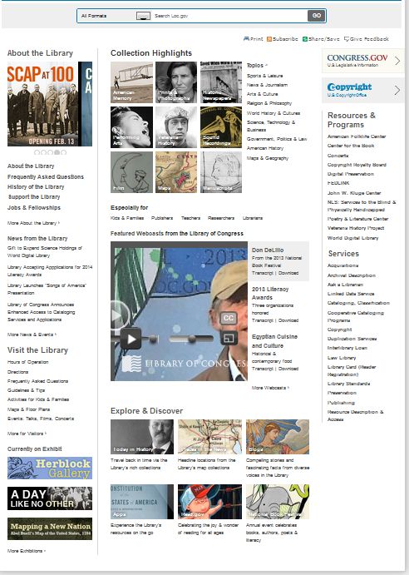

Components of the American Memory Section

Browse Collections by Topic
This box presents a list of all of the digital collections of the American Memory project organized by broad topics. The collection finder is a good place to begin exploring the vast collections within American Memory; however, in order to find more specific sources, you will need to use the “Search all collections” box.
“Browse Collections by Topic” Box

“Search All Collections” Box
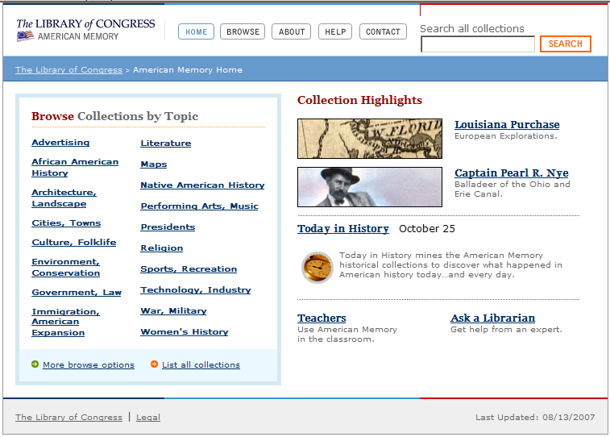
Search All Collections
Search All Collections
The Search all collections box allows you to search by keyword for items across all of the collections. You can go here to find specific items. For example, if you wanted to find items on the Civil War in North Carolina, you could type “Civil War in North Carolina” into the search box and find specific items. Sometimes you have to be persistent and creative with the search, because there are millions of items the search engine searches through.

*Click on Help and then click on Search Help for additional search strategies.

More Browse Options in American Memory

The “more browse options” link at the bottom of the American Memory Home page is a useful way to browse the American Memory site.

“More browse options”

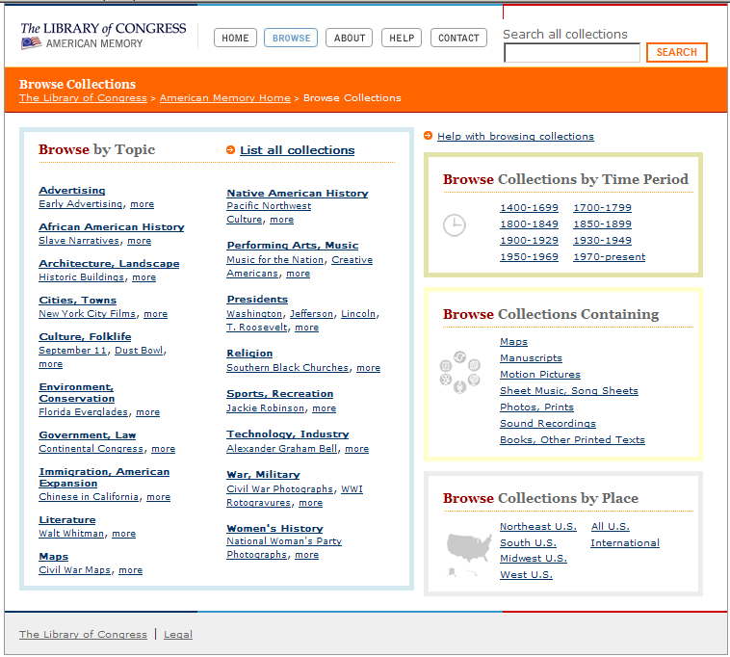

Now you can browse by:

Topic

Time Period

Collections Containing

Place

Citing Primary Sources from the American Memory

The purpose of citing a primary source is to acknowledge the source of information and give as much detail as possible to find that primary source at a later date. The Library of Congress uses a variety of ways to cite primary source material.

Sometimes a credit line is available.

First:
- Find the bibliographic page that contains your primary source
- Look under the Notes area
- Look for the words Cite As:
- Copy the credit line
- Paste it into your document

Second:
- Find the bibliographic page that contains your primary source
- Look at the line above the thumbnail of your primary source
- Click on “Rights and Reproductions”
- Scroll down to CREDIT LINE:
- Copy the credit line
- Paste it into your document (note: change the sample reproduction number or digital ID to the one specific to your primary source)

Third:
- Find the bibliographic page that contains your primary source
- Click on the name of the collection at the top of the bibliographic page
- Scroll to the bottom of the Collection page
- Click on the Copyright and Other Restrictions link
- Copy the credit line
- Paste it into your document (note: change the sample reproduction number or digital ID to the one specific to your primary source)

If credit line is not available:
- Follow the directions for citing sources using the MLA style
- Go to: http://www.loc.gov/teachers/usingprimarysources/mla.html
- Scroll to the type of primary source you are using
- Identify the information needed (ex. Author, title, date, etc.)
- Copy the example line into your document
- Fill in the information from the bibliographic page

Citing and Bookmarking Primary Sources from the LOC

The purpose of citing a primary source is to acknowledge the source of the information and to provide as much detail as possible so the primary source can be located at a later date. There are various ways to locate a citation/credit line depending on where the item is located on the Library of Congress website. There are also several ways to bookmark an item.

Citing an image from Prints & Photographs (from the homepage)
- Click on Prints & Photographs
- Locate the image you need by typing in a search term or choose from a collection
- If there is a thumbnail image on the screen, scroll down to COLLECTIONS to locate the collection where it is housed.
**If there is an enlarged version of the image on the screen, click on ABOUT THIS ITEM on the left side above the image. You should now be on the page with the thumbnail image.
- Scroll down to COLLECTIONS and click on the name of the collection
- Click on RIGHTS and RESTRICTIONS on the left side of the page, the credit line should pop up.
*NOTE: Items located in the MISCELLANEOUS ITEMS IN HIGH DEMAND collection will need to be cited MLA style.
*NOTE: If there is an “e.g.” in the credit line, replace the sample number with the number that is specific to the image you are using.
Bookmarking an image from Prints & Photographs
- Locate the image by typing in a search term or choose from a collection
- From the bibliographic page (page with the thumbnail image) scroll down to BOOKMARK THIS RECORD (this is the permanent URL for this image)

Citing a map from MAPS (from the homepage)
- Click on MAPS
- Locate the map you need by typing in a search term or click on the tab COLLECTIONS WITH MAPS
- To find the citation/credit line, click on the RIGHTS and ACCESS tab (the tab is right above and to the right of the thumbnail image)

Bookmarking a map
- Locate the map by typing in a search term or choose from a collection
- Use the link in the address bar at the top of the page (this is the permanent URL for this image)
Conducting an Advanced Google Search
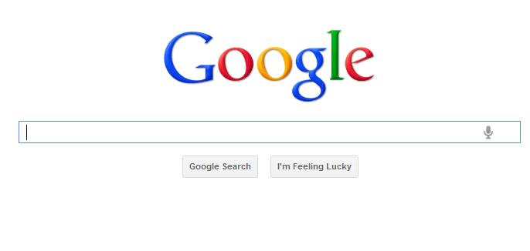
There are times when the previous search strategies just don’t work to find the items you are looking for. The Library of Congress holds many primary resources outside the American Memory Collections. For example, if you wanted to locate items related to the diary of Anne Frank and used the previous search strategies, you may not be able to find what you’re looking for. For times like these that the advanced search option on your favorite search engine comes in handy. The following activity will take you through the steps for using the advanced search option within the Google Search Engine. An advanced search using the Google Search Engine will allow you to easily search the entire Library of Congress web site at once and return useful items that may otherwise be hard to find.
1. Go to the Google at www.google.com
2. Type in the keywords in the Search Box. Click on Google Search.
3. Click on the Settings Icon  in the upper right corner of the page. Click on Advanced search in the menu.
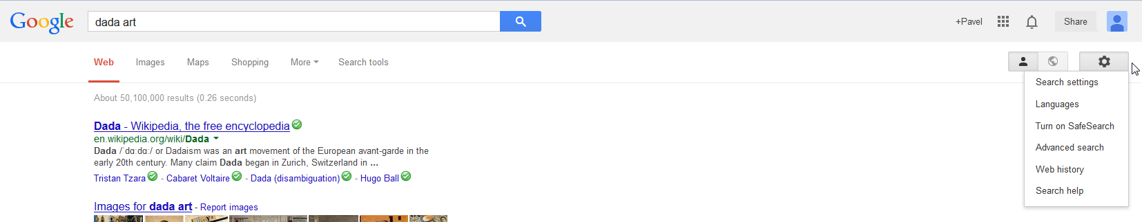
4. Look down the list of options until you find Search within site or domain and type “loc.gov”. Your search term should be in the top box.
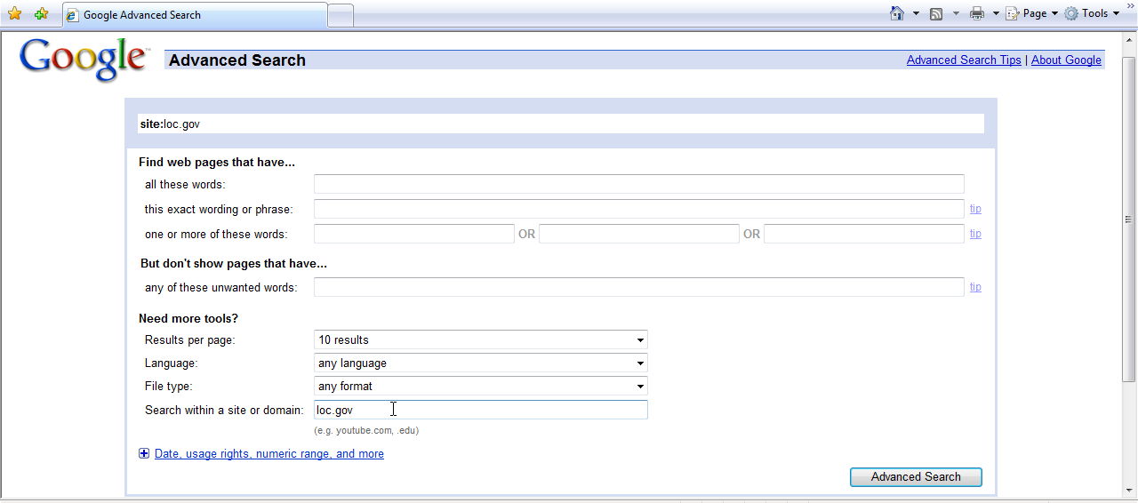
5. Click the Advanced Search button.
Creating a Resource Table

Before we begin saving primary sources, we need to establish some type of management system. One useful, easy technique is to create a table in a Word document to hold the necessary information in order to find the source again, or quickly determine what resources we have collected for our classroom.

To create a table:
(Note: Depending upon the version of your word processor the directions may vary.)
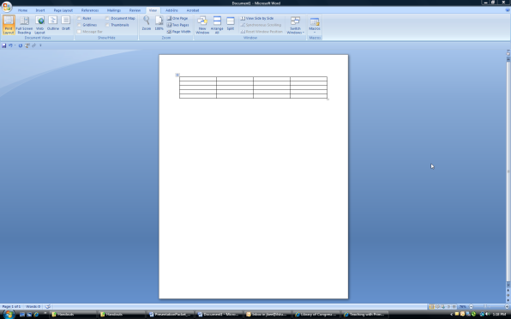
- Click on the INSERT TAB and choose TABLE and then INSERT TABLE
- Use the up/down arrow keys to choose the number of columns and rows you want (4 columns—5 rows)
- Click OK -The table is now inserted into your document.
- Label the columns:
- First Column – Image
- Second Column - Description
- Third Column – Citation
- Fourth Column – URL
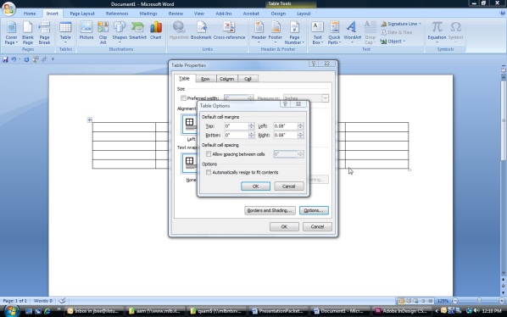
- To control the size of the cells in your table, place the cursor
in one of the cells.
- Right click and choose TABLE PROPERTIES from the dropdown menu.
- Click OPTIONS in the Dialog Box.
- A second Dialog Box will appear, click in the box in front of “Automatically resize to fit contents” to remove the checkmark and click OK.
- Click OK again to return to the table.
Inserting an Image into a Resource Table
It will help to add a small version of the image (thumbnail image) to your resource table so that you can more easily identify sources you are looking for.

- Locate the thumbnail on the web page where you found your image.
- Place the computer’s mouse over the image. The arrow will change to a hand.
- Right click and choose COPY
- Open your Resource Table and click in the cell where the picture will be inserted.
- Right click and choose PASTE
- The thumbnail should appear in your Resource Table.

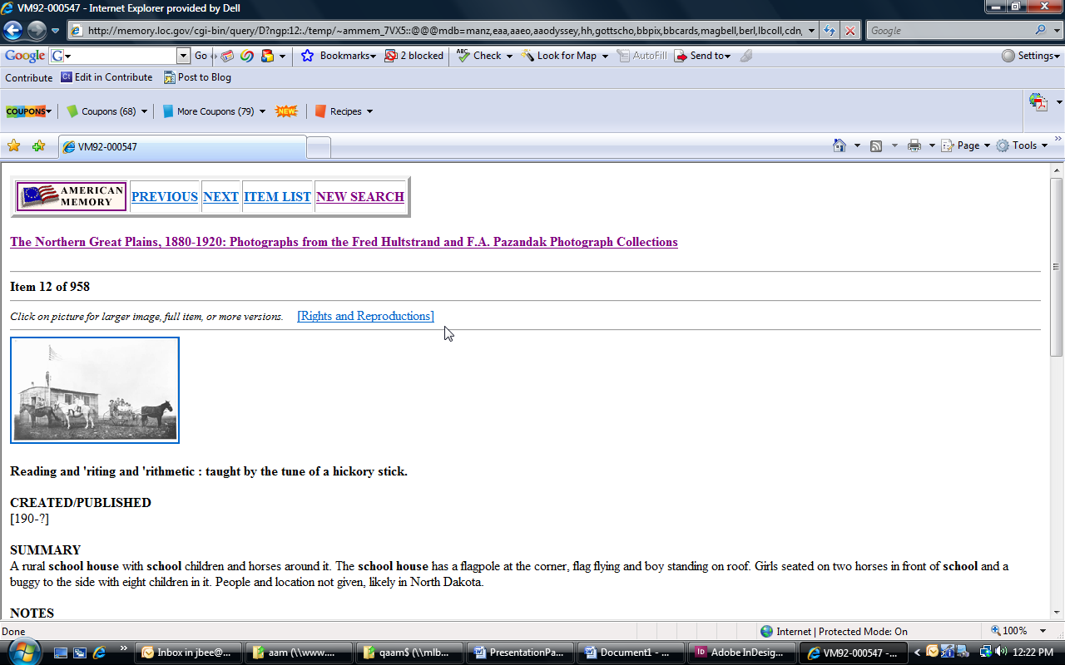

Saving a Permanent URL for a Primary Source in American Memory
When you search American Memory, most of the resources will have a temporary URL in the address bar. If you bookmark the page using this temporary URL and try to come back to the same resource later, you will get an error message. So, how do you get a permanent URL for the item that you have found? There are a few easy steps involved.

Directions:
- Find the primary source that you want to use. You need to be on the bibliographic page, the page with the thumbnail image. (Look at the address bar, you might see “temp” as part of the address) If you have an “enlarged” version on the screen, click on bibliographic information to return to the thumbnail image.
- Right click in the empty space next to the thumbnail image. A menu will appear.
- Click on view source (Note: A new window will popup that contains the html code).
- Scroll down until you see:
- <!-- The following URL will result in display of this document -->
- <!-- http://memory.loc.gov/cgi-bin/query/r?ammem/ngp:@field(NUMBER+@band(ndfahult+b272)) -->
- Highlight the URL underneath that line **starting with the http:// and including the ending parentheses “))”
- <!-- http://memory.loc.gov/cgi-bin/query/r?ammem/ngp:@field(NUMBER+@band(ndfahult+b272)) --
- Click on the link and choose COPY
- Open your Resource Table
- Click in the cell where you want to insert the permanent URL.
- Right click choose PASTE
- Hit ENTER to make the link turns blue. It will now hyperlink you back to the Bibliographic page for your image.

To create an active hyperlink:
- Highlight the link that you just pasted.
- Click on the HYPERLINK icon under the INSERT tab.
- Make sure the address in the dialog box at the bottom matches the URL in your table.
- Click OK.

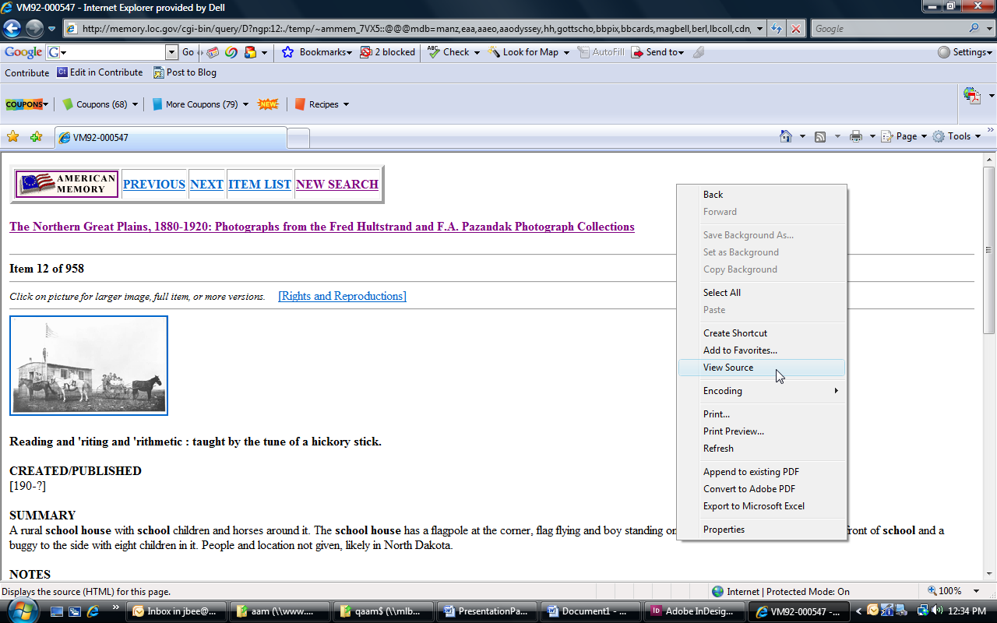

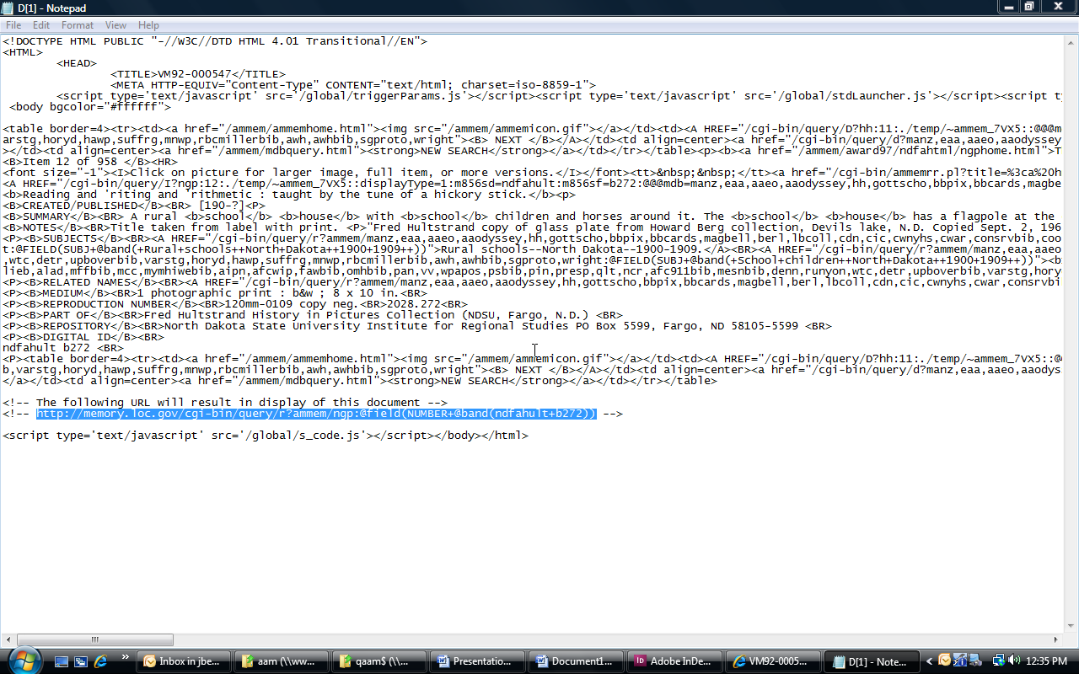

Other Resources

Exhibitions
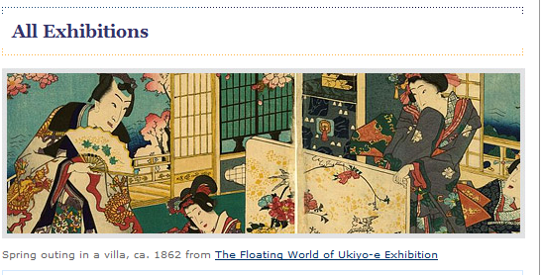
From the Library of Congress homepage, click on More Exhibitions in lower left corner.
Click on All Exhibitions on the left side.

Exhibitions are online exhibits that highlight a specific theme or topic. These special collections allow you to take a virtual tour of the treasures housed at the Library of Congress.

Congress.Gov


From the Library of Congress homepage, click on Congress.gov in the upper right corner.

Congress.gov is the area of the Library of Congress web site that has information on current and past legislation. Congress.gov makes federal legislative information freely available to the public. You can search by word/phrase, bill number or specific legislator. Thomas includes resources and activities for teachers.

World Digital Library
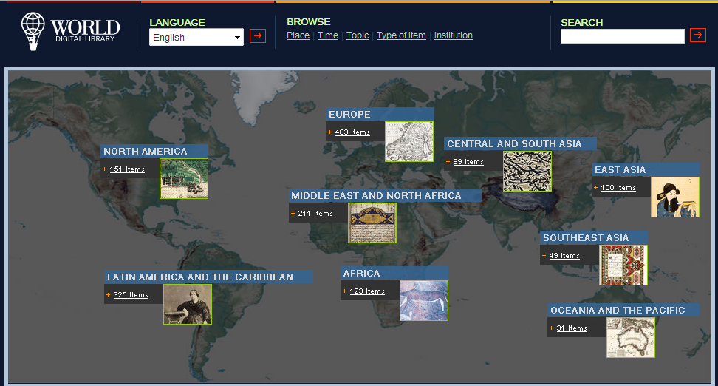
From the Library of Congress homepage, click on World Digital Library under Resources & Programs.

World Digital Library is a cooperative project of the Library of Congress, the United Nations Educational Scientific and Cultural Organization (UNESCO), and partner libraries, archives, and educational and cultural institutions from the United States and around the world.
Kids and Families

From the Library of Congress homepage, Click on Kids & Families under Especially For.

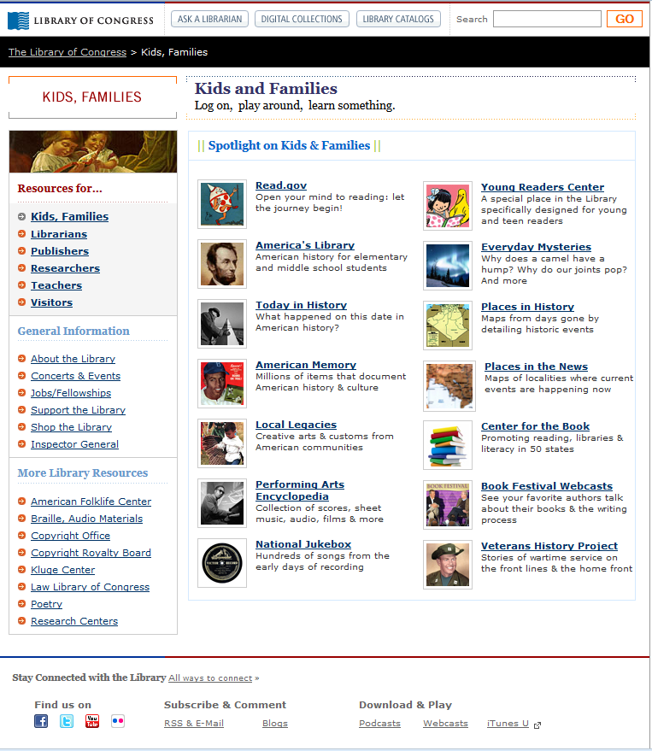
The Kids and Families area of the Library of Congress includes resources, information, and activities that would be of interest to kids, parents and teachers.

America’s Story was designed especially with young people in mind, but there are great stories and activities for kids, parents, and teachers. Discover stories from America’s past: Meet Amazing Americans, Jump Back in Time, Explore the States, Join America at Play, See, Hear and Sing.

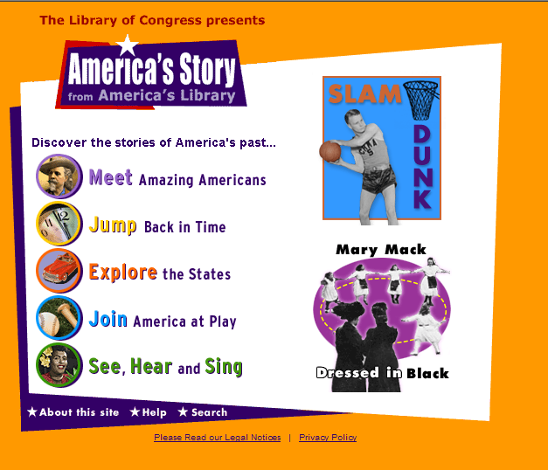

Young Readers Center promotes lifelong literacy beginning with young children. When kids become good readers in the early grades, they are more likely to become better learners throughout their school years and beyond. It’s never too early to open your mind to reading. This site includes poetry, digitized rare children’s books, and resources for parents and teachers.



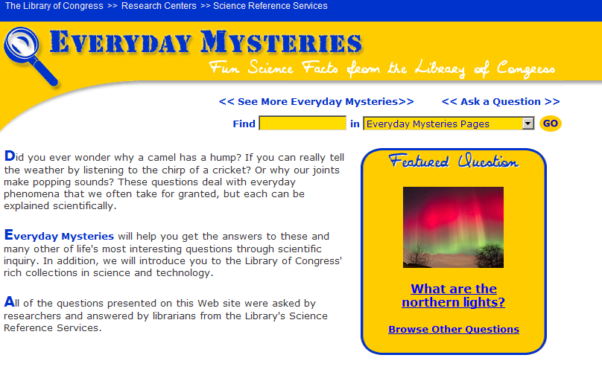
Everyday Mysteries is filled with fun facts from the Library of Congress. Did you ever wonder why a camel has a hump? Can you really tell the weather by listening to the chirp of a cricket? Why do our joints make popping sounds? Visit Everyday Mysteries to learn about the fascinating science behind ordinary things.

Webcasts

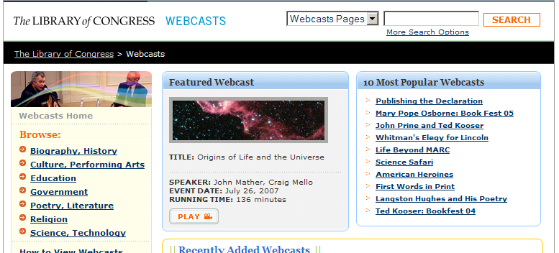

From the Library of Congress homepage, click on More Webcasts under Featured Webcast from the Library of Congress.

Webcasts allow visitors to view presentations from dozens of your favorite authors, poets, and storytellers as well as speakers from a variety of fields including, science, technology religion, government, etc.

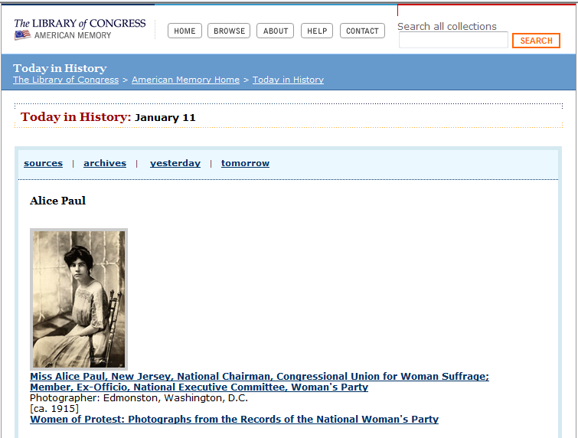
Today in History

From the Library of Congress homepage, click on Today in History under Explore & Discover.

Today in History is a Library of Congress presentation of historic facts. Travel back in time by visiting Today in History and using the archives to search for specific information by topic or date.

Blogs
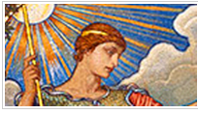
From the Library of Congress homage, click on Blogs under Explore and Discover.

Explore the numerous Blogs with their individual stories, compelling facts, interesting analysis and personal commentaries.

The Prints and Photographs collections include photographs, prints, drawings, posters, and architectural and engineering drawings. The Prints and Photographs Online Catalog holds items that are not located in American Memory, but some collections can be found in both places. Not all images displayed in this catalog are in the public domain, in some collections only thumbnail images are displayed.

- From the Library of Congress homepage, click on Prints and Photographs.

- Type in the search term or terms in the search box.

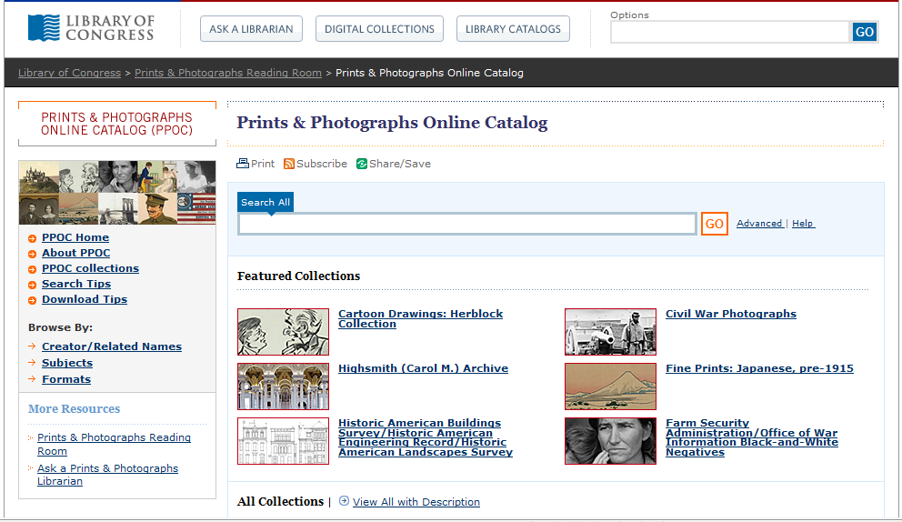

Research Centers Overview
The Library of Congress is organized into Research Centers, also referred to as Reading Rooms, where collections of materials are maintained. Research Centers/Reading Rooms offer hundreds of special format, language, and subject area Collections.

- From the Library of Congress Home page, click on Especially for Researchers.

- Click on the Research Center you want to use. Click on Collection Guides to help you find specific topics.

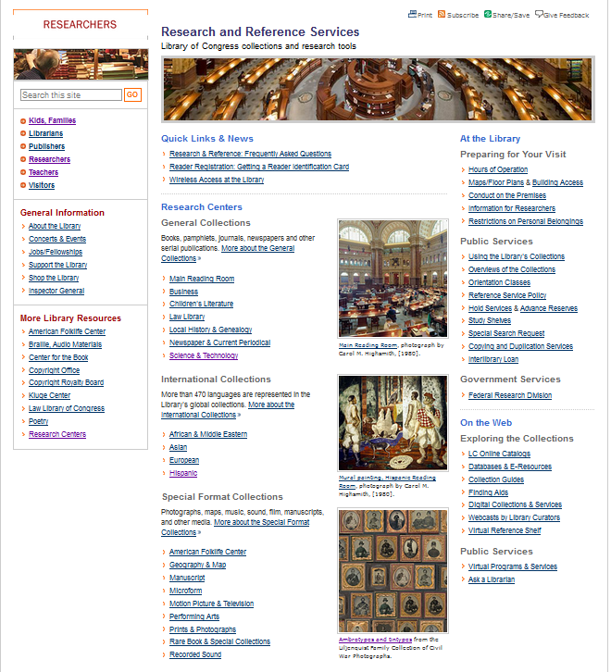

Implementing the Use of Primary Sources in Your Classroom

What is a Primary Source?

Simply put, primary sources are the original items or records that have survived from the past – such as clothing, letters, photographs, and manuscripts. They were part of a direct personal experience of a time or event. The Library of Congress houses millions of primary sources.

What is a Secondary Source?

For the purpose of contrast, it is important to note that secondary sources are created by documenting or analyzing someone else’s experience to provide a perspective or framework of a past event. They may have been written long after an event took place and include items such as textbooks, encyclopedias, biographies, and documentaries.

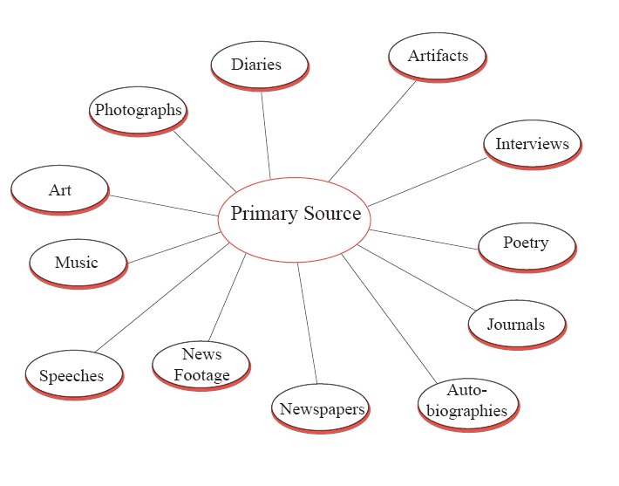

Why use Primary Sources?
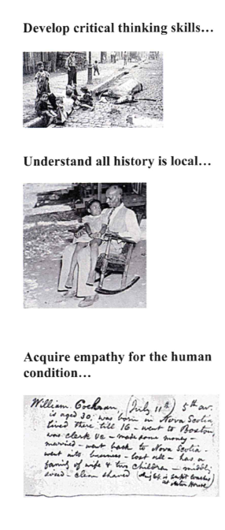

Primary sources are snippets of history. They are incomplete and often come without context. They require students to be analytical, to examine sources
thoughtfully and to determine what else they need to know to make inferences from the materials.

A high school student states, “I learned that in order to do history, one must be objective and be able to look at a puzzle of historical events and put them together in order.”

Local history projects require students to “tell their own stories” about familiar people, events, and places. Memories from an adults’ perspective provide a rich glimpse of history that is not available in a textbook. What evolves is the sense that world history is also personal family history, which provides a compelling context for student understanding.

An elementary/middle school teacher reports that “ ..finding information about topics that are of importance to our local history is invaluable. Students are excited by the fact that our local history is archived nationally. This gives their immediate cultural area importance in their eyes.

Primary sources help students relate in a personal way to events of the past coming away with a deeper understanding of history as a series of human events.

A high school teacher reported that, “ In sharing the Whitman hospital letters, I clearly saw a sheen of tears in students’ eyes and noted an avid interest in Civil War soldiers as ‘people’ not simply as pallid historical figures.

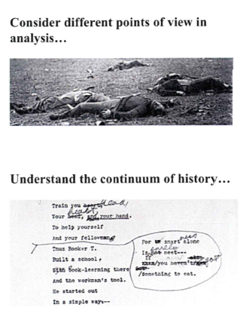
In analyzing primary sources, students move from concrete observations and facts to making inferences about the materials. “Points of view” is one of the most important inferences that can be drawn. What is the intent of the speaker, of the photographer, of the musician? How does that color one’s interpretation or understanding of the evidence?

A high school teacher states that, “Discovering that two people seeing the same primary source differently creates a kind of dissonance that opens up the meaning of the source and creates new understanding in learners”

It is difficult for students to understand that we all participate in making history everyday, that each of us in the course of our lives leave behind primary source documentation that scholars years hence may examine as a record of “the past.” The immediacy of first-person accounts of events is compelling to most students.
“Comparisons of events of the past to events our are students are engaged in daily helps to bring “history” to the present and make it ‘live” for our students.”

Why Should I Use a Primary Sources?

For years, historians and educators across the curriculum have understood the value of primary sources in K-12 education. Two key reasons for including primary sources in the curriculum are:

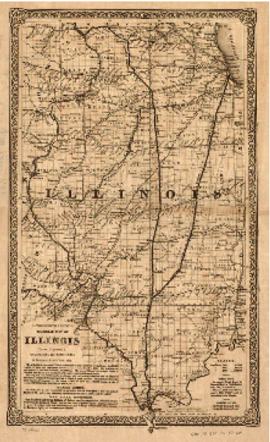

- Primary sources expose students to multiple perspectives on great issues of the past and present. The human experience, after all, deals with matters that were furiously debated by the participants. Interpretations of the past are furiously debated as well, among historians, policy makers, politicians, and ordinary citizens. By working with primary sources, students can become involved in these debates.

- Primary sources help students develop knowledge, skills, and analytical abilities. By dealing directly with primary sources, students engage in asking questions, thinking critically, making intelligent inferences, and developing reasoned explanations and interpretations of events and issues in the past and present. Primary sources also often provide a real-life framework to apply skills learned in the classroom. For example, using a chart documenting production from a copper mine in Bryson City, NC, students can calculate information such as profits and losses, and cycles of production.

Ideas to Enhance the Use of Primary Sources

The following suggestions for student activities can help you enhance your curriculum using authentic artifacts, photographs, audio clips, music, and documents from the Library of Congress and other sources.

Artifacts
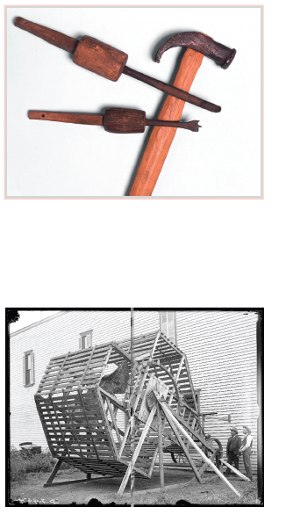
- Make a hypothesis about the use of an unknown artifact pictured in an old photograph. Use online and library research to support or refute the hypothesis. Make a presentation to the class to “show and tell” the object, hypothesis, search methods, and results.

- Study an artifact and trace the development of this invention over time (examples: automobiles, tractors, trains, airplanes, weapons). What can you find about the technology, tools, and materials available through time? Who used the invention in the past? How is the invention used today?

.

Art

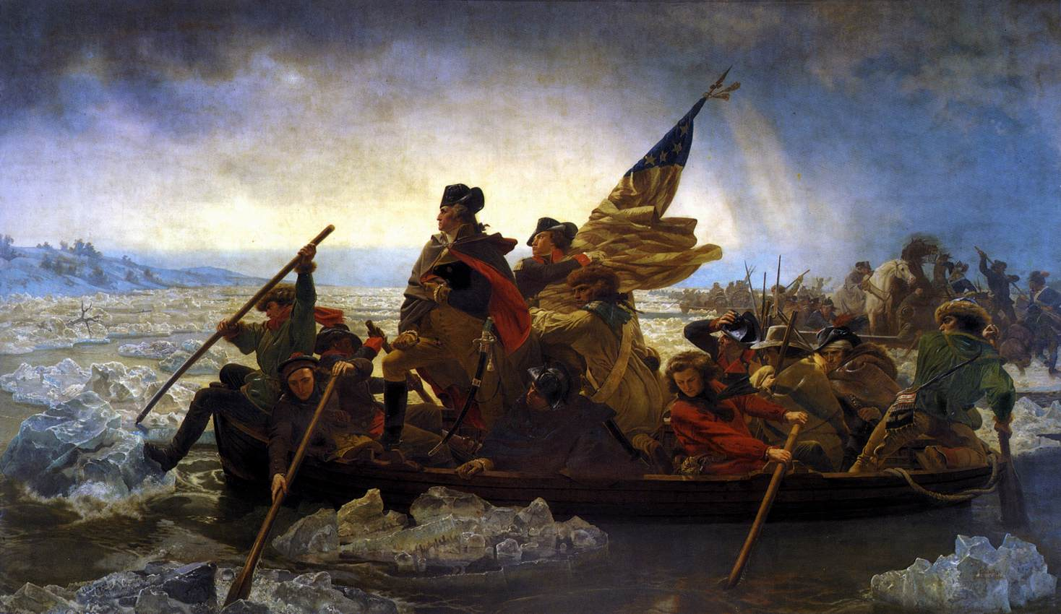
- Select a piece of fine art that appeals to your senses. Research the artist, the date of the piece, and the medium. What does information about the artist; the medium, the subject, and the composition tell you about the prevailing attitudes and conditions of the time period? (For example, What symbolism is used? How is perspective used? In what roles are people portrayed? What is left out of the composition?)

- Use resources to study fashion trends. How has fashion changed over time? How did clothing styles reflect people’s work and their roles in society? What clothing styles have carried over into present times?

Photographs
- Use an historic photograph or film of a street scene. Give an oral description of the sights, sounds, and smells that surround the scene, presenting evidence from the photograph itself and other sources about the time period. Examine the image to find clues about the economics and commerce of the time.
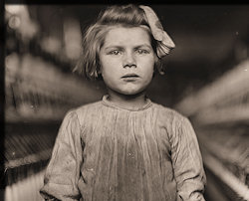
- Select a historical photograph or film frame. Predict what will happen one minute and one hour after the photograph or film was taken. Explain the reasoning behind your predictions
- To encourage focus on detail, show a photograph or film frame to the classroom for three minutes and then remove it. Have students draw the contents of the image on a piece of paper divided into a grid of nine sections. Repeat this exercise with new images and watch students’ ability to recall detail improve

Audio
- Research your family history by interviewing relatives. Use letters, audio recordings, and videotape to compile a report on an important time for your family. Make note of differing recollections about the same event.
- Work in teams to record interviews of older citizens in the community. Focus on and compile interviews on one aspect of community life such as work, family, or schools. Combine class reports with historical images and documents to produce a documentary on the history of your community.

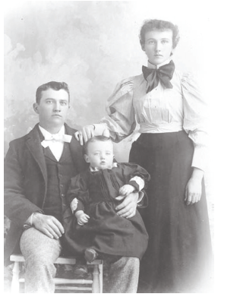
- Introduce an audio recording of a famous political speech. Ask students to think about and write down impressions while they listen to the speech. What is the speaker’s key message? What is the speaker’s point of view? How does the speaker’s oratory style affect the impact of the message? If the text of the speech is available, have students compare impressions from hearing the speech to impressions from reading the speech.

- Have students listen to audio recordings from old radio broadcasts. Compare the language, style of speaking, and content to radio and television programs of today. How does the content of the older radio broadcast exemplify the events and prevailing attitudes of the time? How does modern radio and television programming exemplify events and attitudes of the present time?

Music
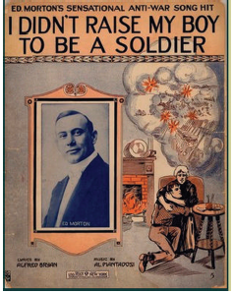
- Research and study lyrics of popular songs from the periods of World War II, the Korean War, and the Vietnam War. What do the lyrics tell you about public attitudes toward the war? Interview veterans of these wars about their perception of the accuracy of the information in the lyrics.

- Have students search for events that have inspired lyrics in current popular music. Have students compare present day events and music to lyrics from the past inspired by historical events. What are the similarities and differences between present day and historical songs and the events that inspired them?

Documents

- Study historical maps of a city, state, or region to find evidence of changes in population, industry, and settlement over time. Use other resources to find and report on causes for the changes you find. Use maps to illustrate your descriptions of these changes.
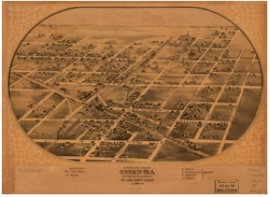
- Choose a famous, historical, public building in your area. Research blueprints or architectural drawings of the building. With help from an architect or librarian, compare the plans to the building as it exists today. What changes do you see? Why do you think the changes occurred?

Promoting Inquiry Through the Use of Primary Sources
“Inquiry is a process of learning that is driven by questioning, thoughtful investigating, making sense of information, and developing new understandings”. How can we apply inquiry learning to the integration of primary sources into our everyday teaching and learning activities?

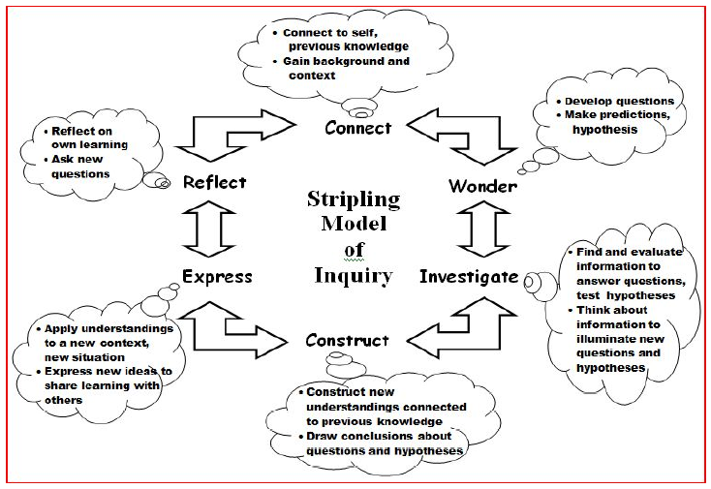
Creating a Primary Source Set

Primary source sets provide a way to gather and present a variety of primary sources on a particular topic or theme. These resources can then be used in a variety of ways to introduce and/or examine the topic or theme more deeply. In analyzing the primary sources students become actively involved and use their critical thinking skills to make connections with previous knowledge, develop questions or make predictions and construct new understandings.

- Read “Creating and Using a Primary Source Set” http://memory.loc.gov/learn/community/using.pdf

- To view primary source sets that have already been created by the Library of Congress go to Especially for… Teachers → Classroom Materials → Primary Source Sets.

- Create a primary source set that includes:
- at least 12 primary sources
- 3 different types of sources (photos, maps, audio, etc.)
- important historical background
- questions that can be used with your students to guide discussions or lead to further inquiry
Primary Source Set Example- Abraham Lincoln: Rise to National Prominence
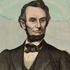  “Abraham Lincoln.” 1865  PDF version (197 KB) | 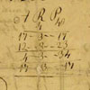  Abraham Lincoln's Student Sum Book, 1824-1826  PDF version (135 KB) | 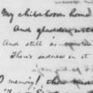  Poem, My Child-hood Home I See Again, 1846  PDF version (76 KB)

Creating a Book Backdrop

A Book Backdrop uses primary sources to not only develop historical background but to bring books alive. Combining primary sources with literature makes learning memorable, meaningful and engaging for students.

Read through the six step process for using primary sources in the classroom to enhance literature.
- Content: Select a topic(s) you will be studying in your classroom. Check your state and local school district standards and curriculum guides for content and skills suggestions.
- Learning Objective: Determine what you want students to learn from working with the primary sources associated with the book you select. What is the enduring understanding?
- Book Selection: Choose a book that aligns with your topic and is appropriate for your grade level.
- Read: As you read the book, compile a list of dates, people and events that might have primary source connections.
- Primary Sources: Search across LOC for primary source items that connect with your book.
- Teaching Strategies: Determine how you will incorporate the primary sources into your lessons.

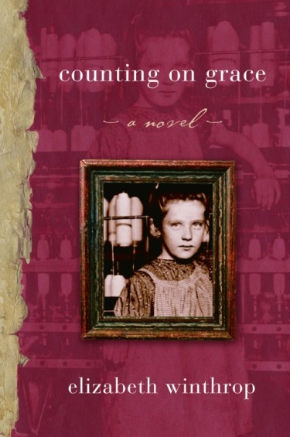
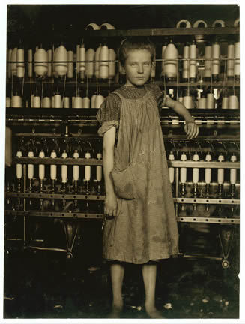

Hine,Lewis W. August 1910. Addie Card, anaemic little spinner in North Pownal Cotton Mill. Library of Congress, Prints and Photographs Division. 6/16/2010. http://www.loc.gov/pictures/item/ncl2004001719/PP

Image References
Page 1,3 Library of Congress home page. http://www.loc.gov
Page 4 Library of Congress Teachers Page. www.loc.gov/teachers
Page 6 Library of Congress Teachers Page. www.loc.gov/teachers
Page 7 Library of Congress Teachers Page, Primary Source Sets, http://www.loc.gov/teachers/classroommaterials/primarysourcesets/
Page 8 Library of Congress Teachers Page, Lesson Plans, http://www.loc.gov/teachers/classroommaterials/lessons/
Page 9 Library of Congress Teachers Page, Presentations & Activities, http://www.loc.gov/teachers/classroommaterials/presentationsandactivities/
Page 10 Library of Congress Teachers Page, Themed Resources, http://www.loc.gov/teachers/classroommaterials/themes/
Page 11 Library of Congress Teachers Page, Collection Connections http://www.loc.gov/teachers/classroommaterials/connections/
Page 13, 12 Library of Congress American Memory. http://www.memory.loc.gov
Page 15, 14 Library of Congress American Memory. http://memory.loc.gov/ammem/browse/index.html
Page 16 Top A Civil War Soldier in the Wild Cat Regiment, Selections from the Tilton C. Reynolds Papers, Library of Congress, Manuscript Division, Library of Congress, http://memory.loc.gov/ammem/tcrhtml/tcrhome.html
Page 16 Bottom American Indians of the Pacific Northwest Collection, Library of Congress. http://memory.loc.gov/ammem/collections/pacific/

Page 18 Google. www.google.com
Page 23 Top Library of Congress Exhibitions http://www.loc.gov/exhibitions/all
Page 23 Middle Library of Congress Thomas http://thomas.gov
Page 23 Bottom World Digital Library http://www.wdl.org/en/
Page 24 Top Library of Congress Kids and Families. http://www.loc.gov/families/
Page 24 Middle Library of Congress America’s Story http://www.americaslibrary.gov/
Page 24 Middle Library of Congress Lifelong Literacy http://read.gov/
Page 24Bottom Library of Congress Everyday Mysteries http://www.loc.gov/rr/scitech/mysteries/
Page 25 Top Library of Congress Webcast. http://www.loc.gov/today/cyberlc
Page 25 Middle The Library of Congress Today in History. http://memory.loc.gov/ammem/today/today.html
Page 25 Bottom. Blogs. http://blogs.loc.gov/
Page 26 Top Library of Congress homepage. www.loc.gov
Page 26 Middle Library of Congress Prints and Photographs. http://www.loc.gov/pictures/
Page 27 Middle Library of Congress Researchers. http://www.loc.gov/rr/
Page 27 Bottom Library of Congress Research Centers. http://www.loc.gov/rr/research-centers.html
Page 28 Top The close of a career in New York. Library of Congress, Prints and Photographs Division, Detroit Publishing Company Collection. http://memory.loc.gov/cgi-bin/query/D?detr:11:./temp/~ammem_soax::@@@mdb=mcc,gottscho
Page 28 Bottom Civil War Treasures from the New-York Historical Society, [Digital ID nhnycw/al al00001] http://memory.loc.gov/ammem/ndlpcoop/nhihtml/cwnyhshome.html, http://memory.loc.gov/cgi-bin/query/r?ammem/cwnyhs:@field(DOCID+@lit(al00001))
Page 28 Detail from Incidents of the war. A harvest of death, Gettysburg, July, 1863. Photographed by Timothy H. O'Sullivan, July 1865 (Library of Congress, Prints and Photographs Division, Reproduction number: LC-B8184-7964-A). http://memory.loc.gov/cgi-bin/query/r?ammem/cwar:@field(NUMBER+@band(cwp+4a40875))
Page 29 Western History/Genealogy Department, Denver Public Library. http://memory.loc.gov/cgi-bin/query/r?ammem/hawp:@field(NUMBER+@band(codhawp+10007078))
Page 30 Colton, G. Woolworth. “G. Woolworth Colton’s railroad map of Illinois”. 1961. Colton, G. Woolworth 1827-1901. (Library of Congress Geography and Map Division), (g4101p rr002040. http://hdl.loc.gov/loc.gmd/g4101p.rr002040)
Page 31Top Hammer and wood-working tools attributed to Thomas Lincoln, Lincoln Collection, Special Collections Research Center, University of Chicago Library. http://memory.loc.gov/cgi-bin/query/r?ammem/fawbib:@field(DOCID+@lit(apc0042))
Page 31 Bottom Butcher, Solomon D., “Carpet cleaner run by gasoline engine in Kearney, Nebraska”. 1907. Prairie Settlement: Nebraska Photographs and Family Letters, 1862-1912. (Nebraska State Historical Society). (nbhips 13006), http://memory.loc.gov/cgi-bin/query/r?ammem/psbib:@field(DOCID+@lit(p13006))
Page 32 Top Catlow Patty Munroe. “Fashion plates of women wearing hats decorated with bird feathers”. 1904. Reclaiming the Everglades: South Florida’s Natural History, 1884-1934.(Historical Museum of Southern Florida). http://memory.loc.gov/cgi-bin/query/r?ammem/fmuever:@field(NUMBER+@band(fmuever+ep00200001))
Page 32 Bottom Chicago Daily News. “Horses and carts used for snow removal lined up on a snow-covered street”. 1903. Photographs fro the Chicago Daily News, 1902-1933. (Chicago Historical Society), http://memory.loc.gov/cgi-bin/query/r?ammem/cdn:@field(NUMBER+@band(ichicdn+n000303))

Page 34 Top Historic American Sheet Music, "I Didn’t Raise My Boy To Be a Soldier”, Music B-633, Duke University Rare Book, Manuscript, and Special Collections Library,
http://memory.loc.gov/cgi-bin/query/r?ammem/dukesm:@field(DOCID+@lit(ncdhasm.a0665))

Page 34 Bottom Ruger, A. “Bird’s eye view of Chenoa, McLean County, Illinois 1869”. 1869. Map Collections: 1500-2004. (Library of Congress Geography and Map Division). (g4104c pm001450 http://hdl.loc.gov/loc.gmd/g4104c.pm001450). http://memory.loc.gov/cgi-bin/query/r?ammem/gmd:@field(NUMBER+@band(g4104c+pm001450))

