Primarily Teaching Lesson Plan

Name: Linda Vanden Bosch

Title: Changing our Landscape and Lives: The Transcontinental Railroad

Grade-level: 5th/6th

Subject Area: United States History

Topic: Changes through technological progress

Standards:
BS: Understands the changing nature of society
BS: Understands the influences on individual and group behavior and group decision making
E: Understands the role of scarcity and economic trade-offs and how economic conditions impact people’s lives
E: Understands that advancing technologies impact the global economy
G: Understands how physical processes and human actions modify the environment and how the environment affects humans
G: Understand how human factors and the distribution of resources affect the development society and the movement of populations
H: Understands historical patterns, periods of time, and the relationships among these elements
H: Understand the role of individuals and groups within a society as promoters of change or the status quo
H: Understand the effect of economic needs and wants on individual and group decisions
H: Understand the effects of geographic factors on historical events
H: Understand the role of innovation on the development and interaction of societies
H: Understand cause and effect relationships and other historical thinking skills in order to interpret events and issues
RH.6-8.1. Cite specific textual evidence to support analysis of primary and secondary sources.
RH.6-8.2. Determine the central ideas or information of a primary or secondary source; provide an accurate summary of the source distinct from prior knowledge or opinions.
RH.6-8.7. Integrate visual information (e.g., in charts, graphs, photographs, videos, or maps) with other information in print and digital texts.
RH.6-8.9. Analyze the relationship between a primary and secondary source on the same topic.

Compelling Question: How did the technology of the transcontinental railroad and subsequent railroads change “life” in the United States and its interaction with the rest of the world?

Learning Objective: Students will evaluate primary and secondary sources to develop an understanding of how great an impact the transcontinental railroad was on our nation and it’s development.

Materials:
- Access to the internet for most of the sources, overhead computer projector, screen size historical map if you have access to it of a map prior to 1820’s, etc. If at all possible it would be great to have the maps enlarged to poster size.
- Map Analysis Worksheet from the National Archives (http://www.archives.gov/education/lessons/worksheets/map_analysis_worksheet.pdf)
- Selection of historical context books from AEA on Transcontinental Railroad and private collection of materials from a NEH Workshop from UCDavis and Stanford.

Resource Table of Library of Congress Materials:
Image | Description | Citation | URL
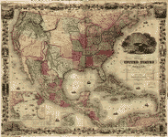 | 1850 Map of the United States | "Map of the United States of America." Map of the United States of America. N.p., n.d. Web. 20 Aug. 2014. | http://memory.loc.gov/cgi-bin/query/r?ammem/gmd:@filreq(@field(NUMBER+@band(g3700+ct000761))+@field(COLLID+gnrlmap))
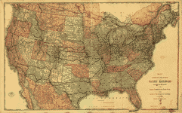 | Map exhibiting the several Pacific railroads | United States. Department of Commerce and Labor. Bureau of Statistics. Map exhibiting the several Pacific railroads prepared for the report on the internal commerce of the United States by the Bureau of Statistics. [Chicago] Rand, McNally & Co., 1883. Scale ca. 1:4,500,000.  col. map 68 x 107 cm.  G3701.P3 1883 .U5 | http://lccn.loc.gov/gm71000841
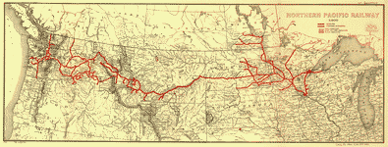 | Northern Pacific Route | Northern Pacific Railway 1900." Northern Pacific Railway 1900. N.p., n.d. Web. 20 Aug. 2014. | http://memory.loc.gov/cgi-bin/query/r?ammem/gmd:@field(NUMBER+@band(g4126p+rr005020))
Western US without railroads | Example of historical map without railroads |  | http://memory.loc.gov/ammem/gmdhtml/rrhtml/rr250.jpg
History of Railroads and Maps | Variety of historical railroad maps and background info. |  | http://memory.loc.gov/ammem/gmdhtml/rrhtml/rrintro.html
Central Pacific Museum | Artifacts and collections from the Central Pacific Railroad | "Central Pacific Railroad Photographic History Museum." Central Pacific Railroad Photographic History Museum. N.p., n.d. Web. 20 Aug. 2014. | - http://cprr.org/Museum/index.html#
Union Pacific Museum | Artifacts and collections from the Union Pacific Railroad | "Exhibits." Union Pacific Railroad Museum. Friends of the Union Pacific Railroad Museum, n.d. Web. 20 Aug. 2014. | http://www.uprrmuseum.org/museum/exhibits/index.shtml
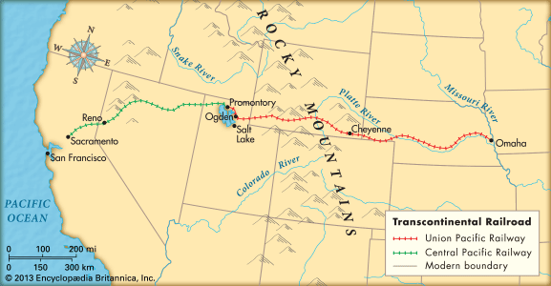 | Britanica Map to Compare to | "Transcontinental Railroad." -- Kids Encyclopedia. N.p., n.d. Web. 20 Aug. 2014. | http://kids.britannica.com/elementary/art-178792/The-transcontinental-railroad-was-completed-on-May-10-1869-in
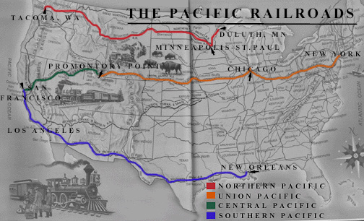 | Example of a biased report | "North vs South on the Transcontinental Railroad." Southern Nationalist Network. N.p., n.d. Web. 20 Aug. 2014. | http://southernnationalist.com/blog/2012/06/10/north-vs-south-on-the-transcontinental-railroad/
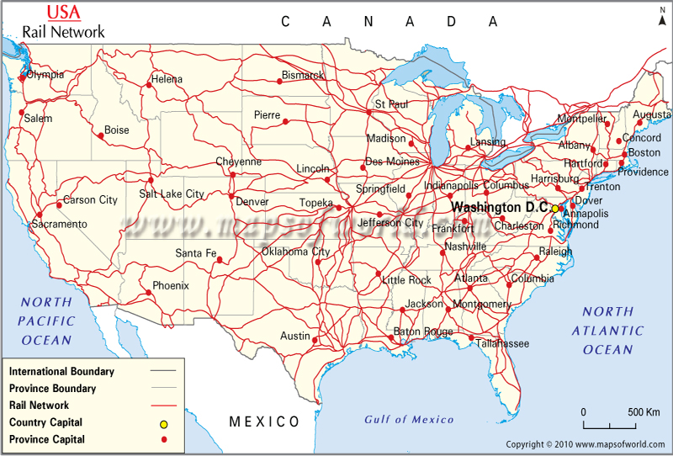 | Present day map of Railroads | "USA Rail Map." , US Rail. N.p., n.d. Web. 20 Aug. 2014. | http://www.mapsofworld.com/usa/usa-rail-map.html#
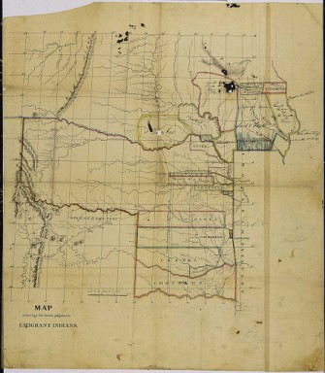 | Native American Emigration map to spark thinking/brainstorming process | "The National Archives Experience: DocsTeach." Map of Lands Assigned to Indians, Western Territory. N.p., n.d. Web. 20 Aug. 2014. | http://docsteach.org/documents/306588/detail?mode=browse&menu=closed&era%5B%5D=expansion-and-reform&page=5
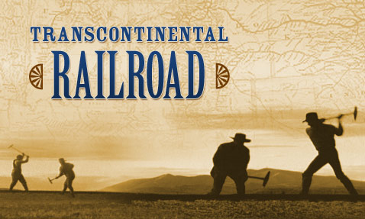 | Background material for group presentations | American Experience: TV's Most-watched History Series." PBS. PBS, n.d. Web. 20 Aug. 2014. | http://www.pbs.org/wgbh/americanexperience/films/tcrr/

Procedure:
- Prior Knowledge: Background of history up to the point of the consideration to actually complete the path of the transcontinental railroad. (What is happening during this time period that may be relevant to the learning.)
- Bellringer Question: Where are the nearest railroad tracks to where you live? What do they transport? Does anything that the railroad/trains do that raise or lower your constitutional rights? How does it affect you or the people that are nearby?
- Students will discuss in small groups their answers.
- Show the students of a map prior to the beginning of the railroad without telling them the date.
- Analyze the map as a class to determine the date of the map.
- Then show them the map of the Central Pacific Route, analyze the date and the changes as a group.
- Then show the students a map of the Union Pacific Route, analyze the date and further changes that they see.
- Likewise then the complete map of the transcontinental, and then a map of all the railroads that developed as a result.
- Finish with a map of what our railroad system looks like today and again complete the analysis.
- Brainstorm as a class through a board or Prezi web, all the changes that took place as a result of the railroad system (if possible guide the students to geographical impacts, environmental impacts, travel impacts, transportation of goods, economics, lifestyle and cultural changes, immigration, migration, etc.)
- When the web is complete, assign students (in groups) each portion of the web to investigate further.
- The groups will have 1-2 days to complete their research (using sources as cited above or additional if time allows). Students will develop a power point or Prezi to present their work to the rest of the class.

Assessment:
Students will reflect on the map activity and the group presentations to come up with an essay about how the railroad was such a major impact on our country. The evaluative piece will be a rubric.
CATEGORY | 4 | 3 | 2 | 1 | 0
Focus On Topic | Essay goes above expectations and includes further analysis from pesenations. | Entire essay is focused on the assigned topic and does not stray to unrelated topics. | Most of the essay is focused on the assigned topic but some areas of the essay depart from the assigned topic. | Most of the essay is not focused on the assigned topic. | No essay was turned in.
Introduction |  | The introduction is clear, engaging and previews the structure of the paper. | One of the previously mentioned aspects of the introduction is lacking. | More than one of the previously mentioned aspects of the introduction is lacking. | No essay was turned in.
Organization |  | The paper is well organized and details are placed in a logical order. There are no awkward aspects of the paper which leave the reader trying to understand what is being said. | Some areas of the paper are not well organized or not placed in a logical order. There are awkward aspects of the paper which leave the reader trying to understand what is being said. | There are several areas within the paper which are not well organized and are not placed in a logical order. There are several awkward aspects of the paper which leave the reader trying to understand what is being said. | No essay was turned in.
Conclusion |  | The conclusion is strong, ties the paper together and leaves the reader feeling they understand what the writer was getting at. | One of the previously described aspects of the conclusion is lacking. | More than one of the previously mentioned aspects of the conclusion is lacking. | No essay was turned in.

