Primarily Teaching Grant Lesson Plan

Name: Joseph Judge
Title: Lusitania
Grade-level: 11
Subject Area: American History
Topic: Sinking of the Lusitania

Standards:
- Understand the influences on individual and group behavior and group decision making. (SS.9-12.BS.2)
- Cite specific textual evidence to support analysis of primary and secondary sources, attending to such features as the date and origin of the information. (RH.9-10.1)

Compelling Question:
- When are nations justified in declaring war on another nation?
- What are reasons to resist calls for war?
- What Influences people’s decision on these two questions?

Learning Objectives:
- What factors lead to the USA to enter WWI?
- Demonstrate Historical Analysis and Interpretation.

Materials:
- Image Materials listed in resource table.
- Teacher’s Guide: Analyzing Photographs & Prints http://www.loc.gov/teachers/usingprimarysources/resources/Analyzing_Primary_Sources.pdf

Resource Table of Library of Congress Materials:

Image | Description | Citation | URL
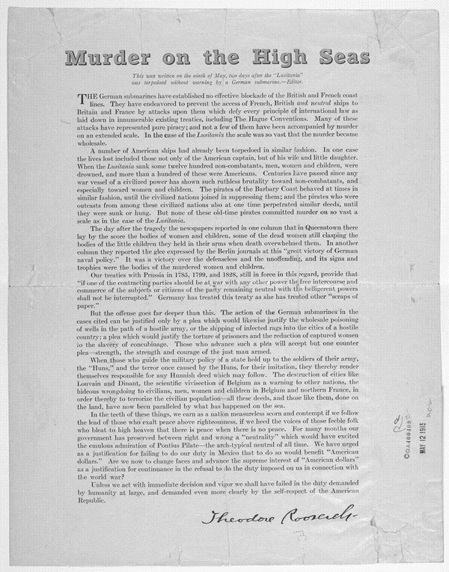 | Written on the ninth of May, two days after the Lusitania was torpedoed.  Theodore Roosevelt. New York May 11, 1915. | Theodore Roosevelt, Metropolitan Magazine, May 11, 1915. New York | http://1.usa.gov/1qj3606
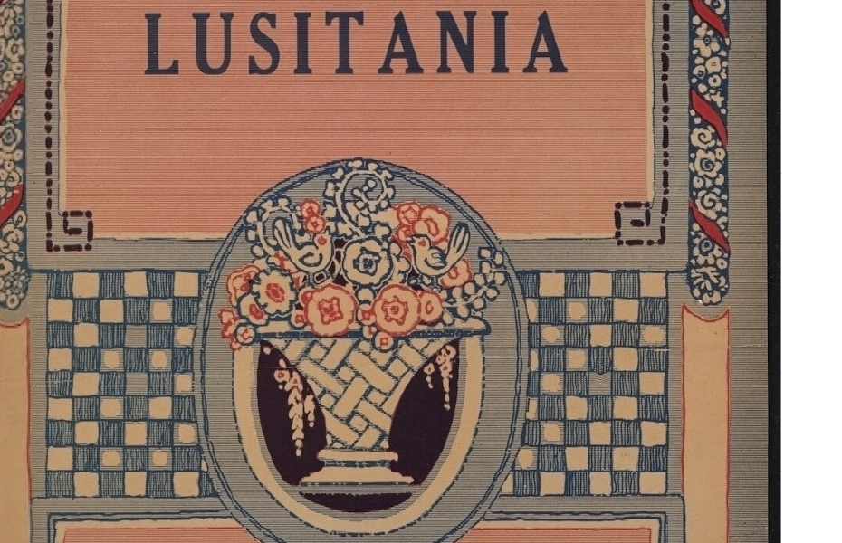 | Sheet music (3 pages) Lyrics discuss the sinking of the sinking of the Lusitania | Words by Ainelia Hunt Garcia ; music by Leo Friedman  North American Music Company,, Chicago :, [1918]. | http://www.loc.gov/resource/ihas.200202377.0#seq-1
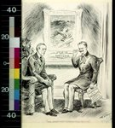 | Political Cartoon with Wilson in discussions with German Diplomat Johann Heinrich Von Bernstorff | William Allen Rogers, New York Herald, November 28, 1915 | http://www.loc.gov/pictures/item/2010717742/
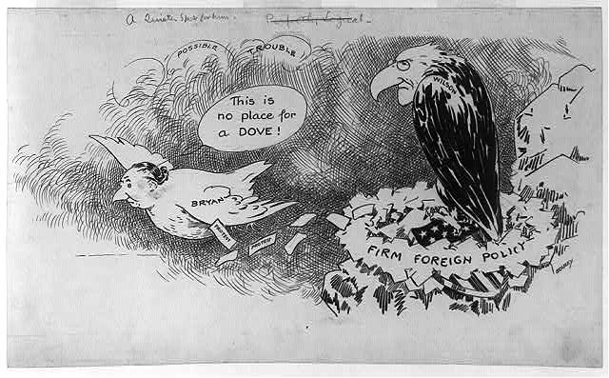 | Political Cartoon with W.J. Bryan as a dove flying away from Wilson’s Hawk nest. | Luther Daniels Bradley,  Chicago Daily News  June 9, 1915 | http://www.loc.gov/pictures/resource/cph.3b30627/
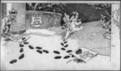 | “this cartoon published the day before Valentine's Day, illustrates this course of events by showing Bryan as cupid with wings, bow, and arrows, walking away after delivering "Official Valentines" to King George and Kaiser Wilhelm.” | Luther Daniels Bradley,  February 13, 1915 | http://www.loc.gov/pictures/item/2009616347/
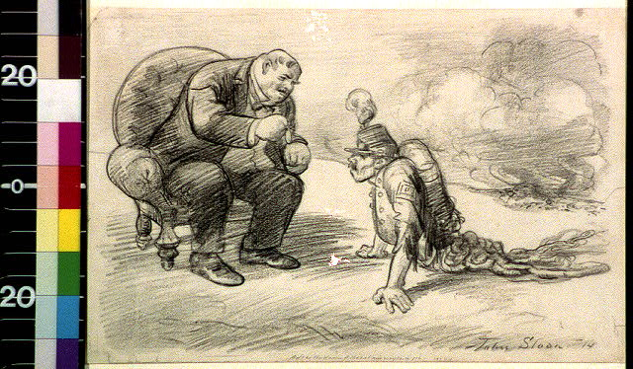 | “Cartoon drawing shows a World War I veteran walking on his hands, dragging his entrails behind him. He approaches a fat capitalist, who sits on a chair and leans over to give him a medal for his service as a soldier.” | John Sloan, 1914 | http://www.loc.gov/pictures/resource/cai.2a14692/

Procedure:
- Divide Class into groups of 6. Each student in the must take one of the primary sources and complete the Analyzing Tool
OBSERVE  1. What do you notice first?  2. What do you notice that you didn’t expect?  3.What do you notice that you can’t explain?  4.What do you notice now that you didn’t earlier? | REFLECT  1. Where do you think this came from?  2. Why do you think somebody made this?  3.What do you think was happening when this was made?  4. Who do you think was the audience for this item?  5. Why do you think this item is important?  6. If someone made this today, what would be different?  7. What can you learn from examining this? | QUESTION  1. What questions do you have after analyzing this document?

- Once completed, have each student partner with another student in the class that analyzed the same document. Have them share their responses with each other. What things do they agree on and what things did they have different opinions about?
- Have students rejoin their original group of six and explain their document, what they observed and share their answers to the questions.

Assessment:
Formative assessment - will be the student’s responses to the Analyzing tool.
Summative assessment - Students will respond to the following questions using information they learned through their group discussions:
When are nations justified in declaring war on another nation?
What are reasons to resist calls for war?
What Influences people’s decision on these two questions?
What reasons do you think kept the USA out of war for 2 years after the sinking of the Lusitania?

