Primarily Teaching Grant Lesson Plan

Name: Patrick Williams

Title: Propaganda and Total War

Grade-level: 9th

Subject Area: World History

Topic: World War I

Standards:
- Iowa Core RH. 9-10.1
- RH.9-10.4
- RH.9-10.9
- WHST.9-10.9

Compelling Question: How do the combatant nations in World War I use propaganda on the home front to convince their citizens to sacrifice for total war?

Learning Objectives:
- Historical empathy-the concept of total war was new in the early 20th Century and had to be “sold” to people.
- Analysis of primary sources will also be an emphasized skill.

Materials:
1) Primary source examples (propaganda posters)
2) Q & A forms small group (2’s), table group (4’s)
3) Total war narrative explanation student short reading with questions
4) intro to propaganda
5) Quick Check for assessment

Resource Table of Library of Congress Materials:

Image | Description | Citation | URL
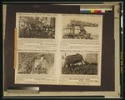 | Poster showing the Alpini soldiers, who toured in support of the Liberty Loan campaign. | Library of Congress, Prints & Photographs Division, WWI Posters, [reproduction number, LC-USZC4-7837 | http://www.loc.gov/pictures/collection/wwipos/item/2003663051/
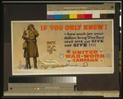 | Poster showing a soldier standing in snow, holding a mug from which steam is rising and eating a piece of pie, he has a big smile on his face. Also shown are emblems from the following organizations: War Camp Community Service; National Catholic War Council; YWCA; American Library Association; YMCA; Jewish Welfare Board - U.S. Army and Navy; and The Salvation Army. | Library of Congress, Prints & Photographs Division, WWI Posters, [reproduction number, LC-USZC4-7462 | http://www.loc.gov/pictures/collection/wwipos/item/00651562loc.gov/pictures/collection/wwipos/item/00651562/n/wwipos/item/00651562/
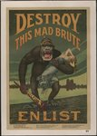 | Propaganda poster shows a terrifying gorilla with a helmet labeled "militarism" holding a bloody club labeled "kultur" and a half-naked woman as he stomps onto the shore of America. | Library of Congress, Prints & Photographs Division, WWI Posters, [reproduction number, LC-DIG-ds-03216 | http://www.loc.gov/pictures/collection/wwipos/item/2010652057
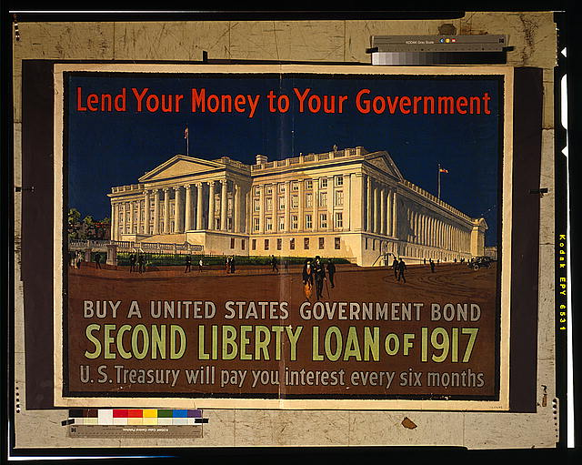 | Poster showing a panoramic view of the U.S. Treasury Building from the southeast. Encouraging Americans to buy war bonds. | Library of Congress, Prints & Photographs Division, WWI Posters, [reproduction number, LC-USZC4-8021 | http://www.loc.gov/pictures/collection/wwipos/item/2001695789/
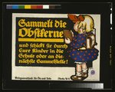 | Poster shows a little girl with a backpack holding a fruit pit. Text instructs people to save fruit pits and send them to school with their children or to bring them to the next collection site. Poster was issued by the Kriegsausschuss für Öle und Fette (War Commission for Oils and Fats.) | Library of Congress, Prints & Photographs Division, WWI Posters, [reproduction number, LC-USZC4-11556 | http://www.loc.gov/pictures/collection/wwipos/item/2004665875/
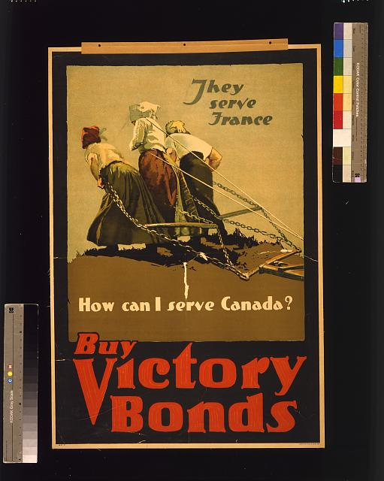 | Poster showing three women pulling a plow. | Library of Congress, Prints & Photographs Division, WWI Posters, [reproduction number, LC-USZC4-10650 ] | http://www.loc.gov/pictures/collection/wwipos/item/2003652830/

Procedure:
- Opening discussion (5 min) How are people motivated by others to do things? (buy certain products, invest, etc…) Thinking about advertising in the modern sense.
- Short PP intro to propaganda (5-7 min) it’s uses, goals and methods (see attached)
- In groups of two (10 min)
a. teacher will present the 6 posters (one at a time) on board
b. working with a partner determine the audience (who it was produced for (nation), determine the segment of the population it was intended for and the method-appeal (fear, pride, revenge etc…
- In table groups (4) (10 min)
a. discuss the findings of the partner groups do they agree on the three basics (come to agreement)
b. as a table group decide why that method–appeal was used for that audience in that nation and if the group found it effective & why
- Come together as a class and discuss number 4 as a class (5 min)
- Class reading on Total War (10min) what it is and how it changed society –this will serve more as a summary as students will have already studied industrialization and it’s impact on people (see attached)

Assessment:
- In all classes, I utilize and “exit ticket” a quick check for understanding, on a half sheet of paper. (see attached)

Name _________________ Name _________________ group # ___

With your table group, discuss and decide why that appeal was used and if you think it is effective. Explain your groups answer.
Working with your partner answer in the chart below the first three questions about each of the six posters I’ll show on the screen then stop.

Which nation is Which segment of is Which emotion (s) Is it effective?
this from? society is it aimed at ? does it appeal to? Why?

1

2

3

4

5

6

The concept of “total war” is relatively new in history. Although wars have been fought throughout human history and those wars occasionally were wars of total annihilation, those conflicts were rare. Wars were usually fought between armies (men) on battlefields and when one side defeated the others armies, the conflict ended with a peace treaty. Money, land, sometimes slaves/prisoners were exchanged. When the fighting concluded even though there may have been many killed on the battlefield, the warring nations went on.
The shift from an agricultural world, populated mainly by farmers, to an industrial world in which a society is dependent on factories made war very different. In this world the contenders are willing to make any sacrifice in lives and other resources to obtain a complete victory. This means that as the technology of killing (machine guns, poison gas, airplanes/bombing etc…) improved the fighting moved from the battlefield to the opponent’s homeland placing their civilians in danger as well as their soldiers. Better technology on the battlefield meant that more soldiers would be lost, so more soldiers would be needed to replace those killed or wounded. Increased demand for soldiers meant more of them were taken (willingly or not) in mass armies of civilian-soldiers. These soldiers were not professionals. They were given at most 8-10 weeks of training then sent to the battlefield. They were seen as a disposable resource, just like resources used in factories. These men had to be replaced in the factories so production of the materials needed on the battlefield would not slow. The replacement workers were drawn from the ranks of society who had previously not been involved in industries seen as vital to national survival. To be sure women and children had been involved in industrial production, but their role as part of a “war effort” to ensure their nations survival was new to total war.
The added pressure on civilians was also a very new phenomenon. The absolute necessity of providing the materials needed by your army and the deprivation of those resources for opponent’s army meant that a nation’s civilians were forced to make do with less and constantly strive to produce more. Even though in a nation with abundant natural resources (or access to resources) the hardships encountered by civilians may make life less comfortable, they pale in comparison with a nation that has limited resources and must use everything it has to fight the war. In short, the economic needs of total war make essential the sacrifice of many more lives on the battlefield and the sacrifice of civilians; in some cases their very lives even though they may be thousands of miles from the fighting.

Quick Check
1. Propaganda is:
a. something used to hold open a door b. something intended to promote a point of view
c. an attempt by a government to reveal d. trade between nations at war
the complete truth about something

2. Total War is:
a. warfare between small numbers of b. the belief that warfare fought only on the experienced, professional soldiers battlefield, would be without mercy
c. the involvement of a complete society d. a really bad idea (soldiers and civilians) in the war effort

Describe how total war impacts civilians left at home (use specific examples from today’s class)
________________________________________________________________________________
________________________________________________________________________________
________________________________________________________________________________
________________________________________________________________________________
________________________________________________________________________________

