Primarily Teaching Grant Lesson Plan

Name: Leah Slick Driscoll

School: Meskwaki High School

Title: American Indians in the Civil War; Motivations for Participation or non-Participation in the War.

Grade-level: 9th-12th

Subject Area: American History

Time needed: 4 -5 days depending on how in depth the instructor wants to go

Topic:
Native Americans who participated in the war, Natives who chose not to participate and their motivations. How various Native nations were affected by these choices.

Background:
Native Americans have fought in every war in America, beginning with the Revolutionary war, in higher numbers proportional to their percentage of the population than any other racial or ethnic group in America. It is difficult to guestimate the approximate Native population in 1860, but it is widely estimated that by 1890, 220,000 Natives remained alive in the United States. This is anywhere from two percent to five percent of the original pre-contact population depending on which beginning figure you use. Despite their small population, more than 20,000 Natives fought in the Civil War, some for the Union and others for the Confederacy. This was a gray area, and one that the U.S. government struggled with, both because Natives did not become citizens until 1924 and because people of color were not at first allowed to serve in the military. By the end of the war, both sides had all Native regiments, as well as mixed African American and Native regiments. Ely Parker, a Sachem (chief) of the Seneca tribe in New York was educated as an engineer and a lawyer. Early in the war he tried to enlist for the Union, but was denied. He was a personal friend of Ulysses S. Grant, and eventually served as Grant’s personal secretary. It was Ely Parker who drafted the terms of surrender signed by Robert E. Lee in 1865, at Appomattox Courthouse, VA. He was the highest ranking American Indian officer for the Union. On the Confederate side, Stand Wattie, a Cherokee whose tribe had been removed from the North Carolina and Georgia region thirty years earlier during what is called the Trail of Tears, served as a brigadier general for the south. He was the last general to surrender after the Confederacy lost the war. It is crucial to break down the stereotype, that such a thing as the “Native American” experience or “the Native American perspective” exists. To use the term Native American perspective is a way of making all of the more than 600 tribal nations that existed at this time (today there are 566 federally recognized Native nations in the US) seem the same faceless entity. We could sooner talk about the “European experience” or “European perspective” of World War ll. One crucial piece of background information that students need to understand is the removal experience. All tribes east of the Mississippi have their own personal Trail of Tears, not just the Cherokee as some students have been led to believe by the fact that many teachers and textbooks highlight the Cherokee, Choctaw, Creek, and Chickasaw as the only ones who had a removal experience. In fact, every one of the 800 plus tribes that existed in 1600 had a removal attempt, war, or experience. A tribe’s experience during removal directly influenced the response of tribes to the Civil War, and some tribes such as the Creeks and Cherokees were divided right down the middle by those who participated and those who feared the consequences of participation if the side they fought on lost the war. Others tribal nations in the west were having their own crisis to survive “westward expansion”, or invasion, death, and dispossession. The Civil War was a four year reprise, as soldiers were called to fight other Americans for a time. Once the war ended, many peacetime soldiers were then sent west to solve the “Indian problem”. If your students have a good background in the Removal Act of 1830 and understand that most tribes were affected by it, then they have the foundation needed to critically think about the experiences and perspectives of various tribes in this conflict.

Standards: Iowa Core
Understand cause and effect relationships and other historical thinking skills in order to interpret events and issues
- Understand relationships between and among significant events.
- Understand facts and concepts drawn from history, along with methods of historical inquiry, to inform decision-making about and action-taking on public issues.
- Understand the process of critical historical inquiry to reconstruct and reinterpret the past.
- Understand multiple viewpoints within and across cultures related to important events, recurring dilemmas, and issues.
- Understand how and why events may be interpreted differently depending upon the perspectives of participants, witnesses, reporters, and historians
Compelling Question: Why did some Natives choose to participate in the war, while others tried to remain neutral or uninvolved? How were Native nations in various parts of the U.S. and the territories affected by the war and the war’s end?

Learning Objectives:
- Students will examine the long term effects of removal policies on the Lumbee Nation of North Carolina, the Cherokee Nation of Oklahoma, and the Seneca Nation of New York among others to find out what role the event had in the decision to either participate or remain neutral in the Civil War.

- Students will see that various Native nations found themselves in unique circumstances, and will seek to understand why different tribes or individuals within tribes made the decisions that they did based on their circumstances. Students will also find that tribes may have been divided in their desire to participate, to remain neutral, or to work against one or both armies participating in the war.

- Using primary documents such as photograms and drawings, students will examine non Native perspectives of Natives serving in the war. They will have the opportunity to examine whether or not these perspectives of Natives had a bearing on how Native communities were affected after the war based on their role on either the winning or losing side. Based on a role playing activity, students will be able to place themselves in the position of tribal nations that had a difficult decision to make in whether or not to participate, and on which side they might fight on to the benefit of themselves or their tribal nation.

Materials:
- Access to the following Library of Congress primary documents (found on the website)

- The History Channel’s documentary: “Indian Warriors; The Untold Story of the Civil War” 44 min long Can be found on youtube.com http://www.youtube.com/watch?v=FbSJRmrRm60 or can be ordered in DVD format

- First Peoples: A Documentary Survey of American Indian History, by Collin G. Calloway p300-310

Access to the website : http://alexandriava.gov/historic/fortward/default.aspx?id=40164
Which belongs to the Fort Ward Museum in Alexandria, Virginia. The title of the site is We Are All Americans: Native Americans in the Civil War

- For how the tribes were divided in their response and were affected after the Civil war:, the Oklahoma Historical Society has a website at the following address : http://digital.library.okstate.edu/ENCYCLOPEDIA/ENTRIES/C/CI011.html

Resource Table of Library of Congress Materials:

Image | Description | Citation | URL
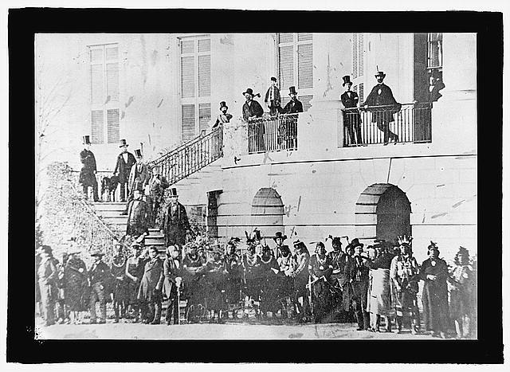 | A group of Native American leaders from Western tribes visit Washington DC during the Civil War to meet with top officials in the U.S. government | From the Library of Congress Website, no known restrictions on publication | http://www.loc.gov/pictures/item/npc2008008801/
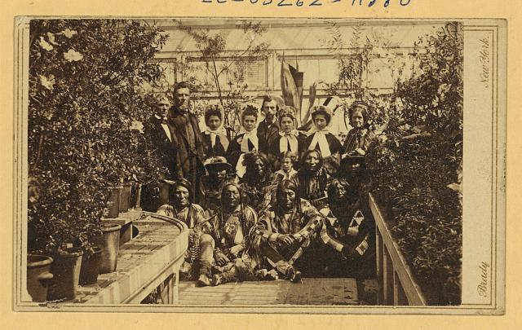 | Summary: Photograph of the Southern Plains delegation, taken March 27, 1863. Included in the picture are an interpreter, an Indian agent, War Bonnet, Standing in the Water, Lean Bear (Cheyenne) and Yellow Wolf (who died from pneumonia days after this picture was taken)(Kiowa). War Bonnet and Standing in the Water both died at the Sand Creek Massacre. Lean Bear was killed by Colorado troops who thought he was “a hostile.” (Source: Diplomats in buckskin, by Herman J. Viola, p. 101). Excerpted from loc.gov summary that comes with the photo. | From the Library of Congress Website, no known restrictions on publication  Photo taken by Brady, Mathew B., approximately 1823-1896, photographer | http://www.loc.gov/pictures/item/2004669812/
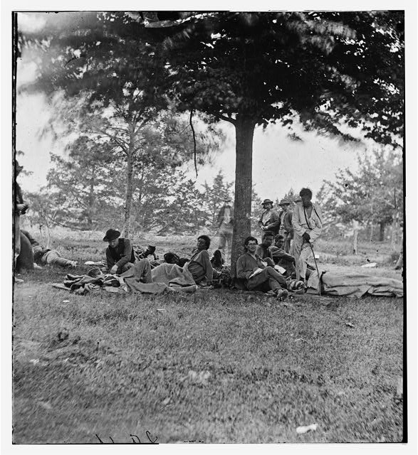 | “Caption from negative sleeve: wounded Indian sharpshooters on Marye's Heights after 2nd Battle of Fredericksburg, May 1864”  Taken in May 1864 | From the LOC glass negatives collection from the Civil War.  No known restrictions on publication | http://www.loc.gov/pictures/item/cwp2003004737/PP/
LOC title:  1862 | Quoted from the LOC summary that accompanies the drawing: “ A Civil War cartoon showing New York Herald publisher and editor, James Gordon Bennett, as an American Indian whose pants, torso, and face are embellished with the Stars and Stripes. He awaits the arrival of a fleet of oncoming ironclad ships bearing the flag "Charleston Harbour." He holds a war club in one hand and his banner, the New York Herald, tied to a spear, in the other.”  This is a source from the time (published in 1862) that may help your students understand how many Americans thought of Indian men in general (although not a lot has changed sadly). Because it is a political cartoon, the author assumes that the readers will immediately get the insult to James Gordon Bennett. And if this is the accepted stereotype about Native men, your students may ponder the benefits or down side to using Native men in the war on either side. | No known restrictions on publication
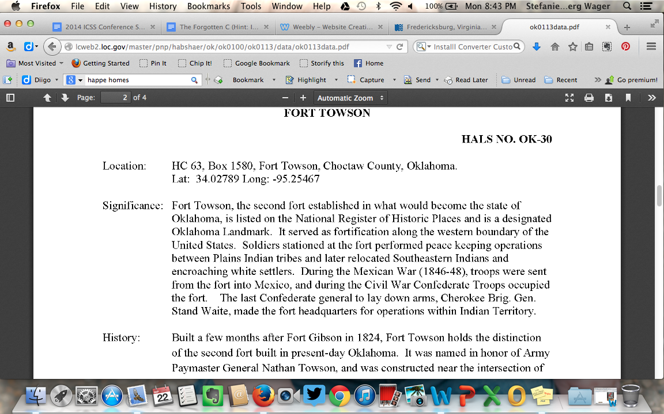 | Fort Towson was located in Indian Country, in what would later be called Oklahoma. It was originally set up so that U.S. soldiers could keep the peace between Plains Native nations and Southeastern Native nations who fought each other over scarce resources after southeastern nations were forced to remove to there after 1830. The army also was responsible for keeping the peace between white settlers and Native nations. During the Civil war, Stand Wattie, Cherokee and Last Confederate General to surrender, made this fort his official headquarters for he and his Confederate troops. | LOC collection: American Landscapes Survey  No known restrictions on publication | http://www.loc.gov/pictures/item/ok0113/
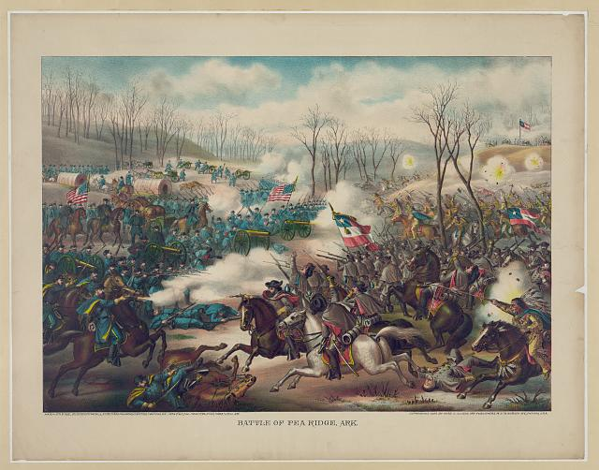 | “ Print shows an attack by Confederate cavalry and infantry, with Native American troops, against a line of Union cannon and infantry at Pea Ridge in Arkansas”  LOC summary quoted | No known restrictions on publication | http://www.loc.gov/pictures/item/2013645343/
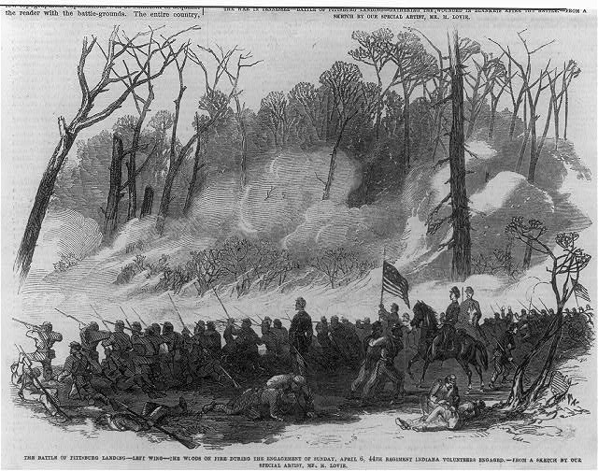 | Wood engraving  Repository: Library of Congress Prints and Photographs Division | No known restrictions on publication | http://www.loc.gov/pictures/item/2005694845/

Procedure:
Day 1 (50 minute class period)
This exercise is optional, but is especially useful to students who have not had a lot of background with the Removal Act of 1830. It will help students empathize and understand what many Natives experienced during removal.
- Have students take out a sheet of paper and draw a line halfway through the sheet. Give students 2 minutes to draw a picture of their house from the outside, including the yard. (Reassure students that it is a quick drawing that is only for their own use and will not be turned in).

- Next have students take an additional 2 minutes to draw a picture of something that symbolizes their hometown on the bottom half of the sheet of paper (this might be the Welcome to ________sign on the edge of town, or a landmark of significance).
- Now pass out 12 small pieces of paper to each student and have them fill them out in the following ways:
- on four slips of paper write the four people in your family you would take with you on the getaway space shuttle if the Earth was no longer inhabitable.
-on four slips of paper the four possessions they would take on the shuttle under the assumption that they would have power sources for them and the ability to use the items. (It’s okay if they say a fridge or a car)
-on the remaining four sheets have them write four things they enjoy doing for fun or as a hobby.

- Now have students place their drawing of home and hometown symbols on the floor in a corner of the room. (they will file past it shortly and look at their own drawing).

- Read the following scenario to students:

Two alien civilizations landed on Earth 150 years ago, without the knowledge of humans. Alien Civilization A set up a base camp under the Arctic Ocean near the North Pole, while their rival and enemy set up base camp in the South Pole. The two have been arguing amongst themselves, and have even fought each other in space over the division of the Earth, all without humans being aware. Both Alien civilizations come from the same galaxy (far, far away, naturally) and both have booming populations that their home planets cannot provide enough resources for. They set out in search of another compatible planet that seemed empty or underused to them. Their technology in the areas of weaponry, transportation, and building design are far superior to that of humans. Humans are in fact so far short of their level of advanced technology that they view humans almost like animals. Just five years ago, Alien civilization A finally won an all out victory against Alien Civilization B, and civilization A now claims our Earth as their own on their maps. Alien civilization B has agreed to give up and sell North and South America to civilization A for a fair price. Because the Midwest of what was formerly known as the United States, has such fertile crop land, the aliens have decided to “settle” there first, and “southward expansion” is about to begin. The first county to be “settled” is your county. You have been told that you will have to leave this area, and that you will have a journey of 500 miles on foot to a new location in the desert southwest where you will be given new lands to live on. You have already sent some young men and women out to fight the aliens, but most did not come back. You have seen what the weapons of the aliens are capable of. It is now time for you to pick up your four closest family members, your four prized possessions, and the papers with your four hobbies on them and get in line at the front of the room as you hold them in your hand and begin your journey. (Wait for students to line up—you as the teacher will play the role of the alien commander talking on your head phone and mouthpiece communicator….Tell students to file past their homes and home symbols as they file out of town)
Alien Commander speaking into communication device: “Hey guys! You have really got to get out here and claim some of this fertile farm land! The soil is black and rich in nutrients! We will be able to grow 500 bushels of crop on this soil. I am watching these primitive humans file out now, so the land is open! Hurry before it’s all gone!!”

Have students take their seats again, and have them lay their 12 pieces of paper out on their desk. They are now on the fictional removal journey to the southwest (where they will be distant from the new settlers and where the aliens deem the land less useful to them).

Events on the removal journey:
- Event 1--Announce to students that on the journey 1 of their loved ones has just passed away from small pox. The students will remove this piece of paper from their desk.

- Event 2—the small amount of food and water rations provided by the aliens is not sufficient to keep the family going. They find they must sell or trade one of their prized possessions for more food. Have students crumple one possession.

- Event 3—The oldest member of the family is suffering from exhaustion and is starting to show signs of pneumonia. There is no medical facility or doctor on hand. Also the weather is very cold, and the flimsy tents provided by the aliens do not keep people warm enough now that winter has come. You find it necessary to trade another prized possession for more blankets on the way. The trader throws in some herbal medicine for your family member’s possible pneumonia. Crumple another prized possession up. And crumple two hobbies up, since you are so busy making sure you and your family make it, that you have very little free time at all.

- Event 4—Your oldest family member just passed away from exhaustion and pneumonia, despite your best efforts to help them. Crumple that piece of paper or remove it from the desk.

- You finally arrive at your destination after 6 weeks of walking. You are told by the Aliens that you can begin to rebuild your life on the reservation of land they have set aside for you. You notice that the alien army posts soldiers on the outskirts of your reservation lands to ensure no one from your community tries to leave.

- After being there in the new lands for 4 years, you hear rumors that the alien settlers have expanded nearly all the way south and west to just a few miles outside your boundaries. You begin to hear talk that you and the people in your community may have to move again if these settlers want your land, or perhaps the rumor just says they will “allot the land” and give you’re a much smaller piece in order to teach you to be more “civilized”, meaning to have a culture more like the aliens.

Homework for that night:
Possible responses of Native nations in three regions to the news that the Americans from north and south are at war with one another. Give students a sheet of paper that you have cut and pasted the following chart into (but in enlarged form) and have them brainstorm possible ideas for the next day’s discussion based on the role playing scenario they just took part in…if it were the aliens at war with each other, what are pro’s and con’s for Americans if they get involved in one side or the other? Explain to students that this scenario is designed to help them understand what many Native people must have felt or experienced during removal and “westward expansion” (a heavily biased word for it).
 | Reasons for remaining neutral or not getting involved in the war | Reasons for entering the war either for the Union or the Confederacy:
Northern Native Nations
Southern Native Nations
Natives in the west or in territories

Hopefully during the discussion the next day some of the students are able to put themselves in the place of tribes to imagine some possible motives for each response.

 | Reasons for remaining neutral or not getting involved in the war | Reasons for entering the war either for the Union or the Confederacy:
Northern Native Nations | Natives are not citizens of the US, so it’s best to stay out of it!  We have already been through enough trauma in the past 25 years, what if we fight for the losing side and lose our land again? | Here is a way to practice our traditional way of life for young men (warriors )  The Union is bound to win, and maybe our lands and lives will be more secure if we are seen to have helped win the war  Here is a way to earn money and legally leave the reservation/settlement
Southern Native Nations | Natives are not citizens of the US, so it’s best to stay out of it!  If some of our people get involved, the war might come to our homelands and destroy what we have built together in the past 25 years  We have already been through enough trauma in the past 25 years, what if we fight for the losing side and lose our land again? | Here is a legal, and even encouraged (by the Confederacy) way in which we can fight the U.S. army and get some of our own back for our lost land all those we lost during removal  By joining those Confederates around us, maybe our lands and lives will be more secure if we are seen to have helped win the war against the Union.  Or  By joining the Union, we will be seen as loyal by the U.S. government at the end of the war, and may be rewarded with safety and security.  Here is a way to earn money and legally leave the reservation/settlement  Here is a way to practice our traditional way of life for young men (warriors )
Natives in the west in territories (areas such as present day South or North Dakota, Utah, Montana, etc.) | Fighting their own battles with the U.S. and settlers encroaching on their lands. For the most part they are uninvolved in the fight the Americans are fighting amongst themselves. | Natives in the west are seen as enemies in the ongoing fight…very few took part in soldiering. As the box to the left says, they are struggling with imminent problems on their own lands.

Day 2: (50 minute class period)

  - 20 minutes: Discuss ideas your students came up with for each category. If the conversation stalls out, go back to the alien scenario. If after several years we hear that Alien civilization A controls the whole of the former United States, and they are divided against each other on a point of contention they hold to be so important that they are now killing each other in a Civil War, What will your student’s fears, hopes, and predictions be should they become personally involved in one side or the other?

  - Have students visit the website: (30 minutes) http://alexandriava.gov/historic/fortward/default.aspx?id=40164. This is a museum website that gives a pretty good background to some of the most notable Natives that were involved in the war (Stand Wattie, Ely Parker, Henry Barry Lowry, and more). They also profile a few tribes that were divided in their response to the war such as the Cherokees. This website will give them a bit of background for Day 3 when the video is shown and students divide into groups to discuss and view the primary documents from the Library of Congress.

Day 3: (50 minute class period)
  - 15 minutes: Have Students divide into groups and view the 6 photos from the Library of Congress Website. Pass out the group questions so that students can analyze the photos and discuss their findings with each other in the Initial examination section.

  - 30 minutes: Have students watch the video “Indian Warriors; The Untold Story of the Civil War” 44 min long either on Dvd or on youtube (which ever you have available).

  - Homework: have students read pages 300-310 at home. They should primarily pay attention to what was happening in western areas in the Northern and Southern plains during the war.

  - Main questions for students to consider during this homework assignment:
- What happened during the Great Sioux Uprising in what we called today Minnesota?
- What happened at the Sand Creek Massacre?
- How would events such as these affect whether or not Natives in the West would or would not participate in the Civil War?
- How would these western plains tribes view the eastern tribes that had been removed to Indian Territory (what would become Oklahoma) from the north and southeast? For instance consider dwindling buffalo herds and the fact that they are “assigned land” that southern plains Natives consider theirs.

Day 4: (50 minute Class period)
  - 15 minutes: Have students finish watching the final 14 minutes of the film clip.

  - 15 minutes: Have students re-examine their LOC photos and find out of any of the original interpretations of what these photos tell them have changed. What motivations might have caused the Natives pictured to be there in that time or place?

  - 15 minutes: have students log on to the internet and take a look at the website http://digital.library.okstate.edu/ENCYCLOPEDIA/ENTRIES/C/CI011.html
This is a great website to use to follow up on how tribes such as the Cherokees were affected by their division over the Civil War, and their participation. Students can also look at several other Native nations to see how the war affected them.

Assessment:
If you have a fifth day to spend on this mini unit, you could divide your class up into 3 or 4 different groups who will then do their own short research on the war’s effect on tribes mentioned in the film such as the Cherokee, Creek, Lumbee (of North Carolina) or individuals such as Stand Wattie and Ely Parker. What were the long term effects of their choices? This individual research exercise could be the assessment as they share with the class during discussion.

If you do not have another day, you might try a Socratic Seminar in which you get in a circle as a class and students lead discussion based on 3-4 main questions you give them in advance concerning this topic. For information on how to do a Socratic Seminar you can view the website: www.hhh.k12.ny.us/uploaded/PDFs/DI_Pdfs/Day_1/hertberg.pdf

Or

You can have students write a short essay on what influenced Natives to enter the war or try to remain neutral. Have them discuss what was occurring in the west with such tribes as the Cheyenne or Sioux Nations. Finally, have them discuss the long term effects of at least three different Native groups of their choices concerning the Civil War.

Below are two worksheets that could be used with this lesson plan:

Native Warriors in the Civil War Name____________________

- Who was Ely Parker? What did he do for a living?

- Why were Native people not able to join the Union army when the war started? What did Ely Parker do in response to this?

- How are Natives in the East (of Mississippi) treated differently from Natives in the south?

- What benefits or promises are made to Natives if they will either fight with the Union or the Confederacy?

** How many Natives fight in the Civil War (give the range). Why is it difficult to tell just by looking at names if the person is Native or not? Skip to 16:20

- How was slavery different in Indian Territory than in the South? Why do you think some Cherokees began to “own” enslaved people in the first place?

- Who was Stand Wattie?

- (Skip to 24:40) What strategy did the Lumbee Tribe of North Carolina take in trying to preserve their nation?

- What were the Lumbee people forced to do for the Confederate Army? What were the conditions like?

*How do the Lumbee men responds to this forced act?

- What did the Home Guard do to the father of Henry Lowery (Lumbee men)?

- How do Henry Lowery and other Lumbee men get their revenge on the Confederacy?

- Were the promises made by both the Confederacy and the Union to Native people kept after they served in war?
---------------------------------------------------------------------------------------------------------------------------------
Group Primary Document Examination:
Image Analysis Notes

Name/s_________________________________________________________

Initial Examination:  Why do you think this image was made?  What people and objects are shown? | Initial Examination:  What is happening in this image?  Who do you think was the audience for this image? | Second Examination:  Has anything changed about what you think is happening in this image?  What motivations might the person making or taking the image have had for doing so? | Second Examination:  What do you still wonder about…who?...what?...where?...when?…  why?...how?  What more do you want to know and how can you find out?
Image 1
Image 2

Image 3
Image 4
Image 5

Image 6
Image 7

