Primarily Teaching Grant Lesson Plan

Name: Deb Loftsgard

Title: Map It!

Grade-level: Junior

Subject Area: American History

Topic: War Theme PBL Unit. Goal is to discover points of history in which the actions of the victors of war regarding political boundaries (geography) changed the world and possibly contribute to continued world conflict. Students will be encouraged to discover the wars from WWI-Vietnam (at minimum) by demonstrating proficiency of the 11 I can statements and eventually answering the driving question.

Standards:
C3 Standards
1. D1.5.9-12. Determine the kinds of sources that will be helpful in answering compelling and supporting questions, taking into consideration multiple points of view represented in the sources, the types of sources available, and the potential uses of the sources.
2. D2.Civ.3.9-12. Analyze the impact of constitutions, laws, treaties, and international agreements on the maintenance of national and international order.
3. D2.Civ.12.9-12. Analyze how people use and challenge local, state, national, and international laws to address a variety of public issues.
4. D2.Civ.13.9-12. Evaluate public policies in terms of intended and unintended outcomes, and related consequences.
5. D2.Eco.1.9-12. Analyze how incentives influence choices that may result in policies with a range of costs and benefits for different groups.
6. D2.Geo.2.9-12. Use maps,satellite images, photographs,and other representations to explain relationships between the locations of places and regions and their political, cultural, and economic dynamics.
7. D2.Geo.5.9-12. Evaluate how political and economic decisions throughout time have influenced cultural and environmental characteristics of various places and regions.
8. D2.His.1.9-12. Evaluate how historical events and developments were shaped by unique circumstances of time and place as well as broader historical contexts.
9. D2.His.5.9-12. Analyze how historical contexts shaped and continue to shape people’s perspectives.
10. D2.His.9.9-12. Analyze the relationship between historical sources and the secondary interpretations made from them.
11. D2.His.15.9-12. Distinguish between long-term causes and triggering events in developing a historical argument.

Compelling / Driving Question: How can we as historians learn from the actions of leaders involved in WWI, WWII, Cold War, Korea, and Vietnam and use the skill of cartography to prevent escalation of current hostile regions of the world?

Or if less direction is needed:

How is the failure of peace tied to geography?
Learning Objectives:
1. I can determine sources that will help me answer questions while taking multiple perspectives in account
2. I can use treaties/executive agreements of WWI, WWII, Cold War, Korea, and Vietnam to discover politicians’ intention in recreating Europe and Southeast Asia in an attempt to maintain order.
3. I can analyze how people challenge national and international law during the 5 time periods and use this knowledge to apply to current hostile regions of the world.
4. I can determine intended and unintended consequences of politicians’ actions regarding map configuration during the five time periods as well as the connection to today’s hostile areas.
5. I can analyze costs and benefits of world economic policies for different groups throughout the world.
6. I can use maps and photographs to explain relationship between location and and political and cultural activity.
7. I can evaluate how political decisions throughout time have influenced cultural characteristics of various places and regions.
8. I can evaluate how historical events (5 wars) were shaped by unique circumstances regarding geographical issues.
9. I can analyze how historical context shape people’s perspectives.
10. I can analyze relationship between primary and secondary sources
11. I can distinguish between a long term cause of war and a triggering event in making conclusions regarding today’s hostile areas of the world.

Materials and Procedures:

Entry Event: Show students clips of recent news events of the fighting in various parts of the world. Discussion over article: Top 10 Controversial Territorial Disputes. Debate why these completely different groups are living together in one country, how it was decided they would be in one country, the role of victors and losers of war in determining sanctions, the role of the US in world affairs.

Level 1 Demonstrates minimal understanding of grade level standard:
Procedure: This phase of the learning process is designed to introduce the students to the complexity of geography, history, and economics in world conflict and peace. Students will be gaining background knowledge by exploring the maps from throughout history of Europe.

1. Students will need to first make a copy of their Map it! Student PBL Document
a. this will be used by the students to document their progression through the levels for each I Can statement.
1). The overall challenge is to utilize the skills and knowledge
gained (in levels 1-2); to inquire about the I can statements (level 3) to uncover their groups’ answer to the driving question (level 4).

2. Students will be using the primary document to begin building background knowledge regarding the changes in maps and how these changes correspond with War
a. Map Analysis document: Observe/Reflect/Question to prepare for building Need to Know Questions in Level 2.
b. Possible questions to get students started: Observe: What do you see?
Reflect: What on the maps look strange? What do the maps tell you about the changes happening in history? What differences do you notice in the different maps?
Question: What general questions do you have regarding the maps throughout history?

Resource Table of Library of Congress Materials:

Image | Description | Citation | URL
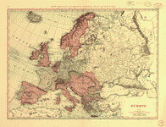 | 1898 Europe Map | Credit Line: Library of Congress, Geography and Map Division. | http://www.loc.gov/item/99466751/
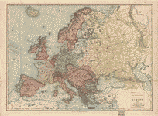 | 1912 Europe Map | Credit Line: Library of Congress, Geography and Map Division. | http://www.loc.gov/resource/g5700.ct002032/
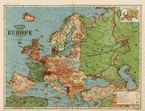 | 1920 Europe Map | Credit Line: Library of Congress, Geography and Map Division | http://www.loc.gov/item/2006629791/
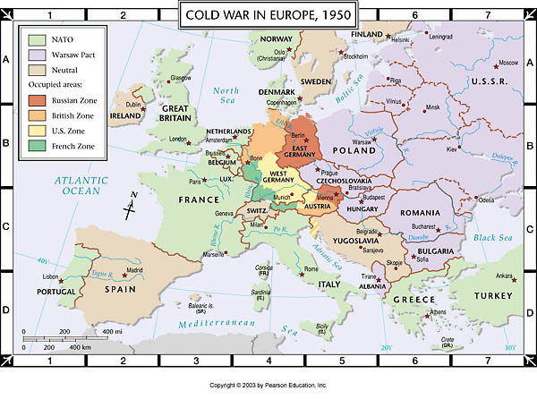 | 1950 Europe Map | Copyright: 2003 Pearson Education | http://wps.pearsoncustom.com/wps/media/objects/2428/2487068/atlas/atl_ah6_m002.html
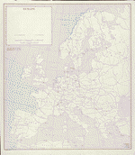 | 1960 Europe Map | Credit Line: Library of Congress, Geography and Map Division. | http://www.loc.gov/resource/g5701a.ct002872/
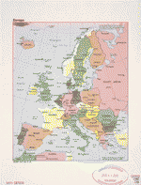 | 1982 Europe Map | Credit Line: Library of Congress, Geography and Map Division. | http://www.loc.gov/resource/g5700.ct003313/
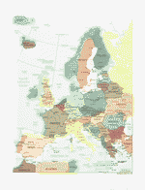 | 2008 Europe Map | Credit Line: Library of Congress, Geography and Map Division. | http://www.loc.gov/resource/g5700.ct002360/

3. Students will be given work time to also complete a Reading Assignment providing basics of the five time periods in an attempt to add to their foundation knowledge understanding of the the wars.
Formative Assessment: Group and student/teacher conversations throughout map analysis, discussions / share-outs regarding findings, Map it! Student PBL Document: Students should reflect on their understandings after completion of the map analysis (level 1) to demonstrate development of foundation knowledge

LEVEL 2 Demonstrates developmental understanding of grade level standard:
Procedure: Identify what students know and what they need to know in order to address the I can statements to make connections to current conflicts of the region.
1. Organize students into groups based on learning styles/group needs-dynamics
a. Set group norms, assign group roles, create individual copies of goal sheets and Map it! Student PBL document (each student should have own copy),
place it in the group folder, and organize group folder
b. Use Proficiency Checklist as a conversation starter to share understandings from readings and map work from Level 1. (proficiency checklist will be created and is dependent on level students’ understandings)
1.) WWI
2.) WWII
3.) Cold War
4.) Korea
5.) Vietnam (example)
c. Be sure to record any questions that may be arising on your group’s I Can/N2K table to Map it!

2. Alternate between group work creating questions and teacher led mini-lectures:
a. Using foundation knowledge created in Level 1: Group discussion: what more do you need to know to answer the driving question.
1.) Groups use the I Cans/N2K Table to ‘Map It’ to brainstorm NEED to KNOW questions to the individual I can statements
b. Teacher led instruction
1.) Pre-assessment with Socrative.com regarding time periods
2.) Lead discussion about basic facts of WWI, WWII Cold War, Korea, and Vietnam based on need/level of understandings
a.) Various formative assessments as needed based on the learners’ needs
3.) Periodic low level vocabulary/key phrases/people/events of time
periods quizzes to ensure basic understanding
b.) Reteach/Reassess until student demonstrates 80% proficiency and has foundation knowledge to be successful with the inquiry process in Level 3
c. Teacher led instruction to provide basics as begin to launch inquiry process
1.) Advanced Google searches
2.) Library of Congress searches

Formative Assessments: conversations, proficiency checklists, pre-assessments, low-level quizzes

LEVEL 3 Demonstrate an understanding of grade level standard:
Procedure: At this point in the learning process, the students have demonstrated 80% mastery of the basic facts of the 5 time periods and have created a wealth of Need to Know questions regarding the I Can statements based on their current understandings of the historical events and the impact on the geography of Europe and SE Asia as well as how the I Cans may be used to uncover reasons for current hostilities in the world. They are now ready to begin the inquiry process and start to uncover their groups’ answer to the Driving Question: How is the failure of peace tied to geography? OR for students who may need more direction/focus- How can we as historians learn from the actions of leaders involved in WWI, WWII, Cold War, Korea, and Vietnam and use the skill of cartography to prevent escalation of current hostile regions of the world? (Keep the driving question constantly posted in the room)

1. Students will be given voice and choice to determine the documents, actions, policies, map/photographs, decisions, perspectives, causes, and sources of each conflict that will be best be used to explore their groups’ path/answer to their driving question. They will also need to determine which hostile area of the world they would like to further discover.
a. this may require much discussion (led by group’s coordinator) prior to embarking into the inquiry.
b. once each student in the group is aware of the group’s goal ( as stated on the group goal sheet); each student should create an individual goal sheet from the group’s folder.

2. Challenge students to keep up with their individual and group documents within their group folder. Be sure to have coordinator of the group lead discussion regarding daily goals and have conversations within group throughout day and at end of each day to ensure progress toward the group’s daily goal is being met.
a. While each student will work on each of the I Can statements; they should be utilizing different resources to add to their group’s focus of the driving question.
b. Identify an event or change in boundary within the historical time periods and conduct research to identify specifics to build knowledge regarding the situation. This information should assist your group in answering your focus of the driving question.
c. Be aware of the validity of the source; understand perspective and bias of resources

For Example:

I Can #2. I can use treaties/executive agreements of WWI, WWII, Cold War, Korea, and Vietnam to discover politicians’ intention in recreating Europe and Southeast Asia in an attempt to maintain order.

Challenge - group members may choose to develop skill of analyzing treaties/executive agreements from various wars to determine reparations and how victors recreated the map of Europe and SE Asia in order to determine if conclusions can be drawn in order to apply to the hostile location of today (in which the group chose).

3. If practice of the skill is needed (or member of group needs a jump start); students will be encourage to utilize the following primary documents throughout their learning process to demonstrate proficiency of the I Can statements. Although, they may also find it more useful to locate a primary document or resource that is more closely related to their path of inquiry regarding the Driving Question

-----

Resource Table of Library of Congress Materials:

I Can #1. I can determine sources that will help me answer questions while taking multiple perspectives in account
Goal: Analyze recordings to gain understandings of perspectives on same account
Assessment: Reflection / Discussion of skill/content and how this information will be used in the answer to the driving question
Image | Description | Citation | URL
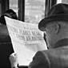 | Audio recordings after Attack on Pearl Harbor | Credit Line:  After the Day of Infamy: "Man-on-the-Street" Interviews Following the Attack on Pearl HarborLibrary of Congress, American Folklife Center. | http://memory.loc.gov/ammem/afcphhtml/afcphhome.html

I Can #2. I can use treaties/executive agreements of WWI, WWII, Cold War, Korea, and Vietnam to discover politicians’ intention in recreating Europe and Southeast Asia in an attempt to maintain order.
Goal: Use Treaty to discover intent regarding reparations to Germany and geographical changes to Europe
Assessment: Reflection / Discussion of skill/content and how this information will be used in the answer to the driving question
Image | Description | Citation | URL
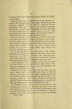 | Treaty of Versailles - Section III : | Treaty of Versailles; speech of Hon. Philander Chase Knox of Pennsylvania delivered in the Senate of the United States, Friday, August 29, 1919. | https://archive.org/details/treatyofversaill00knox

I Can #3. I can analyze how people challenge national and international law during the 5 time periods and use this knowledge to apply to current hostile regions of the world.
Goal: Analyze photo to understand meaning; see what connections to policies and current regional conflicts.
Assessment: Reflection / Discussion of skill/content and how this information will be used in the answer to the driving question
Image | Description | Citation | URL
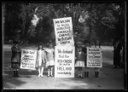 | Children Protesters against Mr. Wilson. | Rights Advisory: No known restrictions on publication. | http://www.loc.gov/pictures/item/hec2013000909/

I Can #4. I can determine intended and unintended consequences of politicians’ actions regarding map configuration during the five time periods as well as the connection to today’s hostile areas.
Goal: Use this and possibly additional research to discover the intended and unintended consequences of the Berlin Wall and discover current geographic disputes as well as their intended and unintended consequences such as Ukraine.
Assessment: Reflection / Discussion of skill/content and how this information will be used in the answer to the driving question
Image | Description | Citation | URL
 | Berlin Wall | H.Con.Res.186 — 100th Congress (1987-1988) | https://beta.congress.gov/bill/100th-congress/house-concurrent-resolution/186

I Can #5. I can analyze costs and benefits of world economic policies for different groups throughout the world.
Goal: Analyze Cold War relations and discover cost/benefits of economic policies on groups in Russia.
Assessment: Reflection / Discussion of skill/content and how this information will be used in the answer to the driving question
Image | Description | Citation | URL
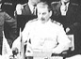 | Soviet and US - Russian Archives: Early Cooperation: Economic Cooperation | Acknowledgments  "Revelations from the Russian Archives" was made possible by the generous support of the Metromedia Company. Additional funding was provided by the Soros Foundation — Soviet Union, the Medveckis Foundation, and a grant from the International Research and Exchanges Board (IREX) with funds provided by the National Endowment for the Humanities and the John D. and Catherine T. MacArthur Foundation.  Credits for Online Version of the Exhibit  June, 1993  Robert Zich  Kathryn D. Ellis  April, 1996  Nancy De Sa, Library Services  Lynn Ellis Brooks, Information Technology Services  Gene Roberts, Interpretive Programs Office | http://www.loc.gov/exhibits/archives/sovi.html#eare

I Can #6. I can use maps and photographs to explain relationship between location and and political and cultural activity.
Goal: Using maps from level 1 activities; discover the relationship between location and cultural conflicts
Assessment: Reflection / Discussion of skill/content and how this information will be used in the answer to the driving question

I Can #7. I can evaluate how political decisions throughout time have influenced cultural characteristics of various places and regions.
Goal: Using the map; to make conclusions regarding the impact of political decisions on geographic changes in the former Yugoslavia area
Assessment: Reflection / Discussion of skill/content and how this information will be used in the answer to the driving question
Image | Description | Citation | URL
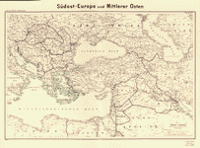 | 1940 Southeast Europe map | Credit Line: Library of Congress, Geography and Map Division. | http://lccn.loc.gov/2013593012

I Can #8. I can evaluate how historical events (5 wars) were shaped by unique circumstances regarding geographical issues.
Goal: Using interview regarding Potsdam conference; evaluate the decisions regarding the geographic issues regarding Europe and how this led to the Cold War relations with the Soviets.
Assessment: Reflection / Discussion of skill/content and how this information will be used in the answer to the driving question
Image | Description | Citation | URL
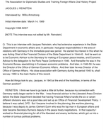 | Interview about Potsdam Conference - start page 6 | Frontline Diplomacy, Manuscript Division, Library of Congress, Washington, D.C.  1989 Interview with Jacques J. Reinstein. | http://hdl.loc.gov/loc.mss/mfdip.2004rei02

I Can #9. I can analyze how historical context shape people’s perspectives.
Goal: Using photograph from Vietnam time period (within the context of history vs present) has the perspective of the viewer changed regarding the same event?
Assessment: Reflection / Discussion of skill/content and how this information will be used in the answer to the driving question
Image | Description | Citation | URL
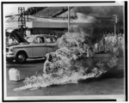 | Buddhist monk | Credit Line: Library of Congress, Prints & Photographs Division, NYWT&S Collection, [reproduction number, e.g., LC-USZ62-111157] | http://www.loc.gov/pictures/item/2001699990/

I Can #10. I can analyze relationship between primary and secondary sources while discovering truths of war time.
Goal: Using the interview - primary document discussing the Korean War atrocities at Sunchon Tunnel and a secondary source -songs of the Korean War time period; how do the two types of sources aid in your comprehension of the time period?
Assessment: Reflection / Discussion of skill/content and how this information will be used in the answer to the driving question
Image | Description | Citation | URL
 | Korean War Atrocities, Hearing, Part 3  -Choose any of the interviews provided; all recount same events. | United States Senate, Committee on Government Operations. . Korean War Atrocities, Hearing, December 4, 1953. (S Res. 40). Washington: U.S. Government Printing Office, 1954. | http://www.loc.gov/rr/frd/Military_Law/pdf/KW-atrocities-part3.pdf
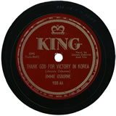 | Secondary Source: Songs about Korean War | "Music About the Korean War: 1950-1954." Music About the Korean War: 1950-1954. N.p., n.d. Web. 19 Aug. 2014. | http://www.authentichistory.com/1946-1960/2-korea/3-music/

I Can #11. I can distinguish between a long term cause of war and geographic triggering events in making conclusions regarding today’s hostile areas of the world.
Goal: As the last I can statement; use the skills of analysis, synthesis, and evaluation to launch your inquiry into level four by considering the causes and impact of geographic conflict as well how it continues to cause such devastation in our world.
Assessment: Reflection / Discussion of skill/content and how this information will be used in the answer to the driving question

--------

3. Once students demonstrate proficiency for each I can statement, they will receive a 3 out of 4 in the gradebook for the standard; they need to keep documentation of movement through the levels on the Student PBL Document (began in level 1) and will need to keep a chart like the one below to document the resources they are using to make their conclusions.

4. In order to achieve 4/4 for the standard; the student must fully demonstrate understanding of standard as well as utilize the skill and content in an original creation/answer to the driving question.

Formative Assessments: Each I Can statement will be individually assessed. Students may not begin to synthesize information on level 4 until they have demonstrated their knowledge/skill for each I Can statement. Students may choose to use the provided exercises to demonstrate their proficiency, or they may choose to use documents that better suit the needs of their group. Teacher-student, group member, and teacher-group conversations regarding the inquiry process and daily goals will be held throughout process to make instructional decisions. .

LEVEL 4 Demonstrates thorough understanding of grade level standard by incorporating this standard into the final product. :
Procedure: Students will begin to synthesize all of the groups research and begin to have in depth discussions and begin to make conclusions regarding the driving question. The group will also use the knowledge to create an original piece of work to demonstrate skills and content obtained.

In addition to level 3 skill building performances, the student will develop in-depth thoughtful responses, seek to answer questions that challenge the ideas of other group members/researchers in order extend research of group’s focus.

May include non-content standards

They will show continued growth in the skill set of the 4 Cs: Communication, Collaboration, Critical Thinking, Creativity as well as in the use of technology to raise awareness and start conversations regarding this standard.

