Primarily Teaching Grant Lesson Plan

Name: Cynthia Hofmeister

Title: Indian Removal Act

Grade-level: 8th grade

Subject Area: U.S. History

Topic: Indian Removal Act- students will question the justification of the Indian Removal Act which led to the Trail of Tears.

Standards:
- Determine the central ideas or information of a primary or secondary source (RH. 6-8.2).
- Understand the influences on individual and group behavior and group decision making (SS. 6-8 BS.3).

Compelling Question: Was Congress justified in the creation and support of the Indian Removal Act and its consequences?

Learning Objectives:
- Students will be able to analyze primary sources on the Indian Removal Act.
- Students will be able to established an opinion if the U.S. government was justified in removing Native Americans from their homes.

Materials:
- Sources from Library of Congress
- Document-Based Assessment for U.S. History by Kenneth Hilton
- Students will need notes from a previous lesson on the Trail of Tears that provides general information on the Indian Removal Act and the Trail of Tears
- Access to video clip from previous lesson
- Writing instrument.

Resource Table of Library of Congress Materials:

Image | Description | Citation | URL
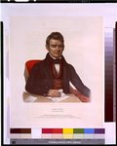 | A picture of John Ross. | Bowen, John T., John Ross, A Cherokee Chief. 1843. Philadelphia. <http://www.loc.gov/pictures/item/94513504/> | http://www.loc.gov/pictures/item/94513504/
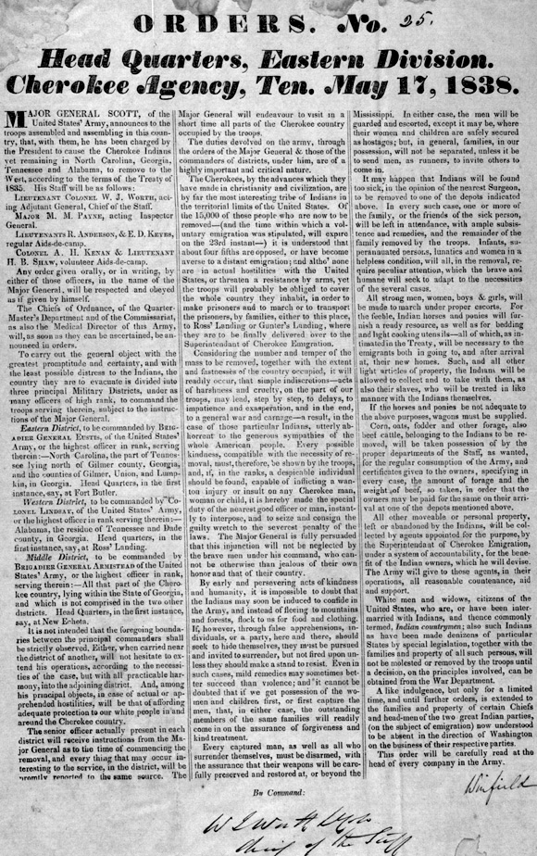 | Published orders to General Winfield Scott about Cherokee removal to Oklahoma. | America’s Story from American’s Library. “Orders No. 25 Head Quarters, Eastern Divisions Cherokee Agency Ten. May, 1838.” <http://www.americaslibrary.gov/aa/jackson/aa_jackson_indians_4_e.html> | http://www.americaslibrary.gov/aa/jackson/aa_jackson_indians_4_e.html
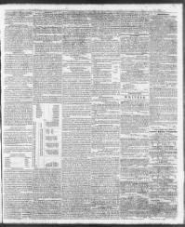 | An article in the North Carolina Standard in 1839. The article expresses an opinion on the removal of the Cherokees. | “The Cherokee.” The North-Carolina Standard. 23 Jan. 1839. From Chronicling America: Historic American Newspapers. Lib. of Congress. <http://chroniclingamerica.loc.gov/lccn/sn85042147/1839-01-23/ed-1/seq-3/> | http://chroniclingamerica.loc.gov/lccn/sn85042147/1839-01-23/ed-1/seq-3/
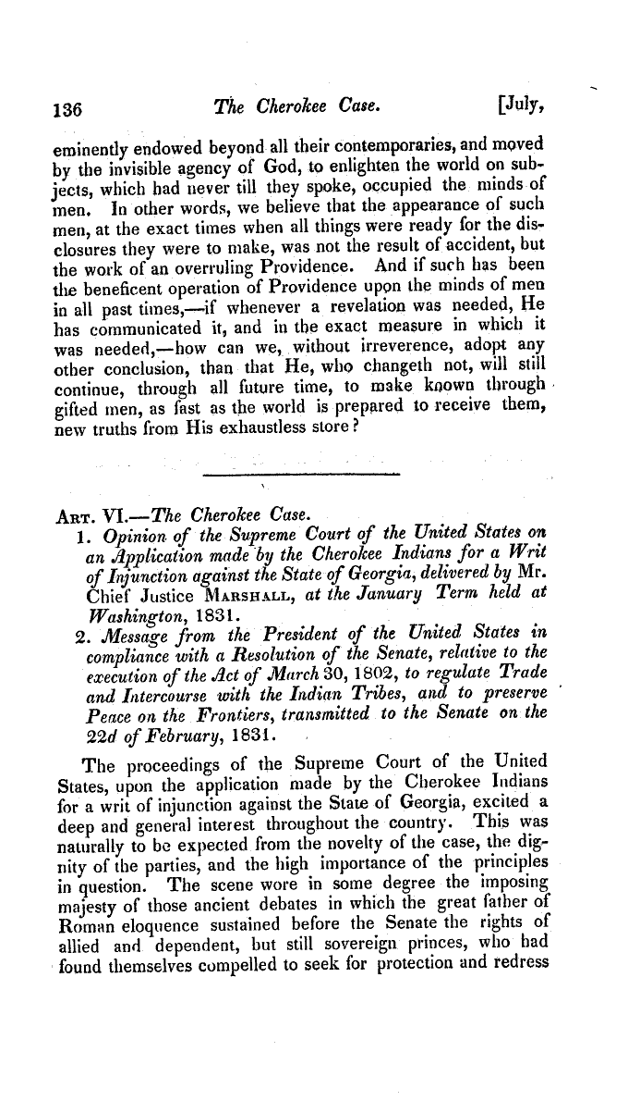 | The Supreme Court ruling on the issues with the Cherokee. | “The Cherokee Case.” The North American Review. 33 (1831): 72. <http://memory.loc.gov/cgi-bin/query/r?ammem/ncpsbib:@field%28DOCID+@lit%28ABQ7578-0033-8_bib%29%29::> | http://memory.loc.gov/cgi-bin/query/r?ammem/ncpsbib:@field%28DOCID+@lit%28ABQ7578-0033-8_bib%29%29::
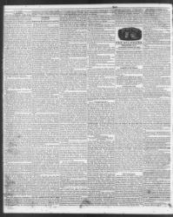 | A notification in the paper that the Cherokees must move by May 1838. | “The Cherokee.” The North-Carolina Standard. 24 Jan. 1838. From Chronicling America: Historic American Newspapers. Lib. of Congress. <http://chroniclingamerica.loc.gov/lccn/sn85042147/1838-01-24/ed-1/seq-2/> | <http://chroniclingamerica.loc.gov/lccn/sn85042147/1838-01-24/ed-1/seq-2/>
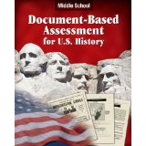 | Premade documents with questions for students on the Indian Removal Act. | Hilton, Kenneth. Document-Based Assessment for U.S. History. Portland: J Weston Walch, 2006. | http://www.amazon.com/Document-Based-Assessment-History-Middle-School/dp/0825159040/ref=sr_1_1?ie=UTF8&qid=1407100231&sr=8-1&keywords=middle+school+document+based+assessments

Procedure:
- Review with students about the Indian Removal Act.
- Students have already gone over the basics of the Indian Removal Act. As a class, we discussed the reasons and attitudes behind the document.
- Students also viewed a clip from the series We Shall Remain on the Trail of Tears and the after effects of the Indian Removal Act.
- Introduction to set of primary documents.
- Students by this point in the year already know how to analyze the primary documents.
- Review the type of documents they will be analyzing. The documents include a picture, small newspaper articles, part of a document from the Supreme Court, and excerpts from related documents.
- Primary Documents
- First students will analyze the picture of John Ross.
- Students will write down what they see in the photo such as people, objects, and so forth. Students will also think if the photo brings up any questions and how would they answer them. When everyone is done it will be discussed as a class.
- Students will be given pages 137-140 of the Supreme Court decision. They will underline items they find important and circle sections that they don’t understand.
- The students’ target is to find the attitude that the Supreme Court has on the removal of the Cherokee’s from their homes. Once all are finish their findings will be discussed.
- Students are to get with a partner and read the two newspaper articles from the North-Carolina Standard. Students will look for how the public views the removal of the Indians and what they think of the leader John Ross. Students should be thinking why do people have this view and is it an accurate depiction of what is truly going on.
- Individually, students are to read the orders given to General Winfield Scott. As students read they will focus on at least three important points made in the document, how did the document make them feel, and did they have any questions about the document. Once finished students will get back with their partner and discuss the document. The main topic for discussion besides their answers to the previous questions is did Winfield Scott follow his orders based on what you know happens with the Indian Removal Act? Explain your answer.
- The class will get together to discuss the findings from the documents and to go over questions.

Assessment:
- Formative: the discussions as a class and partners. Also based on the information they wrote down.

- Summative: Students as an assignment will use documents from Kenneth Hilton on the justification of the Indian Removal Act. At the end students are to create their own newspaper editorial on the Indian Removal Act expressing their own opinions.

