Primarily Teaching Grant Lesson Plan

Name: Jon Parrott

Title: The Freedman’s Savings and Trust Company

Grade Level: High School

Subject Area: American History

Topic: Reconstruction and the Freedmen – The Gilded Age

Standards:
- Analyze relationships between economic systems and their interdependence in the modern world.
- Investigate historical interactions to determine the development and evolution of societies.

Compelling Question:
In what way is the history of the Freedman’s Savings and Trust Company a reflection of the overall policies of the federal government’s policies toward the freedmen during Reconstruction and problems that would plague the nation during the Gilded Age?

Learning Objectives:
- Use primary resources to deepen understanding.
- Compare and contrast primary and secondary resources – how is the information gained from each similar and different.
- Understand how corrupt business practices can impact the general public.
- Evaluate the effectiveness of the federal government’s policy regarding the freedmen.

Materials:

Resource Table of Library of Congress Materials

Image | Description | Citation | URL
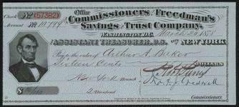 | Office Commissioners of the Freedman's Savings and Trust Company. Pay to the order of Arthur A. Baker. Sixteen Cents. | From Slavery to Freedom: The African-American Pamphlet Collection, 1822-1909 | http://www.loc.gov/item/scsm000519/
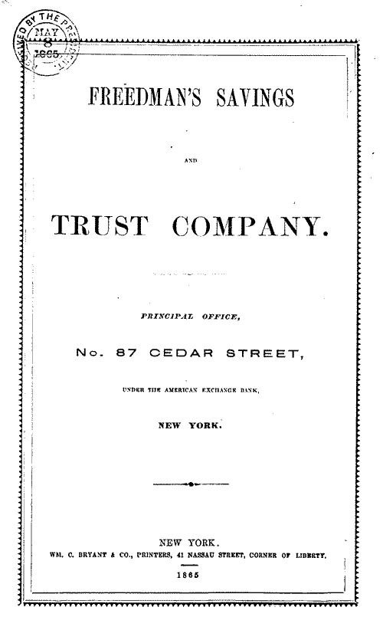 | Freedman’s Savings and Trust Company Charter and By-Laws | From Slavery to Freedom: The African-American Pamphlet Collection, 1822-1909 | http://memory.loc.gov/cgi-bin/query/r?ammem/AMALL:@field%28NUMBER+@band%28rbaapc+09300%29%29
 | An act to incorporate the Freedman's Savings and Trust Company : approved, March 3d, 1865. | From Slavery to Freedom: The African-American Pamphlet Collection, 1822-1909 | http://memory.loc.gov/cgi-bin/query/r?ammem/AMALL:@field%28NUMBER+@band%28rbaapc+31300%29%29
 | Failure of the Freedman's Bank: Freedom, Finance and Security in 19th Century American Capitalism | Webcast 2010/05/16  Jonathan Levy,  Megan Fellow | http://www.loc.gov/today/cyberlc/feature_wdesc.php?rec=4932

Resource Table for other Resources
Image | Description | Citation | URL
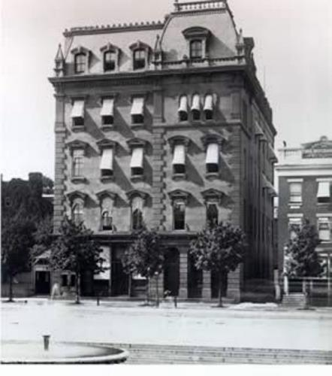 | Freedman’s Savings and Trust Company | BlackPast.org, The Black Past – Remembered and Reclaimed | http://www.blackpast.org/aah/freedmen-s-savings-and-trust-company-1865-1874
 | Letters to the President from depositors of Freedman’s Savings and Trust | Urgent Deficiency Appropriation Bill: Hearings Before the Subcommittee of the Committee on Appropriations, United States Senate, Sixty-third Congress, First Session, on H. R. 7898, a Bill Making Appropriations to Supply Urgent Deficiences in Appropriations for the Fiscal Year 1913, and for Other Purposes [September 22-26, 1913] (Google eBook) | http://books.google.com/books?id=3CcuAAAAMAAJ&pg=PA199&lpg=PA199&dq=letters+to+president+from+depositors+of+freedman%27s+savings+and+trust&source=bl&ots=4z69MWBY3Q&sig=sSjHUMeLWtBFAEPyH8GvtzOFoDw&hl=en&sa=X&ei=Yi_eU9XjIdigyASxy4GgBg&ved=0CDQQ6AEwBA#v=onepage&q=letters%20to%20president%20from%20depositors%20of%20freedman's%20savings%20and%20trust&f=false

Procedure:
The Freedman’s Savings and Trust Company was chartered in March of 1865. It was the first financial institution specifically created to help the really emancipated slaves. The belief was that it would provide financial stability for freedmen and help develop the habits necessary to be successful in a system of free labor. Massachusetts’ Senator, and later Vice President under Grant, Henry Wilson encouragingly stated that deposits made by freedmen in the bank would be “just as safe there as if it were in the Treasury of the United States.”
Eventually 37 branches would be established throughout the South, employing many African Americans as bank administrators and tellers. The federal government, working through agencies like the Freedmen’s Bureau, strenuously encouraged African Americans to make deposits in the bank. Over 100,000 African Americans did just that, making deposits ranging from a few pennies to $50. By 1874, just nine years after its creation, the bank failed and closed all its branches.
To find out what happened to the Freedman’s Savings and Trust and the consequences for the depositors, review all of the resources listed keeping in mind 3 guiding questions:

- What were the original goals of the Freedman’s Savings and Trust?
- How was the Freedman’s Savings and Trust received by the recently emancipated slaves?
- Why did the Freedman’s Savings and Trust fail?

After reviewing all of the resources and feeling comfortable with your ability to answer the 3 guiding questions complete the assessment for this activity

Assessment:
Question One
In what way is the history of the Freedman’s Savings and Trust Company a reflection of the overall policies of the federal government’s policies toward the freedmen during Reconstruction?

Question Two
How was the collapse of the Freedman’s Savings and Trust an example of some of the problems that would plague America during the Gilded Age?

