Primarily Teaching Grant Lesson Plan

Name: Kyle C. Engdahl

Title: A Primarily Electoral Focus

Grade-Level: 11-12th Grade

Subject Area: American Government

Topic: Electoral College

Standards:
- Understand ways citizens participate in the political process at local, state, and national levels.
- Understand the concepts of constitutional government as fundamental principles of American democracy.
- Understand the basic concepts of a federal system of government.
- Understand the concept of civic responsibility.

Compelling Question: Why does the United States use an “electoral college” to select the President and why is the 225 year-old body still a controversy in 2014?

Learning Objectives:
- The Students Will explain the basic process of selecting the President of the United States.
- The Students Will evaluate motives for maintaining or changing the Electoral College.
- The Students Will identify & rank alternatives to the Electoral College.

Resource Table Materials:

Source | Description | Citation | URL
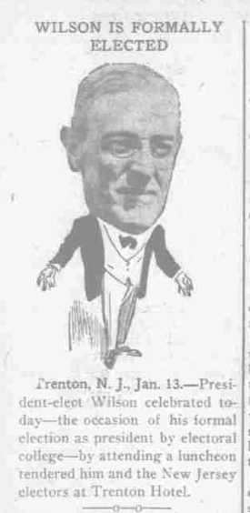 | Screen grab of “The Day Book” from January 1913, highlighting the “formal election” via the Electoral College. | The day book. (Chicago, Ill.), 13 Jan. 1913. Chronicling America: Historic American Newspapers. Lib. of Congress. <http://chroniclingamerica.loc.gov/lccn/sn83045487/1913-01-13/ed-1/seq-4/> | http://chroniclingamerica.loc.gov/lccn/sn83045487/1913-01-13/ed-1/seq-4/
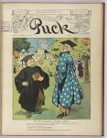 | Front page of Puck depicting Uncle Sam & William Jennings Bryan at a luncheon of the Electoral College, satirizing it as if it was an educational institution, in the run up to the 1908 campaign. | Glackens, L.M. “On the Electoral College Campus.” Puck. 12 June, 1907. <http://www.loc.gov/pictures/item/2011647210/> | http://www.loc.gov/pictures/item/2011647210/
 | 270 to win is a “an interactive Electoral College map for 2012 and a history of Presidential elections in the United States” – also used to project into the 2016 election. | 270towin.com, (2014). 2016 Presidential Election Interactive Map and History of the Electoral College. [online] Available at: http://www.270towin.com [Accessed 18 Aug. 2014]. | http://www.270towin.com
 | From the National Archives, a reference source on the Electoral College for students. | Archives.gov, (2014). U. S. Electoral College: Frequently Asked Questions. [online] Available at: http://www.archives.gov/federal-register/electoral-college/faq.html [Accessed 18 Aug. 2014]. | http://www.archives.gov/federal-register/electoral-college/faq.html
 | Examines the year of 2009 as a modern exemplar of the controversies surrounding the Electoral College. | Neale, Thomas H. “The Electoral College: Reform Proposals in the 109th Congress.” Congressional Research Service. 12 March, 2007. < http://fpc.state.gov/documents/organization/82468.pdf> | http://fpc.state.gov/documents/organization/82468.pdf
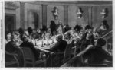 | Highlighting the tension of the 1876 election, this image from Frank Leslie’s Illustrated, shows the backroom deals that are part of the controversy of the election of Rutherford B. Hayes. | “Washington, D.C.--the Electoral Commission holding a secret session by candle-light, on the Louisiana question, February 16th.” Frank Leslie's illustrated Newspaper, v. 44, no. 1119, March 10, 1877, p. 9. Available at: http://www.loc.gov/pictures/item/89712291/. Accessed 17 August 2014. | http://www.loc.gov/pictures/item/89712291/
 | House Joint Resolution 25, from the 107th Congress, by Iowa’s own Jim Leach (R). | H.J.Res.25 - 107th Congress (2001-2002): Proposing an amendment to the Constitution of the United States to abolish the electoral college and establish a new procedure for electing the President and Vice President. Available at: https://beta.congress.gov/bill/107th-congress/house-joint-resolution/25?q=%7B%22search%22%3A%5B%22Proposing+an+amendment+to+the+Constitution+of+the+United+States+to+abolish+the+Electoral+Colleg%22%5D%7D [Accessed 18 Aug. 2014]. | https://beta.congress.gov/bill/107th-congress/house-joint-resolution/25?q=%7B%22search%22%3A%5B%22Proposing+an+amendment+to+the+Constitution+of+the+United+States+to+abolish+the+Electoral+Colleg%22%5D%7D
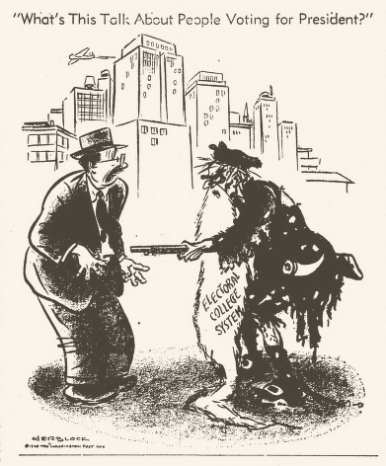 | The entire collection of Herb Block editorial cartoons, of which quite a few pertain to his criticisms of the Electoral College.  {Example to the left was printed nationally & is a screen grab from rom the Wichita Daily Times of Wichita Falls, Texas on July 29, 1948.} | LOC.gov, (2014). Cartoon Drawings: Herblock Collection. Available at: http://www.loc.gov/pictures/collection/hlb/ [Accessed 18 Aug. 2014]. | http://www.loc.gov/pictures/collection/hlb/
 | Data and analysis from Gallup regarding public opinion in the United States regarding the Electoral College. | “Americans Would Swap Electoral College for Popular Vote.” Gallup.com. Available at: http://www.gallup.com/poll/150245/americans-swap-electoral-college-popular-vote.aspx [Accessed 20 Aug. 2014]. | http://www.gallup.com/poll/150245/americans-swap-electoral-college-popular-vote.aspx

Procedure:
- Notes covering the basic structure, past, & controversy of the Electoral College
- Includes “I-Spy” class discussion of images/cartoons listed above
- Group work to analyze election data from the website 270towin.com
- 4 groups picking 4 different elections for compare/contrast of electoral vs. popular vote results
- Group work to brainstorm alternatives & analyze proposed reforms
- Excerpted sections from The Electoral College: Reform Proposals in the 109th Congress” will be distributed
- Utilize National Archives FAQ and other online sources for additional information
- Student groups must post THREE unique sources at http://padlet.com/engdkyl/gov
- Groups must include the web address & a statement of what knowledge they gained from said source
- Assign individual reading/response
- Read Gallup article & compose a 350 word response including your opinion of the Electoral College and supported position of what should happen to the College
Assessment:
- Informal: Group & Individual observations, including participation/cooperation/originality
- Formal: Padlet Quest & Reading Response

