Primary Teaching Grant Lesson Plan
Name: Chad Otdoerfer
Title: Pilgrims (Colonization)
Grade Level: 8th
Subject Area: 8th Grade Social Studies (American History)
Standards:
- RH.6-8.1. Cite specific textual evidence to support analysis of primary and secondary sources
- RH.6-8.2. Determine the central ideas or information of a primary or secondary source; provide an accurate summary of the source distinct from prior knowledge or opinions.
- RH.6-8.7. Integrate visual information (e.g., in charts, graphs, photographs, videos, or maps) with other information in print and digital texts.

Compelling Question:
- What are intended and unintended consequences of mass migrations?
Learning Objectives:
- Students will gain foundational knowledge of Pilgrims by analyzing photos.
- Students will be able to identify people and objects in the colonization photos.
- Students will be able to summarize central messages from the colonization photos.
- Students will be able to form an opinion of author purpose of publishing the colonization photos.
- Students will be able to use technology appropriately to access primary source documents “pushed out” by their teacher.
Materials:
- Library of Congress primary source photos which are listed below.
- Analysis Sheet (https://docs.google.com/a/albia.k12.ia.us/file/d/0B1ehFx0JegzxTGNORWtjM0F2Wm8tNDcxdDdzZXlGMFZCZFhZ/edit)
- Students will use their KUNOS (computer device) to access the primary source photos listed below.
- Student will also be able to access the picture analysis sheet using the KUNO (computer device).
Resource Table of Library of Congress Materials:
Image | Description | Citation | URL
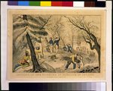 | Creator-N. Currier, Shows Pilgrims landing | Library of Congress, Prints & Photographs Division, [reproduction number, e.g., LC-USZ62-90145] | http://www.loc.gov/pictures/item/95503144/
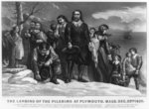 | Creator—Currier & Ives | Library of Congress, Prints & Photographs Division, [reproduction number, e.g., LC-USZ62-90145] | http://www.loc.gov/pictures/item/2002707741/
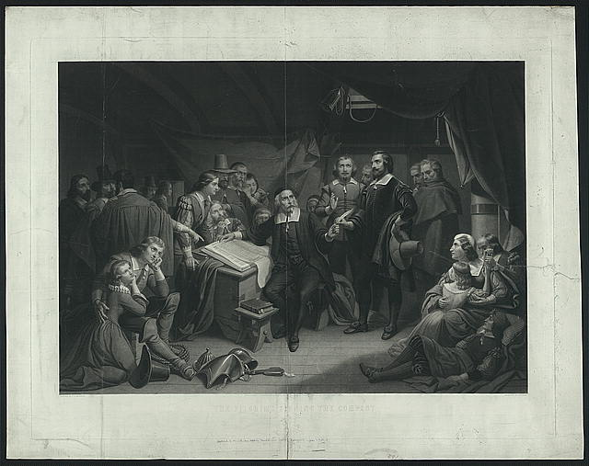 | Creator-T.H. Matteson | Library of Congress, Prints & Photographs Division, [reproduction number, e.g., LC-USZ62-90145] | http://www.loc.gov/pictures/resource/ppmsca.07842/
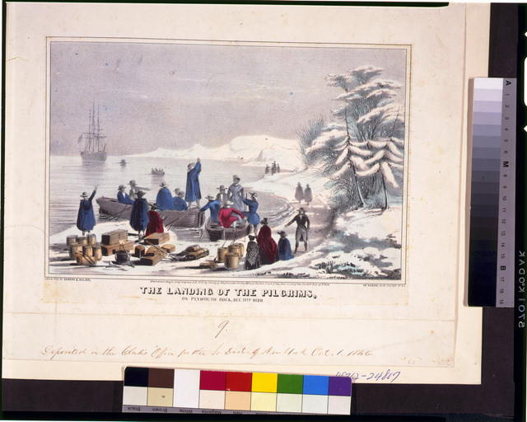 | Creator—Sarony & Major | Library of Congress, Prints & Photographs Division, [reproduction number, e.g., LC-USZ62-90145] | http://www.loc.gov/pictures/resource/cph.3g04311/
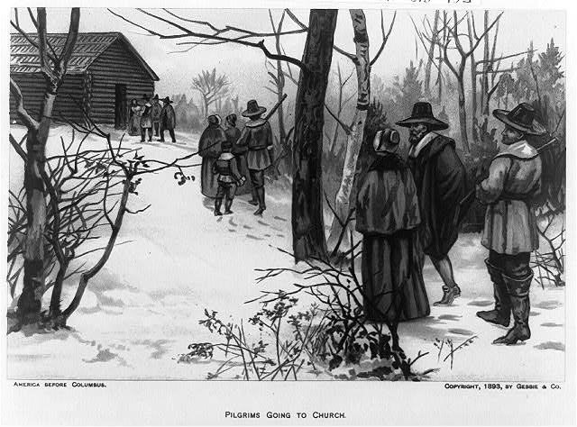 | Creator—N/A, 1893 | Library of Congress, Prints & Photographs Division, [reproduction number, e.g.,LC-USZ62-3030 (b&w film copy neg.]) | http://www.loc.gov/pictures/resource/cph.3a06614/
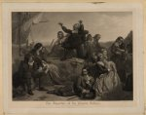 | Creator—N/A | Library of Congress, Prints & Photographs Division, [reproduction number, e.g., LC-USZ62-90145] | http://www.loc.gov/pictures/item/2003666350/
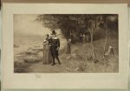 | Creator—N/A | Library of Congress, Prints & Photographs Division, [reproduction number, e.g., LC-USZ62-90145] | http://www.loc.gov/pictures/item/2003666981/
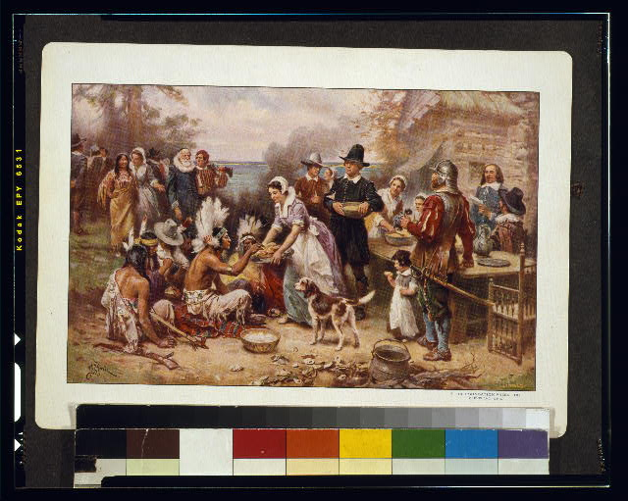 | Creator—Jean Leon Gerome Farris | Library of Congress, Prints & Photographs Division, [reproduction number, e.g., LC-USZC4-4961] | http://www.loc.gov/pictures/resource/cph.3g04961/
Procedure:
- The classroom teacher will give a brief mini lesson explaining reasons Europeans decided to colonize North America, including reasons students have already studied in our Jamestown unit.These reasons include individuals desire for wealth, fame, adventure, a fresh start, economic opportunity, escape from their life in Europe. Then the teacher will explain to students that today our focus will be on the Pilgrims, trying to better understand the Pilgrims through primary source photos. The instructor will not provide any reasons of why the Pilgrims decided to come to North America because it could influence how the students analyze the photos.
- Next, The instructor will explain categorizing the photographs—students will try to put the 8 photographs into 3-4 categories. I will ask them to use a sticky note to write an explanation of why they grouped them together as they did. These groups will be selected by the teacher by drawing playing cards. Groups will be 3-4 students depending on class numbers.
- Students will share out their determined categories and thinking to the class, discussing connections students identify across the groups.
- The teacher will then model how to properly analyze a photo using a photo analysis sheet (Photo Analysis Worksheet designed and developed by the Education Staff that was included within our resource packet I received at the workshop). The classroom teacher will use one of the eight primary source documents and complete a photo analysis for the class by displaying expert thinking out loud (I statements) about the photograph. Ex: “I can identify the Native Americans because of the feather headdresses and body painting. I can also idnetify the other group of people are European because of hats and long shirts. I know these textiles did not exist in North America during this time period. Therefore, I can conclude these came individuals traveled from Europe. The European vessel reinforces my feelings.”
- Students will then access the photos using their KUNO. They will be expected to select one of the remaining seven photographs and complete a photo analysis sheet as a group. If students finish early, they can analyze other photographs for further practice.
- Each group will report out their analysis with conclusions drawn on each photo.
- Students will then independently complete a quick write explaining everything they understand about Pilgrims based on the photographs and their background knowledge. Hopefully, students will connect the importance of religion in Pilgrim culture based on the photo analysis and identify that as a potential reason for the Pilgrims fleeing Europe. (Intended consequence of migration) Later in the unit hopefully students will be able to identify unintended consequences of migration. (starvation, Native American relations, increased migration, etc)

Assessment:
- Formative: I will observe and work with groups as they complete their photo analysis answering questions and providing guiding thoughts as necessary to further their inquiry.
- Summative: I will collect students’ quick write responses to determine their understanding on the individual level.

