Primarily Teaching Grant Lesson Plan

Name: Jeromy Keehn

Title: Changing Models of the Cosmos and Universe

Grade-level: Middle School or High School

Subject Area: Big History

Topic: How did our understanding of the Universe change?

Standards: (Unit Standards)
- H.9-12.1.1 Understand concepts such as chronology, causality, change, conflict, and complexity to explain, analyze, and show connections among patterns of historical change and continuity.
- H.9-12.8.1 Understand processes such as using a variety of sources, providing, validating, and weighing evidence for claims, checking credibility of sources, and searching for causality.
- H.9-12.8.5 Understand multiple viewpoints within and across cultures related to important events, recurring dilemmas, and issues.
- BS.9-12.2.5 Understand that people might ignore evidence that challenges their beliefs and more readily accept evidence that supports them (Claim testing)
- H.9-12.4.3 Understand the significance religious, philosophical, and social movements and their impacts on society and social reform
- H.9-12.1.2 Understand significant historical periods and patterns of change within and across cultures, such as the development of ancient cultures and civilizations, the rise of nation states, and social, economic, and political revolutions.
- H.9-12.8.1 Understand processes such as using a variety of sources, providing, validating, and weighing evidence for claims, checking credibility of sources, and searching for causality.

Compelling Question:
- How and why do individuals change their minds?

Learning Objectives:
- Describe and explain how views of the Universe have changed over time.
- Explain how an evolution of ideas can lead to a scientific revolution; provide examples of some scientific revolutions.

Materials:
- Set of primary documents for each group
- Copies of the articles for group
- Could provide a table to organize answers of the 4 questions posed below

Resource Table of Library of Congress Materials:

Image | Description | Citation | URL
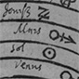 | Illustration of the Ptolemaic concept of the universe showing the Earth in the center. | Glogowczyk, Jan. An illustration of the Ptolemaic concept of the universe showing the  Earth in the center. Print. Cracow: 1513. From Library of Congress: Prints and Photographs  Division. | http://www.loc.gov/teachers/classroommaterials/primarysourcesets/understanding-the-cosmos/pdf/universe.pdf
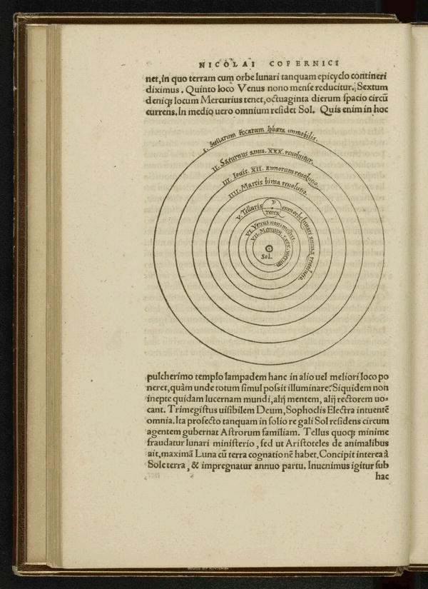 | Copernicus’ Sun-centered model of the cosmos | Copernicus, Nicolaus. Nicolai Copernici Torinensis De revolvtionibvs orbium cœlestium.  Diagram, image 36. 1543. From Library of Congress: Rare Books and Special Collections  Division. | http://www.loc.gov/resource/rbc.2012gen31925#seq-36
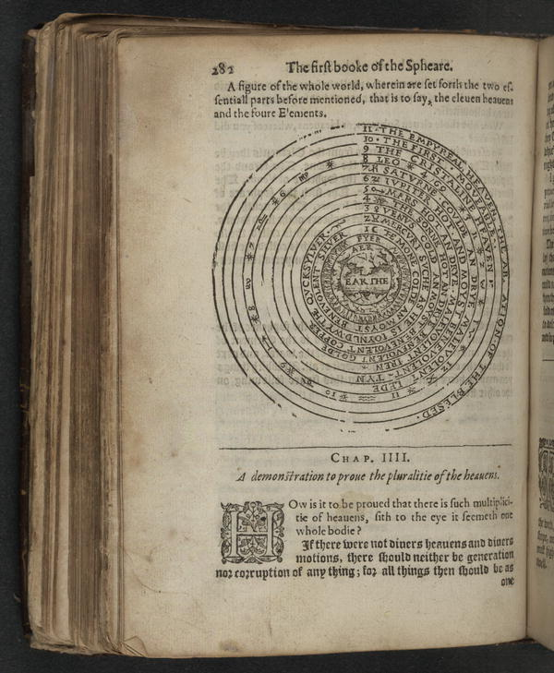 | llustration of the heavenly spheres showing Earth at the center surrounded by the four elements and eleven heavens | Blundeuile, M. M. Blundeuile his exercises: containing eight treatises... Illustration, image  301. London: William Stansby, 1613. From the Library of Congress: The Kraus Collection  of Sir Francis Drake. | http://www.loc.gov/resource/rbdk.d036/#seq-301
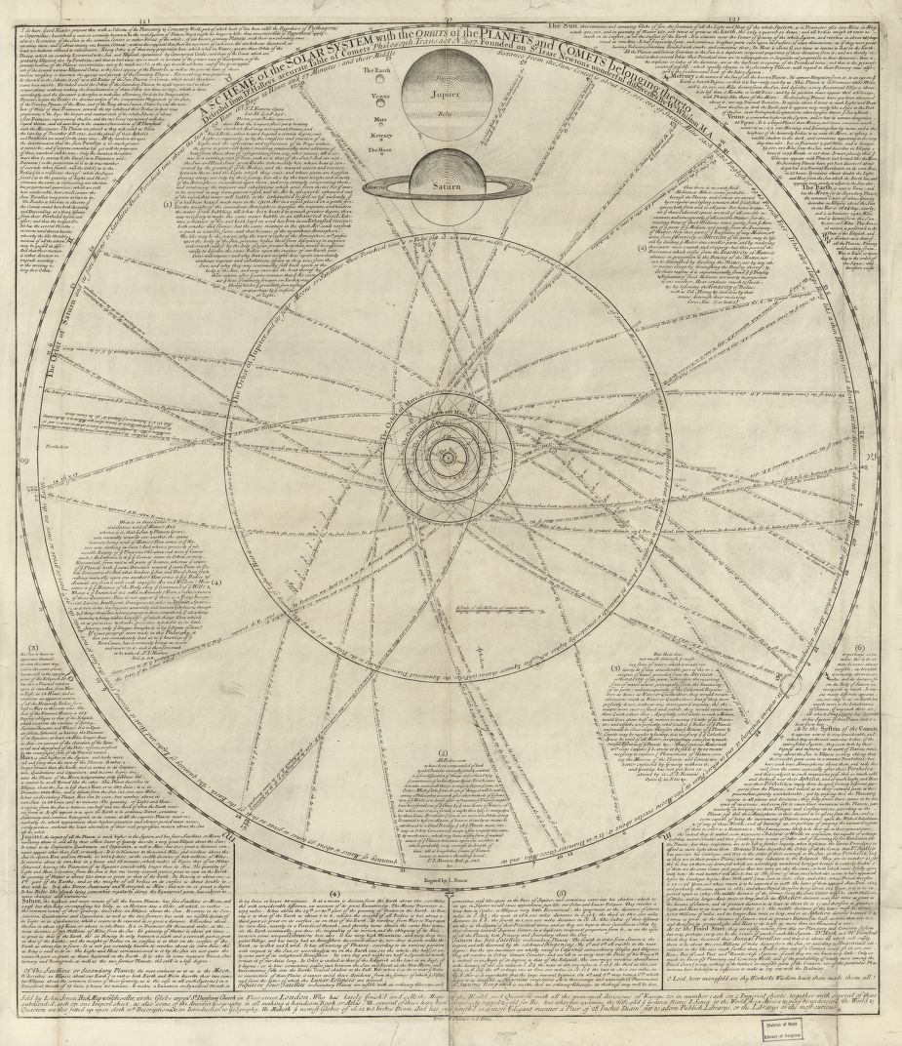 | A scheme of the Solar system with the orbits of the planets and comets belonging thereto | G3180 1720 .W5 Vault.  Library of Congress Geography and Map Division Washington, D.C. 20540-4650 USA | http://hdl.loc.gov/loc.gmd/g3180.ct003814

Procedure:
- Students will be divided into five groups. Each group will be given a set of the primary documents. They will attempt to place them in correct chronological order. They will be given a couple minutes to complete this.
- Then each group will be given a different article that aligns with the Big History 2.0 lesson (Ptolemy, Copernicus, etc.) As they read their article, they will answer the following questions:
- What contribution did this person make to how we view the Universe?
- What previous information did this person build upon or challenge in making the contribution?
- What evidence is used to challenge and to support the contribution this person made?
- What political and social challenges, if any, did this person face when making the contribution?
- Once each group has completed their article, each group will then divide up and regroup with a member of each one of the other groups. In these new groups, they will each share their findings from their article and share it with the other members.
- Once everyone has shared their article with the new group, the students will go back to their original groups and complete the assessment.

Assessment:
Each group will go back and look at their primary documents from the beginning. They may change the order or keep it the same. Students will need to be able to provide reasoning for keeping it the same or changing it based on what they learned from the article. Call on a few students, at least one from each group, to provide those reasons.

