Primarily Teaching Grant Lesson Plan

Name: Kelly Henry

Title: Boston Massacre or Mayham: You Decide

Grade-level: 9

Subject Area: American History

Topic: Boston Massacre

The Boston Massacre is an episode that perfectly illustrates the struggle in pre revolutionary war America about exactly what rights were being denied to the colonists and how those rights should be protected. In March of 1770, a mob of colonists more or less attacked a group of British soldiers, who, in fear of their lives, opened fire. When the smoke cleared 5 colonists were dead. The conflict between the colonists and the British had now resulted in bloodshed. This event becomes known as the “Bloody Massacre” because of a famous engraving made by Paul Revere. The engraving depicts the soldiers as blood thirsty monsters firing upon innocent bystanders. The mob wanted a good old fashioned hanging, let justice be served to those bloody Brits! John Adams, a sympathizer to the cause, did not see it that way. He was in many ways, a moral compass for the patriots. He questioned how the soldiers rights could be denied, especially when one of the chief complaints against the British was the denial of those same rights to colonists accused of crimes. He ends up taking the case to defend the soldiers and is mostly successful in proving the shooting were in self defense. In this lesson students will explore the role of propaganda in social movements and then look at the ethics behind making decisions based on one’s core values.

Standards:
- Understand the role of individuals and groups within a society as promoters of change or the status quo. (Common Core)
- Understand cause and effect relationships and other historical thinking skills in order to interpret events and issues. (Common Core)
- Understand the rights and responsibilities of each citizen and demonstrate the value of lifelong civic action. (Common Core)

Compelling Question: What happened on the night of March 5, 1770?

Learning Objectives:
- Students will analyze primary sources that revolve around the event of March 5, 1770
- Students will identify propaganda and determine its purpose or bias
- Students will evaluate the veracity of the primary sources in order to recreate the actual events that occurred on March 5, 1770

Materials: All sources cited on the Resource table.
- https://docs.google.com/document/d/1vANiEVSYMxm_Q-oOmzwVItBcMhOkIabzO8ste5u85Yk/edit?usp=sharing
- https://docs.google.com/document/d/1_UKmG6RQG9niFQnIPnh7IAQzkiF_Eo80KOlXezWXw7w/edit?usp=sharing
- http://www.archives.gov/education/lessons/worksheets/written_document_analysis_worksheet.pdf
- http://www.archives.gov/education/lessons/worksheets/cartoon_analysis_worksheet.pdf
- http://www.archives.gov/education/lessons/worksheets/photo_analysis_worksheet.pdf

Resource Table of Library of Congress Materials:

Image | Description | Citation | URL
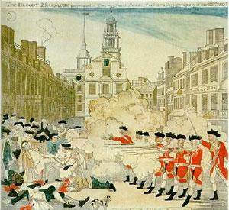 | Paul Revere, the American patriot who warned that the British were coming, engraved this depiction of the Boston Massacre | CREDIT: Revere, Paul, engraver. 'The bloody massacre perpetrated in King Street Boston on March 5th 1770 by a party of the 29th Regt.," 1770. Prints and Photographs Division, Library of Congress. Reproduction Number LC-USZC2-4913. | http://www.americaslibrary.gov/jb/revolut/jb_revolut_boston_1_e.html
 | Summation of John Adams | The Legal Papers of John Adams, No. 64, Rex v Wemms. | http://law2.umkc.edu/faculty/projects/ftrials/bostonmassacre/adamssummation.html
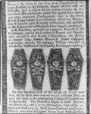 | Title: [Four coffins of men killed in the Boston Massacre] | Title: [Four coffins of men killed in the Boston Massacre]  Creator(s): Revere, Paul, 1735-1818, engraver  Date Created/Published: [1770 March 12] | http://www.loc.gov/pictures/item/2004672647/
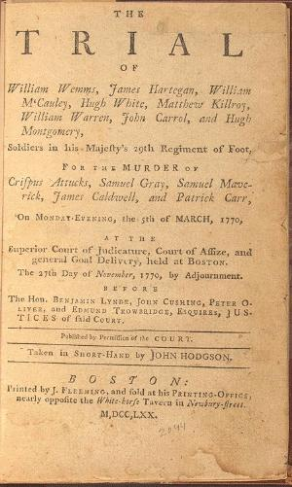 | The Soldiers Trial: October 24 to 30, 1770 | The statements below come from The Trial of the British Soldiers, of the 29th Regiment of Foot. Boston: Published by William Emmons, 1824. | http://law2.umkc.edu/faculty/projects/ftrials/bostonmassacre/soldiersaccount.html
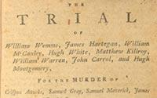 | The Murder of Crispus Attucks | Boston: J. Fleeming, 1770  Law Library | http://www.loc.gov/exhibits/treasures/trr046.html
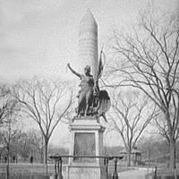 | The Boston Massacre Monument, a monument to American independence | CREDIT: Boston, Mass., Boston Massacre Monument, 1890-1906. Prints and Photographs Division, Library of Congress. Reproduction Number LC-D4-17075. | http://www.americaslibrary.gov/jb/revolut/jb_revolut_boston_3.html

Procedure:
Day One:
- Access background knowledge by conducting a whole class discussion. Discussion should revolve around previous lessons about legislation Parliament had passed that the colonists viewed as unfair. Discussion should also revolve around what rights the colonists felt they had and those the British were clearly violating. Discussion should continue until it is clear the students have a firm understanding that hostilities between the colonists and the British had escalated to the point of potential violence.
- Ask students to access the link to the image of the “Bloody Massacre”. Pass out the Primary Source Analysis Tool. Ask students to fill out the form individually. If time runs out, students should have this completed for class the next day.
- Number students off 1, 2, 3. Ask the 1’s to access the link to the image of the “Bloody Massacre” ,the 2’s the “Four Coffins” and the 3’s the Murder of Crispus Attucks”. Pass out the Primary Source Analysis Tools. Ask students to fill out the forms individually. If time runs out, students should have this completed for class the next day.

Day Two:
- Direct students to get out a clean sheet of paper. Students should fold the paper into 4 equal sections. They should name 3 of the sections after each image and the 4th section should be labeled summary.
- Put students in groups so each has at least one student who examined one of the images. Direct students to share their image/document and their analysis with the other group members. Students should take notes about each image/document as each student shares their analysis. Student should make notes about their own image/document as they discuss it in their groups. After the students have shared out their analysis they should come up with a summary statement about the events on March 5, 1770, based on their analysis. Ask groups to give at least three pieces of evidence based on their primary sources to back up their summary. Invite groups to share their summary statements and evidence with the class. (Groups should come to the conclusion that the soldiers fired upon innocent and defenseless colonists.)
- Introduce the vocabulary term propaganda. (Give several modern day examples, i.e. current campaign literature, government promotions, etc.) Ask students to get back into groups and determine whether each one of the images/documents is propaganda or not. They should record their ideas on their foldable in the appropriate section. Students should cite evidence to support their determinations. This exercise may need to be completed on day three.

Day Three:
- Ask students to review their analysis of the three sources they examined the previous day silently. Ask students to get back into their groups. Pass out copies of John Adams’ Summation and the Soldier’s Trial documents. Pass out the note taking tool. Tell students they will be reading the words of John Adams who agreed to represent the British soldiers and of the soldiers themselves as to what happened on March 5, 1770. Tell students that the language is arcane, but a close and careful reading will reveal the main points in each source. Tell students they will not be able to fill out each box on the note taking tool, that is okay. Direct students to create a new summary based on the two readings on the back of the note taker. If students do not finish in class they should have this ready for class the next day.

Day Four:
- Put students back into their groups. Pass out the analysis tool giving all members a copy. Ask students to access the information about the monument in Boston dedicated to the Boston Massacre. Students should examine the monument and read the accompanying information and then fill out their tool as they discuss what they see. After students have completed this analysis, pass out the assessment question. Students should discuss the question. Direct students to take notes during their discussion. Tell students they should have an individual written response to the question for class tomorrow. Collect their assessment at the beginning of class the next class period.

Assessment:
Students will answer the following question: Is the Boston monument in honor of the events on March 5, 1770 propaganda? Explain using evidence from sources presented in class.

